ROBOTICS (4th exercise)

- Write a program that moves the motors to follow this route:

  - It must stop for two seconds and turn on the red LED when the user presses the button A.

- Write a program that allows the user to use the buttons:
  - If the user presses the button A, the robot will move forward (slowly) for 1 second.
  - If the user presses the button B, the robot will move backward (slowly) for 1 second.
  - If the user presses the button C
    - The first time, the robot will turn right
    - The second time, the robot will turn left
    - The third time, the robot will turn right and so on
  - If the user doesn’t press any button, the robot will remain still.

- Write a program that allows the user to use the buttons:
  - When the user presses the button A, the red led must turn on for one second.
  - When the user presses the button B, the blue led must turn on for two second.
  - When the user presses the button C, the LEDs must blink alternatively.

- Write a program that counts the number of times the user presses the buttons (you must use variables for this).
  - When the user presses any button, the blue LED will turn on for 2 seconds and a message such as the following will appear. “You have pressed the button X times” (where X will be 1, 2, 3, etc).
  - When the counter reaches 4, the program must turn on the red LED for two seconds and set the counter to 0.
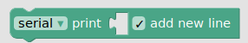
** You have to use comms block and the block that is in the picture).

HOW DO I SEND THE EXERCISES?
1- When you are sure that your exercise is correct, click on “Export” in the menu of the next picture.
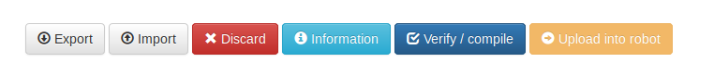
2- After clicking on the button, the file (with xml extension) will be downloaded to Drive
3- Rename the file with the title of the exercise and the names of the members. For example: Exercise1_DavidAlazneJulen
4- Upload to Classroom

