ROBOTICS (2nd exercise)

- Write a program that allows the robot to spin on itself.
  - Write the programme
  - Check it with the robot
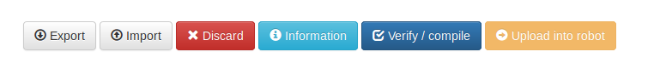
  - Export the programme

- Write a program that allows the robot to make a tour composed of all the types of movement.
  - Move forward
  - Turn right
  - Move backward
  - Turn left
  - Turn on itself

- Write a program that allows the robot to take the next specific route.

EXTRA EXERCISE
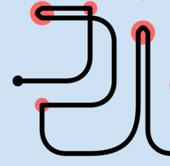
- Write a program that allows the robot to take the next specific route.

Beginning

End

HOW DO I SEND THE EXERCISES?
1- When you are sure that your exercise is correct, click on “Export” in the menu of the next picture.
2- After clicking on the button, the file (with xml extension) will be downloaded to Drive
3- Rename the file with the title of the exercise and the names of the members. For example: Exercise1_DavidAlazneJulen
4- Upload to Classroom

