



Acid-base titration and evaluation of the end point and equivalence point

Original author: Eric Montero Miranda (UNED)
Adapted by: LabsLand

Index

Objectives 3
Introduction 3
Educational cycle and estimated time 4
Laboratory 4
Results 9
Conclusions 14
Bibliography 14

Objectives
The objective of this laboratory is to develop technological skills managing a virtual laboratory, as well as to learn chemical concepts regarding the acidity and basicity of the species under study.

Introduction
Acid-base titration (also known as neutralization or volumetry) is a technique that allows knowing the acidic or basic concentration of an unknown substance. Is a method based on dripping an unknown acid solution with a basic titrant whose concentration is perfectly known and an indicator (phenolphthalein in this case), until the equivalence point is reached. This indicates the equivalence between the analyte and the titrant (see formula below). This effect is observed when the solution changes color. Initially the solution was colorlees and the experiment was stopped when the solution turned pink.
The concepts that must be mastered in this technique are:
- Titrant or standard substance: Solution whose concentration (acidity or basicity) and its volume are known.
- Analyte or unknown sample: Solution whose degree of acidity or basicity is not known, but its volume is.
- Equivalence point: Occurs when both substances, titrant and analyte, are equivalent and the formula N _{a} ·V _{a} = N _{b} ·V _{b} (explained later) is fulfilled.
- pH: Degree of acidity of a solution. pOH would be for degree of basicity. However, they are complementary, that is, if there is a high pH it is an acid solution and if it is low it is a basic solution.
- Phenolphthalein: Colorless chemical indicator in acid solutions and pink in basic ones (pH greater than 8.2).
Since we know the volumes of both solutions and the concentration of the base, we can find out the concentration of the acid with the following formula:
$N_{a}· V_{a}= N_{b}· V_{b}$ Eq. 1
N _{a} : Concentration of the acid in the unknown solution.
V _{a} : Volume of the unknown sample containing the acid.
N _{b} : Concentration of the base in the standard solution.
V _{b} : Volume of the standard sample containing the acid.

Also, in chemistry it is important to determine the concentration very accurately, so the result is always given with its error. For this, it is necessary to take into account the error of the material (volume pipette), of the titrant and of the volume. In Eq. 2, the formula used to determine the error of the citric acid concentration is observed.

$σ$_{Ácid citric}=$\sqrt{{(\frac{Error material}{V_{equivalence point}})}^{2}+{(\frac{Error volume sample}{V_{sample}})}^{2}+{(\frac{Error titrant}{C_{titrant}})}^{2}}$ Ec.2

In short, there are two volumes, one with basic concentration and the other one with acid. The concentration of one of them is unknown, the acid concentration.

Educational cycle and estimated time
Aimed at university students. It could be applicable to high school, but the activity supposes a high difficulty for this level. It lasts approximately a 2-hour session. There are three settings which last 15 minutes. Therefore, the part of the virtual experiment is 50 minutes and the rest, about 1 hour and 10 minutes to generate the graphs with the downloaded data and make the results and conclusions.

Laboratory
The configuration of this experiment allows to select a titrant with a certain concentration and from this one can select between three available tests for the unknown sample. It is important to take into account that, in each trial shown, aliquots were taken from the same unknown sample and the variations in endpoints are expected to be different. So it is recommended to carry out the three trials of the experiment in order to carry out a statistical analysis that allows enriching the experience.
Data processing and calculation example
In this experiment it is desired to determine a sample of citric acid whose concentration is unknown. For this, sodium hydroxide is used as a titrant ([NaOH]=0.065 0.002 mol/L), and phenolphthalein as an indicator.
In Figure 1, the volume of 5.179 mL is observed, this is when the colorless solution turns pinkish, that is, the turning point occurs at that volume.
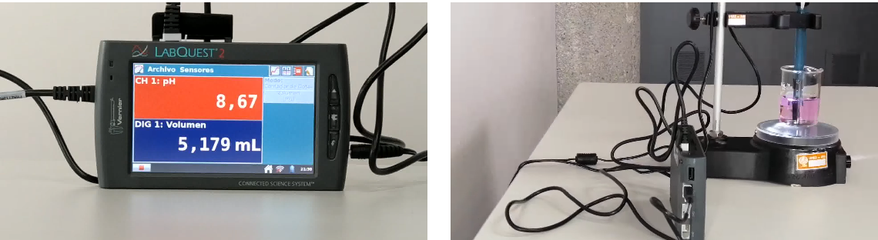

Viraje del indicador
Volumen reportado
Figure 1. [Left] pH meter and volume poured into the beaker. [Right] Burette with the standard substance and beaker with the analyte substance and the phenolphthalein indicator.
Applying Eq. 1, the unknown concentration value for the acid of interest can be obtained:
$$[AcCítr] = \frac{V_{NaOH}· [NaOH]}{V_{alícuota}}$$
$[AcCítr] = \frac{5.179 mL· 0,065 M}{10 mL}$= 0.034M

Graph design and equivalence point estimation
Below is a sample of how to build the graph corresponding to the acid-base titration process and the calculation of the equivalence point from the values obtained in the experiment.
As drops are poured, both volume and pH values are recorded, violet and blue columns, respectively (Figure 2). To create the graph, it is necessary to look for the option “Insert” and then “Scatter graph” marking the two previous columns.
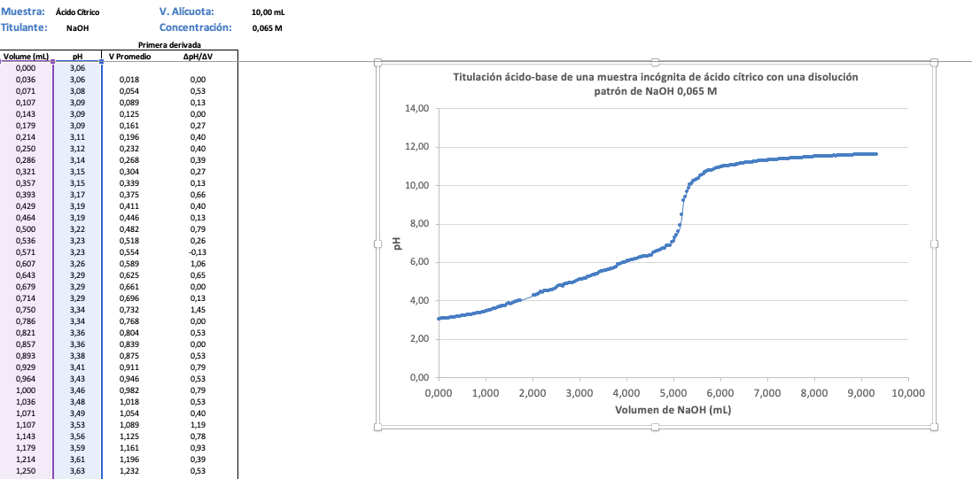
Figure 2. Graphical representation of the pH with respect to the volume discharged.

Then a line must be formed that passes through most of the points on the inflection zone produced by the sudden change in pH (Figure 3). Next, draw a rectangle that touches as many of the sections before and after the inflection point of the graph. Then, it must be reduced until two of its vertices touch the line at their joining point, causing the vertex to pass over the initial line. Finally, you must draw a line that passes through the other two remaining vertices of the rectangle, in such a way that it forms an "X" between the two drawn lines. The intersection point of the lines indicates the volume corresponding to the equivalence point.
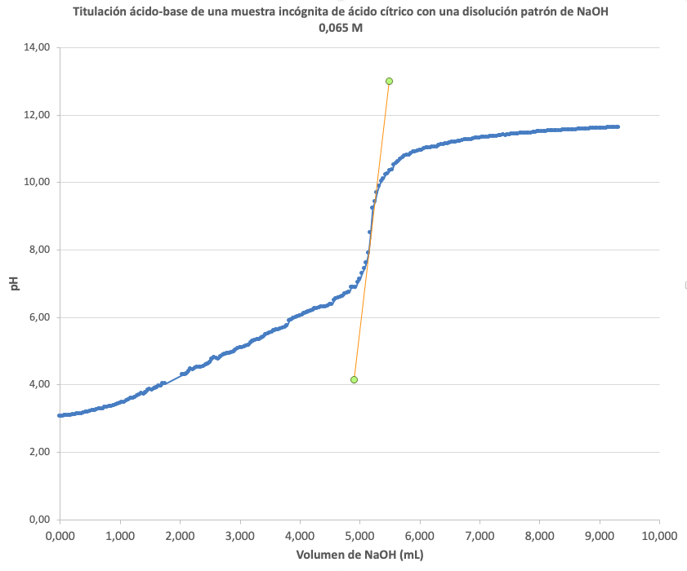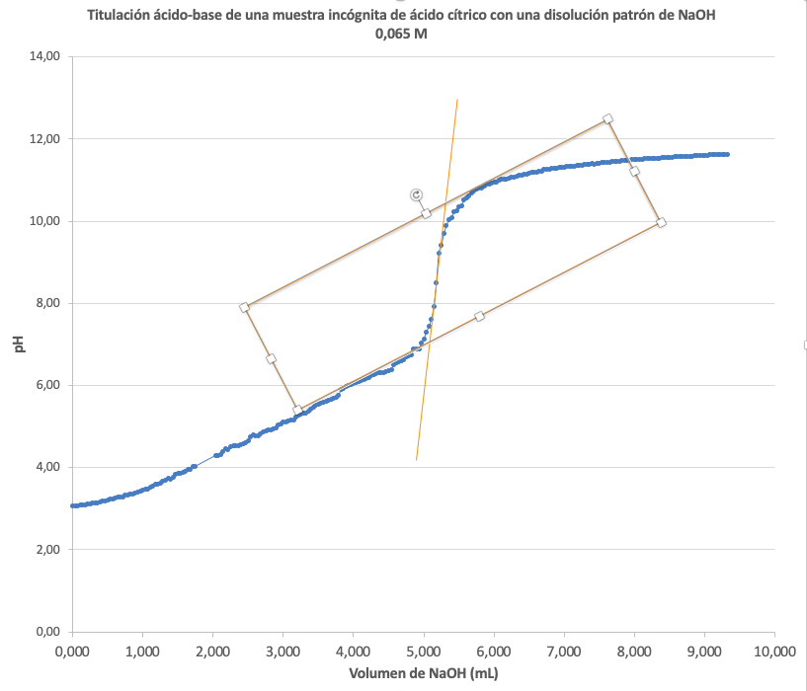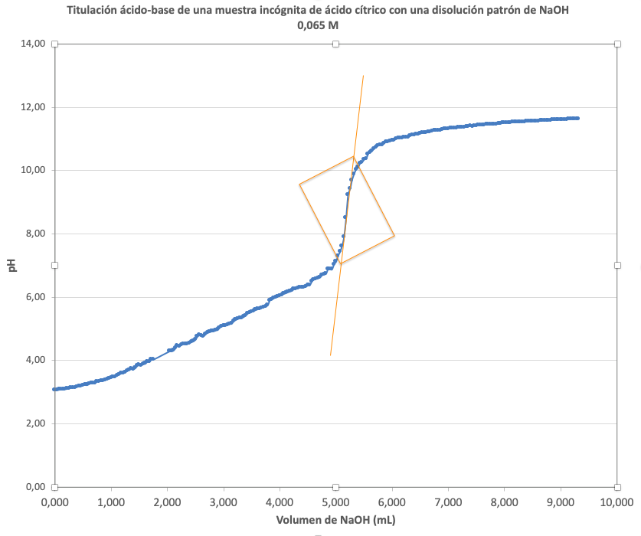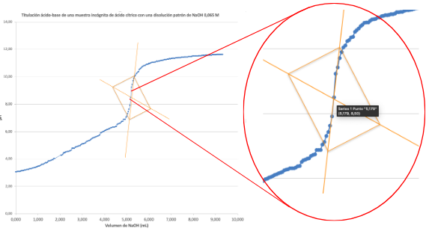

Figure 3. Order to follow to find the intersection that indicates the volume where the equivalence point occurs.

First derivative method to estimate the equivalence point
To find the equivalence point, use the average volume and the equation ∆pH/∆V, which is the difference (subtraction) of the initial or previous volume minus the current or the next (Figure 4).
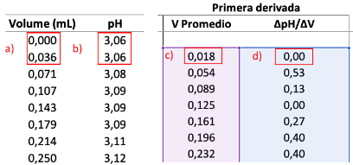
Figure 4. Calculations of the average volume (V) [a & c] and the equation ∆pH/∆V [a, b & d]. a & c) (0-0.036)/ 2 = 0.018. a, b & d) ∆pH = 3.06 – 3.06 = 0.00; ∆V = 0.036 – 0.000 = 0.036; ∆pH/∆V = 0.00 / 0.036 = 0.00

Finally, the titrant volume spent versus pH/V is plotted (Figure 5), and the maximum observed on the graph is the equivalence point volume. This is a way to ascertain and determine the volume of titrant spent more accurately.
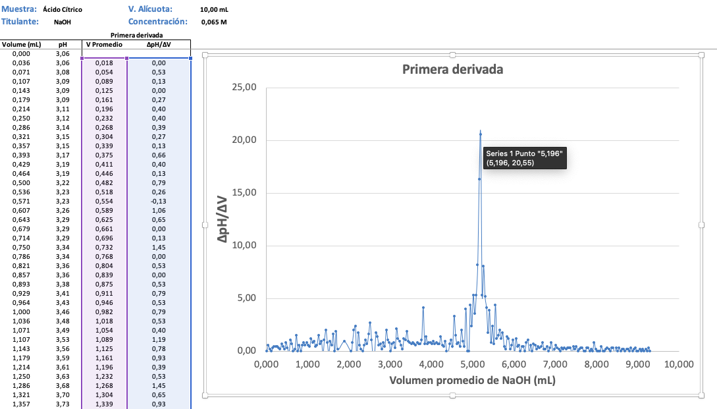
El punto de equivalencia es el valor más alto: 5.196 mL
Figure 5. Graphical representation of the difference in pH between the difference in volume (V) with respect to the average volume of sodium hydroxide consumed.

Second derivative method to verify the equivalence point (optional)
Note: This section is used to verify the equivalence point, in order to increase the accuracy of the result. It is up to the teacher to decide whether to include this activity or not.
To corroborate the equivalence point, we use the average volume and the equation ∆(∆pH/∆V)/∆V (Figure 6).
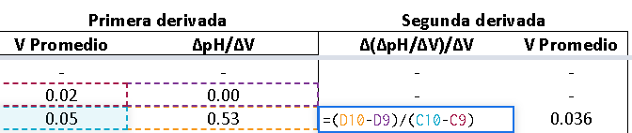
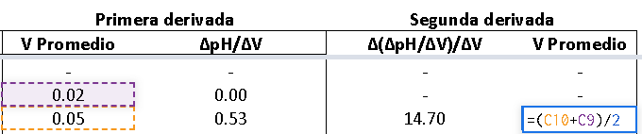
Figure 6. Calculations of the average volume (V) [V_{average}=V₁ - V₀] and the equation ∆(∆pH/∆V)/∆V [(∆pH/∆V₁ - ∆pH/∆V₀)/(V_{average 1} - V_{average} ₂)]
Finally, the average volume versus ∆(∆pH/∆V)/∆V is plotted (Figure 7). It is observed that most of the points are around the X axis, but there is also a maximum and minimum point, and the point that intersects with the X axis, between that maximum and minimum, is the equivalence point.
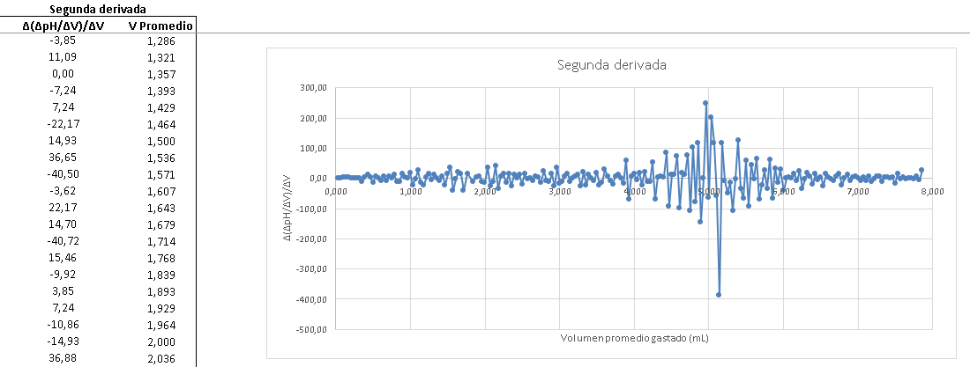
Figure 7. Graphical representation of the difference of the first derivative between the difference in volume (V) with respect to the average volume of sodium hydroxide consumed.

Results

Table 1 shows the results obtained experimentally for the volume of titrant (NaOH) used and for the pH at the time the solution changes from colorless to pinkish.

Table 1: volume and pH results obtained at the turning point observed in the remote laboratory.
Citric acid sample | Volume of NaOH spent (mL) | pH
Sample 1 | 5.14 | 7.92
Sample 2 | 4.50 | 7.72
Sample 3 | 5.07 | 8.11
Average | 4.90 | 7.92
Standard deviation | 0.4 | 0.2

Calculate the concentrations (mol/L) together with its error, of the three unknown samples of citric acid. To do this, you will have to previously find the equivalence point of each sample. Make the graphs you consider appropriate to find the equivalence point as accurately as possible. Also, you will have to take into account the error of the burette, the aliquot and the concentration of the titrant.

Citric acid 1
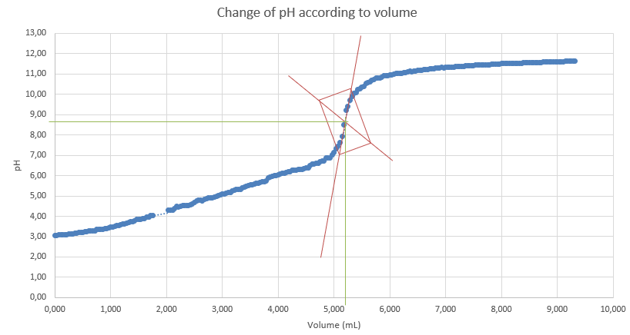
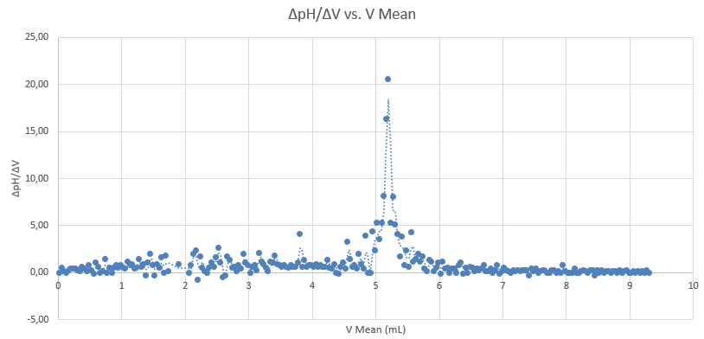
The equivalence point is achieved with the volume: 5.20 mL
$[AcCítr 1] = \frac{5.20 mL· 0.065 M}{10 mL}$= 0.0338 M

Citric acid 2
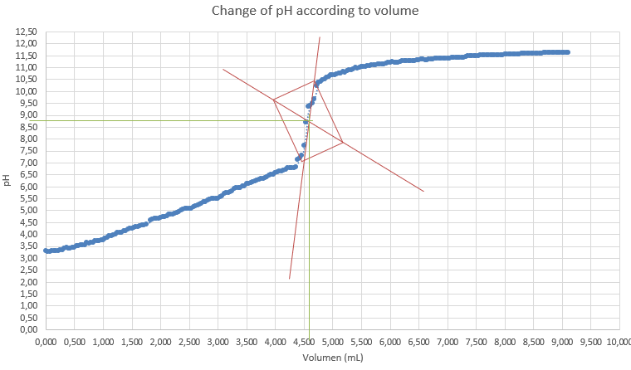
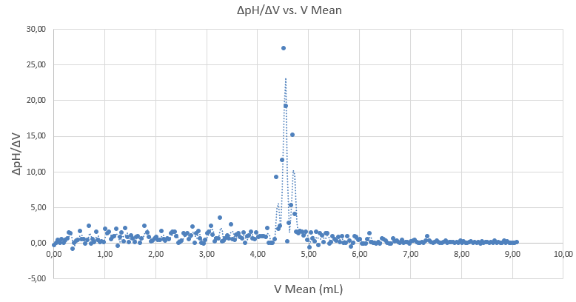

The equivalence point is achieved with the volume: 4.52 mL
$[AcCítr 2] = \frac{4.52 mL· 0.065 M}{10 mL}$= 0.0294 M

Citric acid 3
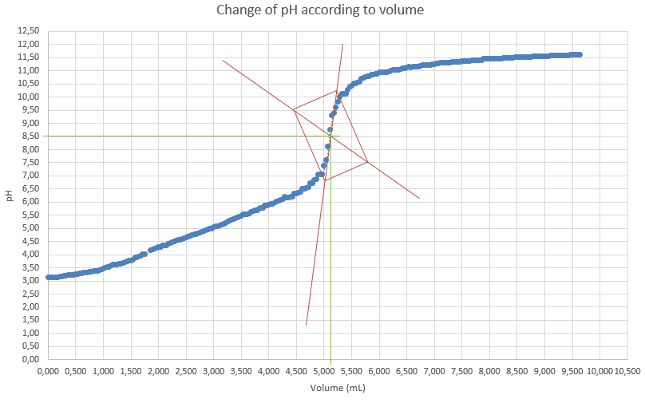
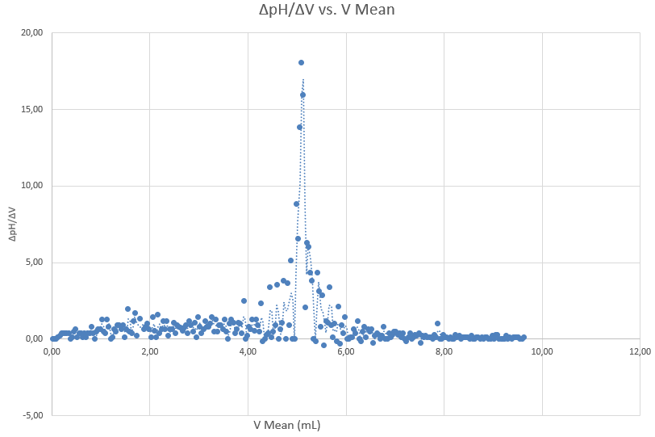

The equivalence point is achieved with the volume: 5.09 mL
$[AcCítr] = \frac{5.09 mL· 0.065 M}{10 mL}$= 0.0331 M

Table 2 shows the results of the concentrations of the samples obtained by analyzing the first derivative (and the second). When talking about this type of acids, the concentrations that are usually handled are g/L. Therefore, taking into account the molecular weight of citric acid (MW=192.13 g/mol), calculate the concentration of the samples in these units.
Table 2: Results obtained from the unknown samples in mol/L and g/L.
Sample | Concentration (mol/L) | Concentration (g/L)
Sample 1 | 0,0338 | 6,49
Sample 2 | 0,0294 | 5,65
Sample 3 | 0,0331 | 6,36
Average | 0,0321 | 6,17

Conclusions

Discussion of the results. Do the sample concentrations come from the same unknown sample? What is the effect of pH in this experiment?
Regarding the molarity of the citric acid samples, they come from the same unknown sample, since they have very similar concentrations, which indicates that they are replicas, that is, the sample comes from the same sample. The pH increases as the volume increases, this is due to the neutralization reaction.

What is the indicator used for? How does it act in the presence of acid and how in a basic medium?
The indicator serves to know when the neutralization has occurred. In acid it is colorless and as it basifies, it turns pink or violet.

What utensils would you use to perform this experiment?
Burette, Erlenmeyer or beaker, fly (to homogenize) and its base, phenolphthalein indicator, sodium hydroxide and acid with unknown molarity. A pH and discharge volume meter would also be needed.

Bibliography

- Skoo AD, West DM, Holler FJ, Crouch SR (2005). Analytical Chemistry , 7th Ed., Mexico: McGraw-Hill.

