



Introduction to
acid-base titration

Original author: Eric Montero Miranda (UNED)
Adapted by: LabsLand

Índex

Objectives 3
Introduction 3
Educational cycle and estimated time 4
Laboratory 4
Results 8
Conclusions 10
Bibliography 11

Objectives
The objective of this laboratory is to develop technological skills managing a virtual laboratory, as well as to learn chemical concepts regarding the acidity and basicity of the species under study.

Introduction
The acid-base titration technique, or also known as titration, is used to determine the exact concentration of an unknown sample.
In this experiment we determine the concentration of a citric acid solution. We use sodium hydroxide as titrant and phenolphthalein as indicator. It is measured by drip until the equivalence point is reached. This is an approximation that indicates the equivalence between the analyte and the titrant (Eq.1). This fact is observed, when the solution that was initially one color, turns another color.
The concepts that must be mastered in this technique are:
- Titrant: Solution whose concentration (acidity or basicity) and its volume are known.
- Analyte or unknown sample: Solution whose degree of acidity or basicity is not known, but its volume is known.
- Equivalence point: Occurs when both substances, titrant and analyte, are equivalent (Eq 1).
- pH: Degree of acidity of a solution.
- Phenolphthalein: Colorless chemical indicator in acid solutions and pink in basic ones (pH greater than 8.2).
We know the volumes of both solutions and the concentration of the titrant, so we can find out the concentration of the acid with the following formula:
${[Ac Cítr]}_{}· V_{aliquot}= {[NaOH]}_{}· V_{NaOH}$ Ec. 1
[Ac Citr]: Concentration of citric acid in the unknown sample.
V _{aliquot}: Volume of citric acid added.
[NaOH]: Concentration of NaOH titrant.
V_{NaOH}: Volume spent of the titrant.

Educational cycle and estimated time
Aimed at Bachelor and High School students. It's a one hour session, and there are three options in the laboratory which last 15 minutes each. Throughout the activity you’ll analyze one of them. The rest of the activity will last 45 minutes to generate graphs and make results and conclusions.

Laboratory
This remote laboratory allows a titrant with a known concentration to be selected, and from this, three unknown samples of citric acid can be selected. Each student will select one of the unknown samples to analyze.
Data processing and calculation example
In this experiment it is desired to determine a sample of citric acid whose concentration is unknown. For this, sodium hydroxide is used as a titrant ([NaOH]=0.065 mol/L), and phenolphthalein as an indicator.
In Figure 1, the volume of 5.179 mL is observed, this is when the colorless solution turns pinkish, that is, the turning point occurs at that volume.
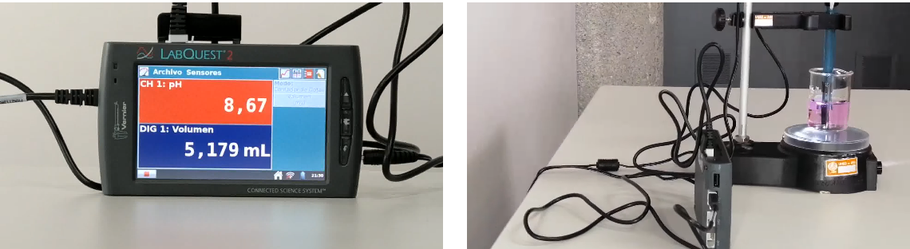Figure 1. [Left] pH meter and volume poured into the beaker. [Right] Burette with the standard substance and beaker with the analyte substance and the phenolphthalein indicator.

Viraje del indicador
Volumen reportado

Applying Eq. 1, the unknown concentration value for the acid of interest can be obtained:
$$[AcCítr] = \frac{V_{NaOH}· [NaOH]}{V_{alícuota}}$$
$[AcCítr] = \frac{5.179 mL· 0.065 M}{10 mL}$= 0.034M

Graph design and equivalence point estimation
Below is a sample of how to build the graph corresponding to the acid-base titration process and the calculation of the equivalence point from the values obtained in the experiment.
As drops are poured, both volume and pH values are recorded, violet and blue columns, respectively (Figure 2). To create the graph it is necessary to look for the option “Insert” and then “Scatter graph” marking the two previous columns.
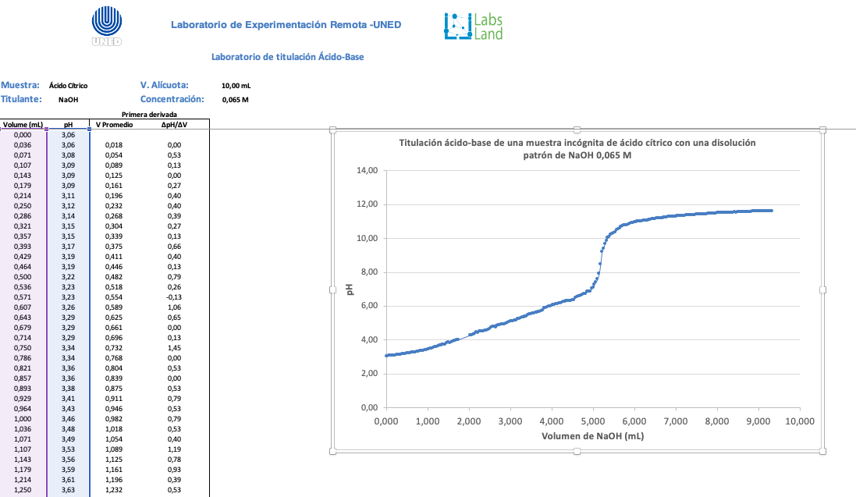Figure 2. Graphical representation of the pH with respect to the volume discharged.
Then a line must be formed that passes through most of the points on the inflection zone produced by the sudden change in pH (Figure 3). Next, draw a rectangle that touches as many of the sections before and after the inflection point of the graph.
Then, it must be reduced until two of its vertices touch the line at their joining point, causing the vertex to pass over the initial line. Finally, you have to draw a line that passes through the other two remaining vertices of the rectangle, in such a way that it forms an "X" between the two drawn lines. The intersection point of the lines indicates the volume corresponding to the equivalence point.

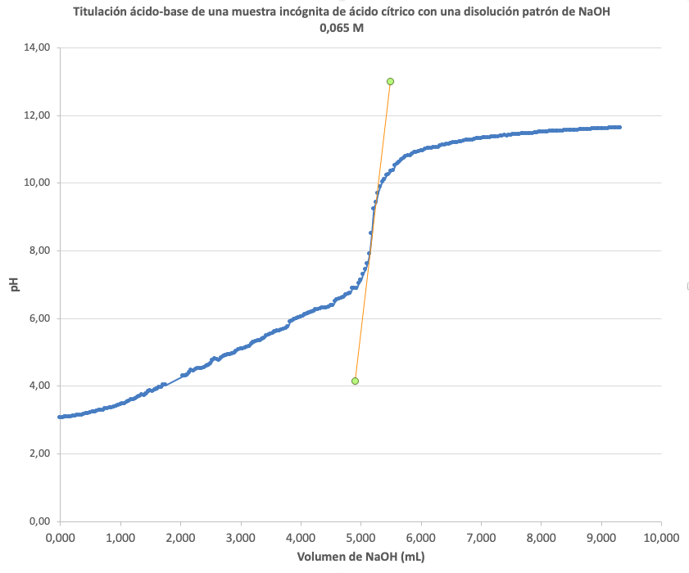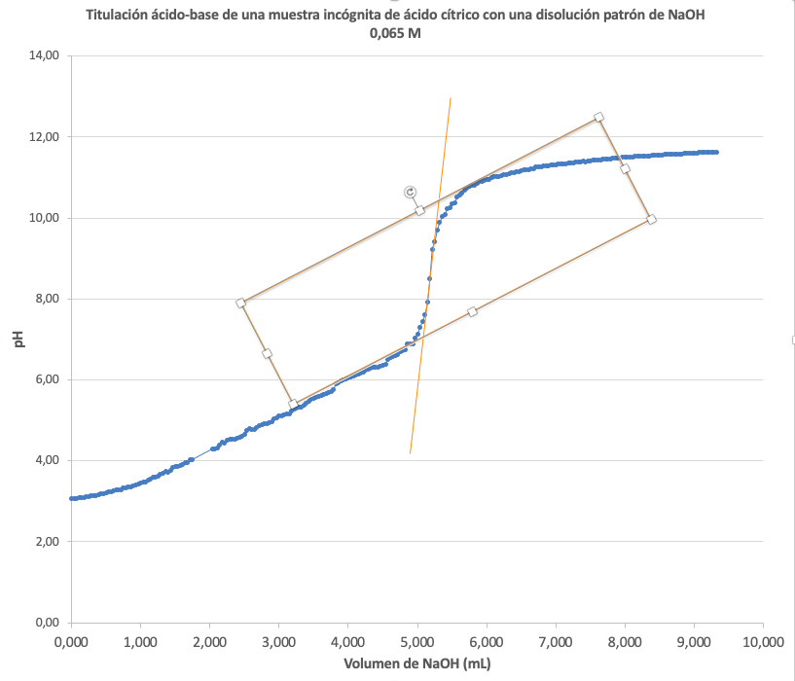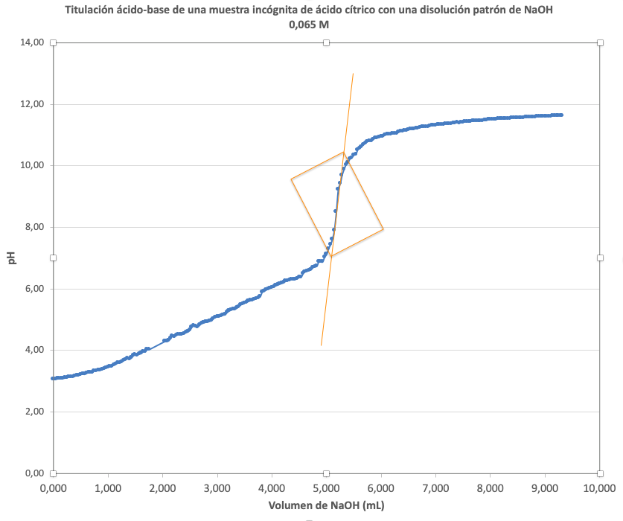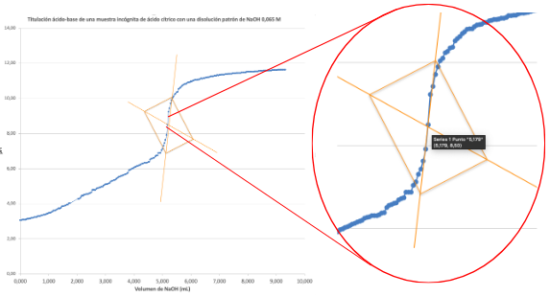
Figure 3. Order to follow to find the intersection that indicates the volume where the equivalence point occurs.

First derivative method to estimate the equivalence point
To find the equivalence point, use the average volume and the equation ∆pH/∆V, which is the difference (subtraction) of the initial or previous volume minus the current or the next (Figure 4).
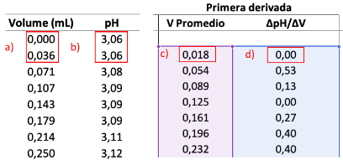
Figure 4. Calculations of the average volume (V) [a & c] and the equation ∆pH/∆V [a, b & d]. a & c) (0-0.036)/ 2 = 0.018. a, b & d) ∆pH = 3.06 – 3.06 = 0.00; ∆V = 0.036 – 0.000 = 0.036; ∆pH/∆V = 0.00 / 0.036 = 0.00

Finally, the titrant volume spent versus pH/V is plotted (Figure 5), and the maximum observed on the graph is the equivalence point volume. This is a way to ascertain and determine the volume of titrant spent more accurately.
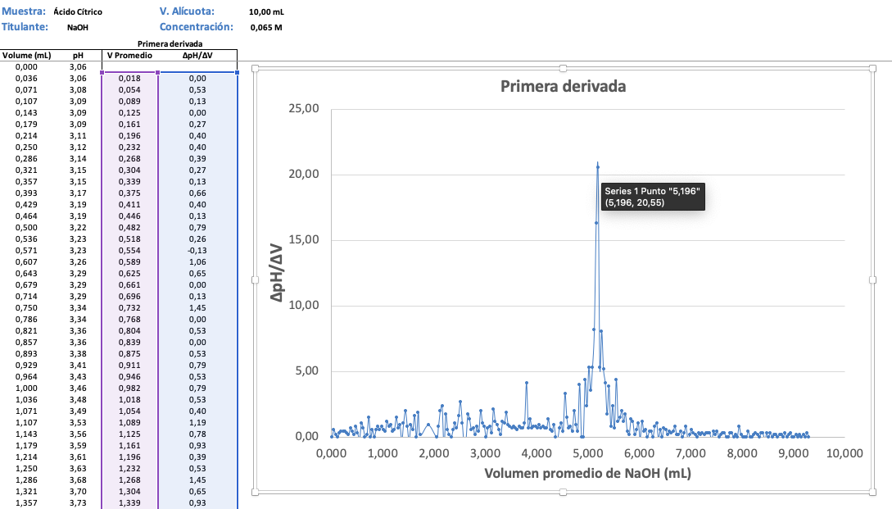
El punto de equivalencia es el valor más alto: 5,196 mL
Figure 5. Graphical representation of the difference in pH between the difference in volume (V) with respect to the average volume of sodium hydroxide consumed.

Results

Table 1 shows the results obtained experimentally for the volume of titrant (NaOH) used and for the pH at the time the solution changes from colorless to pinkish.

Table 1: volume and pH results obtained at the turning point observed in the remote laboratory.
Muestra de ácido cítrico | Volumen de NaOH gastado (mL) | pH
Muestra

Calculate the concentrations (mol/L) and g/L (citric acid molecular weight [MW=192.13 g/mol]) of the selected unknown citric acid sample. To do this, you will have to previously find the equivalence point of each sample. Make the graphs you consider appropriate to find the equivalence point as accurately as possible.
Citric acid 1

Conclusions

Discussion of the results comparing them with those of your classmates. Do the sample concentrations actually come from the same unknown sample? What is the effect of pH in this experiment?

Explain why NaOH is used as titrant in the determination of citric acid. What are the necessary conditions that a titrant must meet? Cite examples of other titrants you know (either acidic or basic).

Bibliography

- Skoo, A. D., West, D. M., Holler F. J., Crouch, S. R. (2005). Química Analítica, 7ma Ed., México: McGraw-Hill.

