

Guide for planarians

Table of contents
1. Document goals 3
2. Learning objectives 3
3. Planarians 3
4. Content of the laboratory 3
5. Activities 5
5.1. Elaboration of a hypothesis about the effect of the different solutions on the planarian’s behavior. 5
5.2. Determine the effect of the substances on the planarian’s behavior. 5
5.3. Determine the effect of a subset of substances on the planarian’s behavior. 5

Document goals
The objective of this document is to provide teachers with a guide for developing the activity of planarians in class. This laboratory is suitable to a wide age range (from secondary school students to introductory university courses).

Learning objectives
- Learn the bases of scientific method.
- Develop a hypothesis about how the planarians will respond to different solutions.
- Determine the effect of different solutions on the nervous system of planarians.
- Make appropriate graphs with the data obtained to simplify its interpretation and analysis.
- Identify the reasons why planarians are a suitable organism to carry out this type of experiment.
- Learn the similarities between the nervous system of planarians and humans.

What are planarians?
Planarians are flatworms of the phylum Platyhelminthes. They are among the simplest animals that possess a central nervous system (CNS). The CNS of planarians contains almost all neurotransmitters found in vertebrate mammals; therefore, these organisms are widely used in experimentation.
In this remote laboratory you can choose the solution into which to place the planaria. These solutions contain different concentrations of excitatory or inhibitory substances of the CNS: pond water (used as a control), sugar, ginseng, caffeine and taurine.
From the observations on the effect of these substances on the planarians’ CNS, the students will be able to reflect on how these compounds affect the planarians and how they could affect the human species.

Content of the laboratory
This experiment allows students to observe how planarians react to different solutions.

After accessing the LabsLand’s Planarians laboratory, the following screen appears:
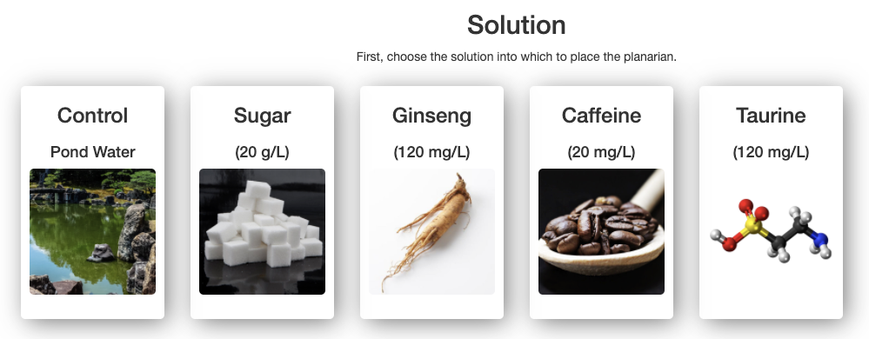
On this screen you can choose the solution into which to place the planarian: pond water (used as a control), sugar, ginseng, caffeine and taurine. Once chosen, the following screen appears:
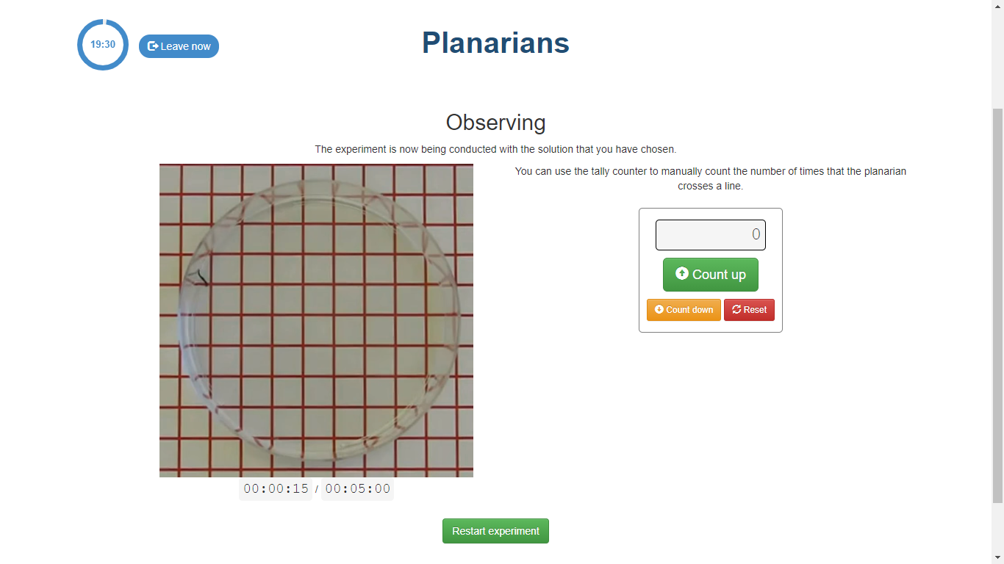
On the right side of the screen is the counter, so you can manually count the number of times the planarian crosses a line. There are three buttons:
- Count up. When pressed, the marker value increases by 1.
- Count down. When pressed, the marker value decreases by 1.
- Reset. When pressed, the marker value becomes 0.
Below the video of the planarian is the chronometer.
Pressing the Restart experiment button, the initial screen appears.

Activities
In this laboratory you can carry out different activities:

Elaboration of a hypothesis about the effect of the different solutions on the planarian’s behavior.
The following questions could be asked to students in order to help them to elaborate their hypothesis.
- Which solution do you think will affect the planarian’s behavior the most? Why? How do you think this effect will be observed?
- Which solution do you think will affect the planarian’s behavior the least? Why?

Determine the effect of the substances on the planarian’s behavior.
As the planarian is in a Petri dish on a graph paper, it is possible to count the number of times the worm crosses a line during a given period of time (5 minutes).
Students will count the number of times the planarian crosses a line when it is in contact with each of the solutions. From the data obtained during the experiment, students can make graphical representations to make their interpretation easier.

Determine the effect of a subset of substances on the planarian’s behavior.
Instead of examining all substances, the effect of a subset of the available solutions could be examined. For example: caffeine and sugar, as they are substances widely consumed on a daily basis.

