

Planarians Lab Guide

Table of contents

1. Document goals 3
2. Learning objectives 3
3. Pre-requisites 3
4. Estimated time 3
5. What are planarians? 4
6. Experiment 4
6.1. Scientific method 4
6.2. LabsLand Laboratory 4
6.3. Hyphotesis 6
6.4. Procedure 6
7. Results 7
8. Conclusions 8

Document goals
The objective of this document is to provide teachers with a guide for developing the practice of planarians in class. This laboratory is suitable for to a wide age range (secondary school students).
This experiment allows students to observe how planarians react to different aqueous solutions. The solutions contain different excitatory or inhibitory substances dissolved. Students will be able to reflect on how these compounds affect planarians and how they might affect humans.
Furthermore, it can be used to explain the scientific method in a more interactive way.

Learning objectives
- Learn the bases of scientific method.
- Develop a hypothesis about how the planarians will respond to different solutions.
- Determine the effect of different solutions on the nervous system of planarians.
- Make appropriate graphs with the data obtained to simplify its interpretation and analysis.
- Identify the reasons why planarians are a suitable organism to carry out this type of experiment.
- Learn the similarities between the nervous system of planarians and humans.

Pre-requisites
- Know the concepts of solution and concentration.
A solution is a homogeneous mixture of two or more substances. The component found in lesser quantity is known as solute and the one found in greater proportion is called solvent.
Concentration is a chemical quantity that expresses the amount of solute per unit volume of solution. If a solution has a concentration of 20 g / L, it means that it has 20 grams of solute for each liter of solution.
- Know the differences between excitatory and inhibitory compounds of the nervous system.
CNS excitatory substances promote the initiation of a nerve impulse, while inhibitors prevent it.

Estimated time
Development of the hypothesis: 10-15 minutes.
Development of the practice: 60 minutes

What are planarians?
Planarians are flatworms of the phylum flatworms. They are among the simplest animals that possess a central nervous system (CNS). The CNS of planarians contains almost all neurotransmitters found in vertebrate mammals; therefore, they are widely used in experimentation. Can you think of more reasons why planarians are used as a model organism? Planarians’ behavior is easy to observe. They are cheap and simple organisms. Little equipment is required to perform these experiments.

Experiment
In this experiment, the effect of different substances on the behavior of the planarians will be determined. These organisms can live in ponds, so pond water will be used as a control. A control is necessary in all experiments to ensure the reliability of the results.
We are going to use the scientific method to answer the question of how the different solutions affect the behavior of the planarians. But ... what is the scientific method?

Scientific method
It is a methodology used for generating new knowledge. The scientific method starts when you ask a question about something that you observe. After that, a hypothesis or a possible answer is formulated. Subsequently, experimentation is carried out, which is the study of a phenomenon under controlled conditions (such as a laboratory). This experimentation is designed in such a way that the previously proposed hypothesis can be confirmed or refuted. After collecting the data, you can make graphs, tables, diagrams or any other element that facilitates its visualization and interpretation. Finally, conclusions are established according to the results analyzed. The initial hypothesis can be confirmed or refuted (in this case the experiment would have to be reviewed and you would have to state a new hypothesis).

LabsLand Laboratory
You must access the LabsLand's Planarians Laboratory. In this remote laboratory you can choose the solution into which to put the planaria: pond water (used as a control), sugar, ginseng, caffeine and taurine.
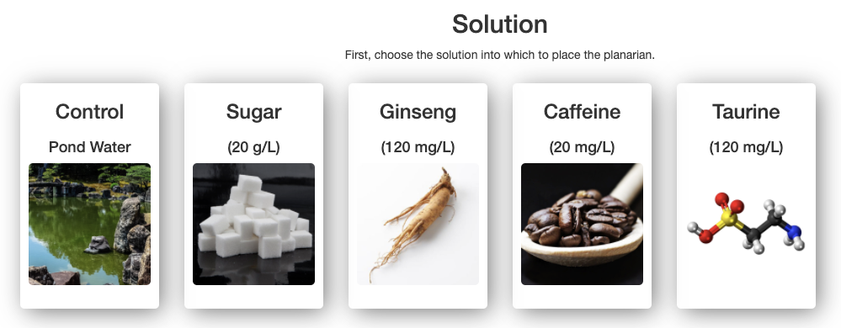
The planarian is found in a Petri dish on a graph paper, so that it is possible to count the number of times the worm crosses a line during a given period of time (5 minutes).
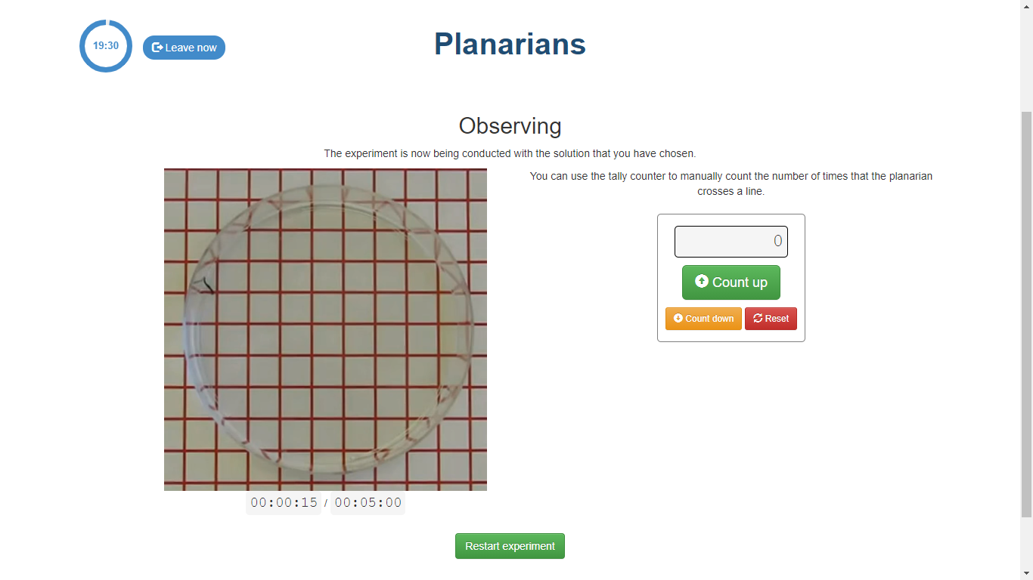
Depending on the number of times a line is crossed, it will be determined whether the compound excite or inhibit the nervous system. What effect do you think a CNS excitatory compound has on planarian’s behavior? And an inhibitor?
If a compound excites the CNS, the planarian will move faster and, therefore, it will cross a greater number of lines in 5 minutes. If the compound is inhibitory, it will cross fewer lines.
It is essential for an experiment to be reproducible, that is, that the data you obtain can be obtained by other people who carry out the same experiment. Therefore, you must define when you are going to consider that the planarian has crossed a line (When the whole body has crossed the line? When half of the body has crossed it? If the planarian crosses the diagonal of a square, are you going count a line or two?). Before starting the experiment, the criteria that will be used throughout the process must be defined.
Another thing you have to decide is when you are going to collect the data. There are different options: you can record the final data (the number of lines it crossed in 5 minutes) or you can record the data from time to time (for example, every 30 seconds or every minute). Which option do you think is the best in this experiment? Why?

Hyphotesis
These questions can help you to develop your hypothesis about how the planaria will respond to the different substances:
- What solution do you think will affect the planarian’s behavior the most? Why? How do you think this effect will be observed?
- What solution do you think will affect the planarian’s behavior the least? Why?

Procedure
Once the hypothesis has been proposed, the experiment can begin.
First, choose the control solution (pond water) and count the number of times the planarian crosses a line in 5 minutes.
Then, choose the sugar solution and count the number of times the planarian crosses a line in 5 minutes.
Then, choose the ginseng solution and count the number of times the planarian crosses a line in 5 minutes.
Then, choose the caffeine solution and count the number of times the planarian crosses a line in 5 minutes.
Finally, choose the taurine solution and count the number of times the planarian crosses a line in 5 minutes.

Results
How many lines did the planaria cross in each case? Fill in the table with the data you have obtained.
Solution | Number of crossed lines
Pond water
Sugar
Ginseng
Caffeine
Taurine

Solution | Time (minutes)
Solution | 1 | 2 | 3 | 4 | 5
Pond water
Sugar
Ginseng
Caffeine
Taurine
This data can be represented in a graph to simplify its interpretation. What type of graph do you think is the most appropriate to represent the data you have obtained?
- If only the final data has been recorded, a good option could be a bar graph in which each bar represents a solution (X-axis) and the Y-axis represents the number of crossed lines.
- If a piece of data has been collected every minute, a good option could be a graph that represents the time on the X-axis and the number of lines the planarian has crossed on the Y-axis.

Conclusions
a) Based on the data you have obtained during the experiment, has your hypothesis been confirmed?

b) What is a control in a scientific experiment? Why is pond water used as a control in this case?
A control is necessary in all experiments to compare the results obtained.
When conducting an experiment, the researcher changes one variable and observes what happens to the others. There are two types of variables: independent and dependent. The first are those that are controlled (in this case, the time), while the second are those that are observed to determine what changes occur in them (in this case, the number of lines that the planarian crosses).
Pond water is used as a control in this experiment because it is one of the habitats of planaria. When the planaria is in that solution we are not altering its behavior. When we put it in the other solutions, we do alter it. For this reason, to determine the effect that the different solutions have on the behavior of the planarian we compare the number of lines that it crosses in those solutions with the number when it is in pond water.
c) Why are planarians used as model organisms in different experiments?
- The CNS of planarians contains almost all the neurotransmitters found in vertebrate mammals: GABA, glutamate ...
- They have a behavior that is easy to observe.
- They are cheap and simple organisms.
- Little equipment is required to perform these experiments.
d) Which of the substances increased planarian’s movement the most? Why?
Sugar and ginseng, because planarians crossed a greater number of lines when they were in these solutions.
e) Which of the substances decreased planarian’s movement the most? Why?
Taurine, because the planarians crossed fewer lines when they were in contact with this solution.
f) How do you think these substances affect the human species? Find out about the effects of caffeine and taurine on the nervous system of the human species. Does it have the same effects? Why?
Caffeine is a stimulant of the central nervous system. It increases people's alertness and reduces fatigue.
Taurine is an amino acid that participates in different physiological processes such as osmoregulation, signal transduction, antioxidant activity, modulation of calcium movements, stabilization of membranes... Taurine is known to be an agonist of GABA (γ-acid) receptors. -aminobutyric). GABA is a CNS inhibitory neurotransmitter. That is, taurine is a molecule capable of binding to these receptors and inducing a response similar to that of GABA.
g) On what vital function of the planaria is this experiment based on: nutrition, interaction or reproduction? Why?
It is based on the interaction function. This function is the set of processes that occur in organisms that allow them to perceive a stimulus and produce an appropriate response. That is, this function links living beings with the environment, something necessary for their survival. Through this function, living beings coordinate their operation to best adapt to their environment.
h) Describe the movement of the planaria in different solutions. Has it been similar in all solutions? Do you think planarians use muscles to move?
Planarians have two types of movements: they can use cilia to glide along the substrate or extend and contract the muscles of their body as they move.
i) What conclusions have you drawn after carrying out the experiment and analyzing the data obtained?

