




EXPERIMENT: GALILEO’S PENDULUM

Author: Javier Garcia Zubía (Universidad de Deusto)

The original document on which this activity is based was carried out in the framework of the R3 project. Rural Remote and Real R3: Promotion of CTIM vocations in rural schools through remote experimentation (FECYT FCT-20-15490).

Content

OBJECTIVES AND SKILLS 3
PROCEDURE AND AVAILABLE MATERIAL 3
Development of the experiment 3
Analysis of experimental results and evaluation 5
Extra work 5

Experiment with Galileo’s Pendulum.

OBJECTIVES AND SKILLS
- To observe and measure the period of a pendulum.
- Understand that some things look one way, but are another.
- Use inquiry techniques in the experiment.
- Organize and carry out an experiment systematically.
- Represent graphically and numerically the results of the experiment.
- Determine the period of a pendulum and what it depends on.
- Communicate results.

PROCEDURE AND AVAILABLE MATERIAL
The Remote Pendulum Laboratory (Galileo) has three pendulums that can be launched from different angles. In addition, the interface has different methods to measure the period. There are three pendulums: the original pendulum, the original pendulum with a Coke can on top and a Coke can on the bottom.
The simplified procedure is:
- Choose an initial angle for the pendulum.
- Launch and measure the motion of the pendulum.
- Sort the results for all angles.
- Evaluation.

Development of the experiment

We will select the Pendulum lab at Labsland and make several groups of students. Each group will work with a different starting angle (10°, 15°, 20°, 25° and 30°) and we will see how the results of the experiment vary for each group.

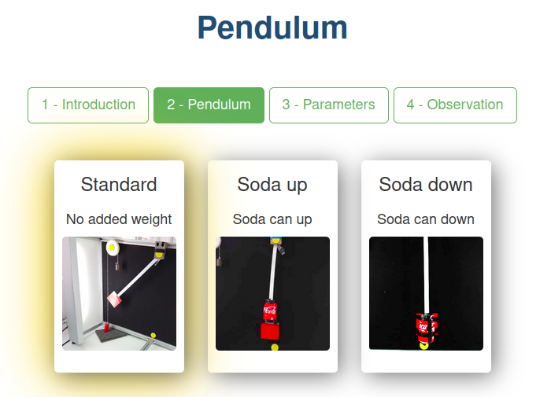
Choose the standard pendulum in the LabsLand lab.
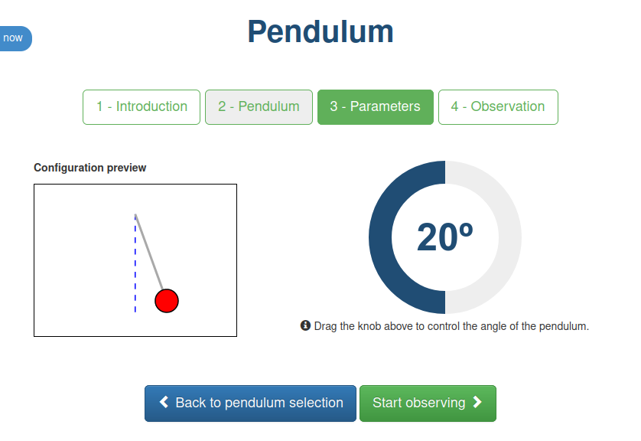
We choose the initial angle of the pendulum.

Once in the laboratory we will release the pendulum and count the number of times the pendulum returns to the starting point in a time of 15 seconds. To count, each time the pendulum returns we will throw a coin in a jar, until the partner watching the clock says that the time is up.

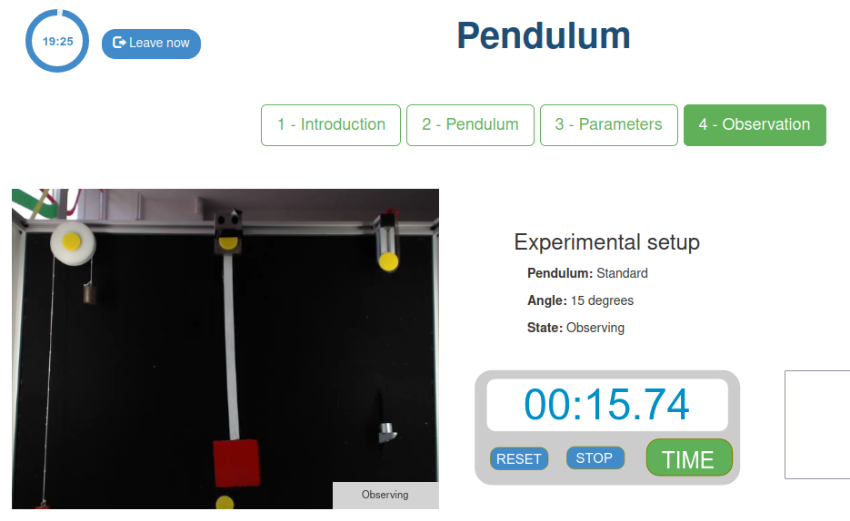
We use the stopwatch in the remote lab to measure 15 seconds
while we measure 15 seconds while counting the oscillations.

We will perform the experiment several times (four is an ideal number), to check that we have counted correctly and give one of the results to the teacher.

Analysis of experimental results and evaluation

The teacher will take the results of all the groups and revealing one of the results, asks the students what will be the number of coins for a different angle, and will continue asking until all of them are revealed.
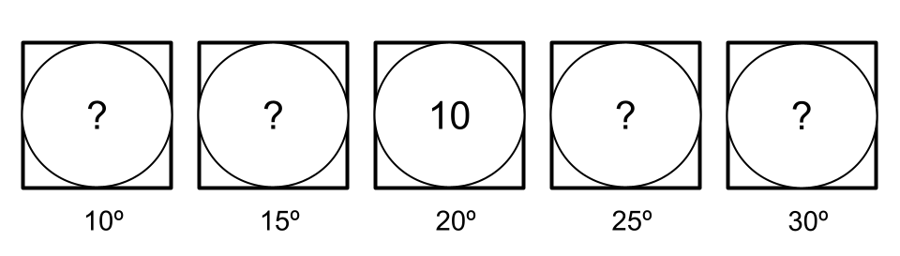
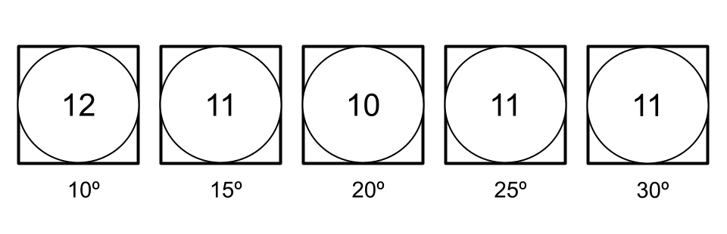
The experiments can be repeated for different starting angles (13°, 18°, 23° and 28°) and students can be asked what would happen if there is more weight on the pendulum (test it using the lab module with the Coke on top and bottom of the pendulum).

The period of the pendulum will be equal to the time we have measured it divided by the number of oscillations, in our case 15/11 = 1.3.

Extra work

In addition to the coin method, there are other methods to measure the period of the pendulum.

First we can look at the graph shown below the pendulum, if we measure the distance between two "peaks" we will get the period, as we can see the distance is just under 1.5 seconds.

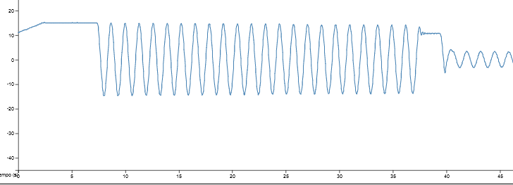

On the other hand we may use the excel that we can download from the lab itself, which will have the data of the angle of the pendulum and the time. For this we will have to find two similar values for the angle (0° for example) but we must take into account that in both of them the following angle must be negative, as in the image.

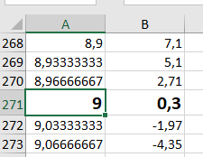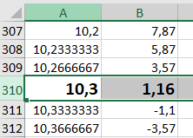

The difference between the seconds for the angles to have the same value is the period itself: 10.3-9=1.3.

As we can see we get the same period by all methods. Finally, if we use the mathematical formula we can check that the previous measurements are correct.

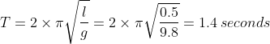

As a last experiment, a pendulum can be constructed in class with a string and a weight. The period of the pendulum can be measured by changing the length of the pendulum and the angles from which it is launched.

