The Digital Trainer
By Intel Corporation
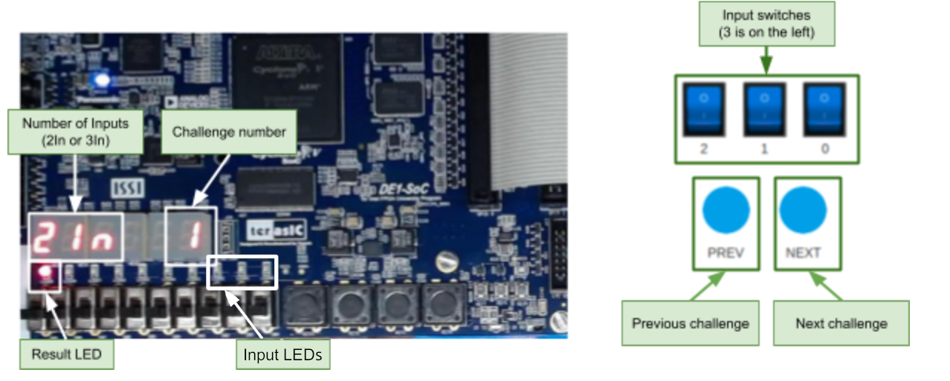

How to Use the Digital Trainer: There are 10 challenges programmed into the board. It is your job to decide what the logic function of each challenge is (the challenge number is displayed on the right of the display) by flipping the input switches and observing the output LED (the light on the left of the board). A switch that is flipped “up” is a 0, and a switch flipped “down” is a 1. Likewise, a LED on is a 1 and a LED off is a 0. The number on the left indicates whether the function has two or three inputs (2In, thus using only the two rightmost switches, or 3In, using all the switches). You can flip between the different challenges using the buttons on the board: to advance to the next challenge press the rightmost button, or press the button on the left to go back to the previous challenge. Try to circle the correct function for each sequence!

Sequence number | Number of inputs | Logic function
1 | 2 | AND | OR | NAND | NOR | XOR
2 | 2 | AND | OR | NAND | NOR | XOR
3 | 2 | AND | OR | NAND | NOR | XOR
4 | 2 | AND | OR | NAND | NOR | XOR
5 | 2 | AND | OR | NAND | NOR | XOR
6 | 3 | AND | OR | NAND | NOR | MUX
7 | 3 | AND | OR | NAND | NOR | MUX
8 | 3 | AND | OR | NAND | NOR | MUX
9 | 3 | AND | OR | NAND | NOR | MUX
10 | 3 | AND | OR | NAND | NOR | MUX

