

Basic Arduino - Visual Code: Introduction

Introduction to the basic arduino board laboratory
Version 1.0

Table of contents

Document goals 4
Introduction 4
Learning objectives 5
Pre-requisites 6
Blinking a LED 6
5.1 Learning objectives 6
5.2 Problem statement 6
5.3 Tips 6
5.4 Solution 7
Writing to the serial terminal 7
6.1 Learning objectives 7
6.2 Problem statement 7
6.3 Tips 7
6.4 Solution 8
Detecting button presses and using conditionals 8
7.1 Learning objectives 8
7.2 Problem statement 8
7.3 Tips 8
7.4 Solution 9
Reading analog input 9
8.1 Learning objectives 9
8.2 Problem statement 9
8.3 Tips 10
8.4 Solution 10

Document goals
This document contains some exercises that can be used with the Arduino Board laboratory (visual). The exercises contain the solutions. It is intended to provide instructors with a starting point to propose their own in-class or out-of-class activities. This laboratory and exercises are suitable to a wide age range (from secondary school students to introductory university courses), particularly to those without previous (or with limited) programming experience.

Introduction
The Arduino Board laboratory (visual) is designed to be used as an introductory laboratory to the Arduino ecosystem. It is designed to resemble the typical low-cost Arduino kits that newcomers to Arduino often rely on for learning. It has several basic peripherals, so it can be used to cover most introductory-level courses. For more advanced Arduino courses and sensors, there is a more advanced laboratory available which is the Arduino Robotics Laboratory (visual). Also, it is noteworthy that text-based versions exist for both this basic Arduino Board laboratory (text-based) and for the Arduino Robotics Laboratory (text-based).
The Arduino Board laboratory implements the following schematic.
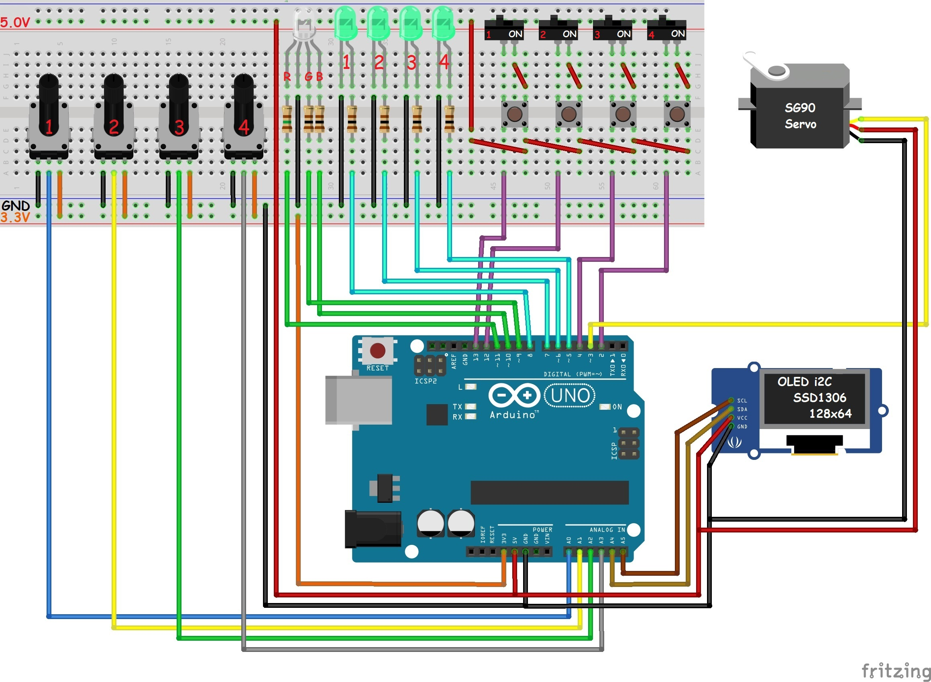

Learning objectives
After completing these activities, the students will have achieved certain learning outcomes. The specific objectives for each activity are detailed in each section, but they are also summarized here:
- Learn what programming is.
- Learn how a visual programming language works.
- Learn how to place blocks.
- Learn how the digital outputs work.
- Learn how to turn on and off the LEDs.
- Learn how to interpret the Fritzing diagram.
- Learn how to use the Arduino Loop and Setup blocks.
- Learn how to use the waiting blocks.
- Learn how to write to the serial terminal.

Pre-requisites
These activities are intended as an introduction to programming and hardware using a visual blocks-based language intended for children. Thus, there are no strict pre-requisites. However, depending on the activity, the teacher might first need to explain certain concepts if they are not already known. Those are:
- What a LED is.
- What programming is.
- How an electric circuit works.
- What voltage is.

Blinking a LED
Estimated time: 10 minutes

5.1 Learning objectives
- Learn how to place blocks.
- Learn how the digital outputs work.
- Learn how to turn on and off the LEDs.
- Learn how to interpret the Fritzing diagram.
- Learn how to use the Arduino Loop and Setup blocks.
- Learn how to use the waiting blocks.
- Learn how to use variable blocks.
- Learn how to read digital inputs.
- Learn how to use the buttons.
- Learn how to use the conditional blocks.
- Learn how to read the analog input value from a potentiometer.

5.2 Problem statement
Make the second LED (LED number 2) of the Arduino Board blink. It must be on for 2 seconds, then off for 1. In an infinite loop.

5.3 Tips
You do not need to create a loop explicitly. You can use Arduino’s standard “loop” function. You will at least need to use the “set digital pin” block (Input/Output blocks) and the “wait” block (Time blocks).

5.4 Solution
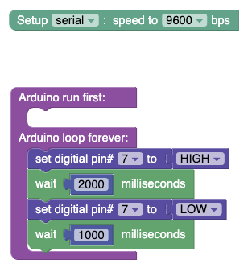

Writing to the serial terminal
Estimated time: 5 minutes.

6.1 Learning objectives
- Learn how to write to the serial terminal.

6.2 Problem statement
Write “Hello world” to the serial terminal repeatedly, waiting 2 seconds every time.

6.3 Tips
You need to ensure that the serial is initialized to 9600 bps. This can be done through the “Setup serial” block. Then, you will need to use the serial print blocks (Comms) to write to the serial terminal.

6.4 Solution
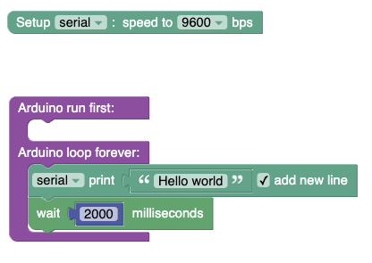

Detecting button presses and using conditionals
Estimated time: 20 minutes.

7.1 Learning objectives
- Learn how to use variable blocks.
- Learn how to read digital inputs.
- Learn how to use the buttons.
- Learn how to use the conditional blocks.

7.2 Problem statement
Turn on LED 1 while button 1 is pressed. Turn on LED 4 while button 2 is pressed.

7.3 Tips
You will need to use several new blocks. You will need to use the “digital read” block to read the value of the buttons you want. The values you read will need to be stored in variables (see “variable” blocks). Finally, you will need to use conditional statements (see “logic” blocks) to turn on the LEDs when the buttons are pressed.

7.4 Solution
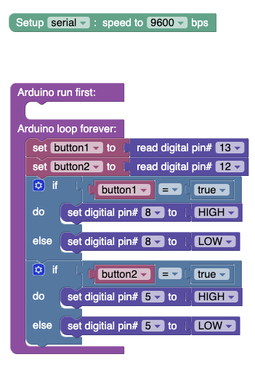

Reading analog input
Estimated time: 10 minutes.

8.1 Learning objectives
- Learn how to read the analog input value from a potentiometer.

8.2 Problem statement
Read the value of the first potentiometer and print the voltage to the serial terminal. Do this every 2 seconds. Remember to print the voltage, and not the raw value returned by analogRead.

8.3 Tips
You will need to use the analogRead block. The analogRead block will return a value between 0 and 1024. You will need to assign this value to a variable. The operating value of the Arduino Board is 5V. Thus, the value between 0 and 1024 will map to a voltage value of a voltage between 0 and 5V. You will need to make certain calculations to output the voltage value as opposed to the raw value.

8.4 Solution
Limitation: Voltage is an int.
