



Acid-base Titration II

Index

Aim of the document 3
Learning objectives 3
Educational cycle and estimated time 3
Theory 3
Development of the experiment 4
Results 6
Questions 7
Bibliography 9

Aim of the document
The objective of this document is to provide a guide to develop the experiment Acid-base titration using two analytical techniques.

Learning objectives
Study the acid-base behavior of the unknown sample. Relate the volume of spent titrant to the concentration of the analyte while observing the color change and the influence of pH in the solution. Teamwork.

Educational cycle and estimated time
This activity can be completed by any student who has taken an introductory course in analytical chemistry and acid-base titrations (high school and middle school students). It can be easily completed in a single session of about 90 minutes if the student has read and understood the document before starting the session. Even if the student is unable to finish everything in class, as long as the Results section has been completed, the last session of Questions can be done as homework, as it does not require any new lab measurements. The Results section should be done in pairs (optional to work in trios).

Theory
Acid-base titration, also known as the volumetric technique, is used to determine the exact concentration of an unknown sample.¹
The basic concepts to be mastered in this analysis are the following: ^{1,2}
- Titrant: A solution of perfectly known concentration and volume.
- Analyte or unknown sample: A solution of unknown concentration, but of known volume, since it is the volume that you add before starting the titration.
- Equivalence point: Occurs when the titrant and the analyte are equivalent and the formula (Equation 1) is fulfilled.
- pH: Degree of acidity of a solution.
- Indicator: Substance that is added to the unknown sample and that produces a physical change (color change) when analyzed.
Once the volume of the titrant and the analyte and the concentration of the titrant acting as a base are known, we can find the concentration of the acid with the following formula:
Equation 1.- Theoretical equation used to determine the acetic acid concentration.
${[Analyte]}_{}· V_{analyte}= {[Titrant]}_{}· V_{Titrant}$ Ec. 1
[Analyte]: Unknown sample concentration.
V _{analyte}: Volume of analyte added.
[Titrant]: Concentration of the titrant.
V_{Titrant}: Spent volume of the titrant.

Development of the experiment
This activity is designed to use two different analytical techniques: The potentiometric technique and colorimetry. Potentiometry measures the electrical potential of a solution by means of a digital pH sensor, since this parameter has a great influence on the equivalence point.¹ Colorimetry, on the other hand, is based on the observation of the color change produced by the indicator.²
In this experiment, the concentration of a 10 mL (analyte volume) solution of acetic acid is to be determined. For this purpose, the titrant sodium hydroxide, which is available in the burette and whose concentration is known, is used. In both laboratories you have two titrants of different concentrations (both titrants will be used). An indicator is also used, which changes color when the solution reaches a pH. An indicator is an acid or a weak base and the amount added to the titrations must be small, so that it does not contribute to the pH of the solution, and only a small amount of titrant is needed for the change to occur.¹
The acid-base reaction(Reaction 1) is the neutralization titration of acetic acid by the addition of a strong base, sodium hydroxide, releasing water and sodium acetate as reaction products.
Reaction 1.- Acid-base neutralization reaction of acetic acid in the presence of NaOH.
$NaOH + {CH}_{3}COOH→H_{2}O +{CH}_{3}COO^{-} + {Na}^{+}$
As shown in Figure 1, drops are dropped from the burette into the beaker containing the unknown sample. A heating-rotating plate is also available, together with a magnet to control the stirring of the solution. It is measured by dripping until the equivalence point is reached. Experimentally it is observed when the dissolution that was colorless becomes pinkish.
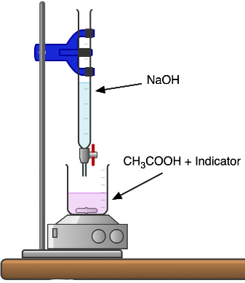
Magnet
Heating plate
Burette
Beaker
Figure 1.- Set-up of the experiment carried out in both laboratories.
Before starting the experiment, some aspects must be taken into account:
- When noting the volumes, the shape of the drop must be taken into account and the volume must be well noted. Below is an image of a burette containing a solution (Figure 2a). The volume to be noted is that of the concave curve, that is to say, that of the end. In this case the volume would be 1.1 mL.
- In colorimetry it is important to make sure that the color change is complete. Sometimes the human eye deceives us, and for that reason it is recommended to add one more drop to make sure that the solution has completely changed color. It is recommended to wait until the solution acquires the color of Figure 2b.
- In potentiometry, on the other hand, the pH display is observed. When the pH is 8.2, the equivalence point has been reached (Figure 2c).
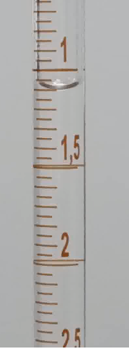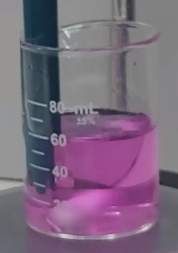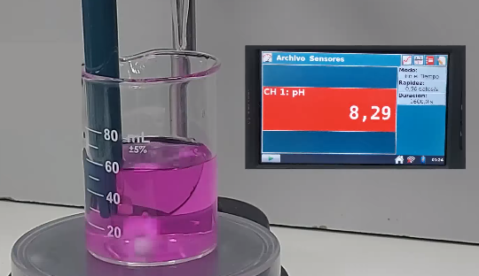
(a) (b) (c)
Figure 2.-(a) Experimental burette to obtain adequate results of the spent titrant. (b) Solution measured by the colorimetric technique once the color change has occurred. (c) Solution measured by the potentiometric technique once the equivalence point (pH 8.2) has been reached.

Results
This section can be carried out with other colleagues, but it is advisable to work in pairs. In order to minimize the experimental error and to obtain accurate results, it would be appropriate that the same person performs the titration of the three samples for the same concentration of titrant.
First, it collects in Table 1 the experimentally obtained results of the spent volume of titrant (NaOH) and the pH at the moment when the solution changes from colorless to pinkish.
NOTE: The volumes determined by the colorimetric technique can be variable, since it is an inaccurate technique that depends on the human factor. In the potentiometric technique there may be fluctuations in the signal, due to a bad calibration of the pH sensor.
Table 1.- Volumes of spent titrant and pH obtained using the remote laboratory Acid-base titration II both potentiometric and colorimetric techniques.
Techniques | Potentiometry |  | Colorimetry
Titrants | [NaOH] 0.151M | [NaOH] 0.244 M | [NaOH] 0.151M | [NaOH] 0.244 M
V _{Sample 1}
V _{Sample 2}
V _{Sample 3}
Next, Equation 1 is used, taking into account that the volume of the unknown solution to be titrated is 10 mL, and the concentration is determined (write the results obtained in Table 2) for each volume in Table 1.
Table 2.- Concentration of samples determined from the volumes in Table 1 and using Equation 1.
Techniques | Potentiometry |  | Colorimetry
Titrants | [NaOH] 0.151M | [NaOH] 0.244 M | [NaOH] 0.151M | [NaOH] 0.244 M
C _{Sample 1}
C _{Sample 2}
C _{Sample 3}
Once the concentration of each sample for the different titrants has been determined, the following questions are answered in the next section of the activity.

Questions
- Do the three different samples provided by the laboratory contain the same concentration or do they have different concentrations? Which sample has the highest concentration and which has the lowest?
Response and justification:

- Is the concentration of the unknown sample (the analyte) influenced by the concentration of the titrant, i.e., is there an increase or decrease in the concentration of the sample when titrating with a titrant of higher or lower concentration, and is there any change in the volume of titrant spent when using titrants of different concentrations?
Response and justification:

- Which technique is more precise, i.e. measures the equivalence point more accurately? Potentiometry or colorimetry?
Response and justification:

- Knowing that the turning point of this acid-base titration is at pH 8.2, what do you think is the indicator used in this experiment? Use of the following link which takes you to a table of the most commonly used acid-base indicators http://www.vaxasoftware.com/doc_edu/qui/indic.pdf
Response and justification:

Bibliography

- Gary, D.C. (2009). Química Analítica, 6ta Ed., México: McGraw-Hill.
- Skoo, A. D., West, D. M., Holler F. J., Crouch, S. R. (2005). Química Analítica, 7ma Ed., México: McGraw-Hill.

