




EXPERIMENTS WITH RADIACTIVITY AND MURDER

Author: Javier García Zubía (Universidad de Deusto)

The original document on which this activity is based was carried out in the framework of the R3 project. Rural Remote and Real R3: Promotion of CTIM vocations in rural schools through remote experimentation (FECYT FCT-20-15490).

Content

OBJECTIVES AND SKILLS: 3
Introduction 3
Experiment development 3
Classroom work proposal 4
Evaluation and open questions 8
Notes for the teacher 9

Experience with Radioactivity

OBJECTIVES AND SKILLS:
- Understand that everything, absolutely everything, emits radiation. For example, bananas.
- There are many types of radiation with different intensity.
- Observe how each type of radiation is more or less effectively blocked by different materials.
- Use inquiry techniques in the experiment.
- Represent graphically and numerically the results of the experiment.
- Propose possible answers to questions or situations raised:
  - is any type of radiation dangerous?
  - is radiation dangerous?
  - what happened to the Russian spy?
- Comunicate results.
- Find Queensland on the map (original physical location of the equipment).

Introduction

The emission of radioactivity in nature is constant. Watch this video.
https://youtu.be/AVYHpxcshc4
Are we at risk when we eat a banana? No. Why?
The atoms of some elements emit radioactivity spontaneously. For example, bananas have potassium (K-40), and K-40 atoms emit radioactivity. The good thing is that a banana does not emit much radioactivity.
What is important is that we distinguish between the different types of radioactivity: alpha, beta and gamma. The K-40 isotope of the banana emits beta radiation, so?

Experiment development
Four elements (nothing, Strontium 90, Americium 241, Cobalt 60) and nine absorbers (nothing, paper, aluminum and lead) are available.
The experiment itself has several parts:
- The material. You can choose between four different ones.
- The absorber. You can choose between 9 different ones. It is the roulette that moves.
- The distance, which is the vertical element that goes up and down.
- The impact detector, which is underneath, measures each incoming particle.
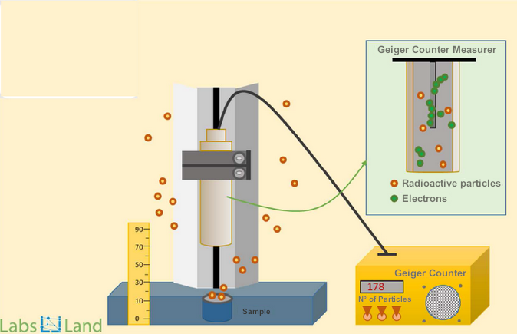
General procedure:
- Choose a material and an absorber.
- Choose a distance and an observation time.
- Run the experiment.
- Record the results.
- Obtain answers to the teacher's questions

Classroom work proposal
A detailed proposed procedure is:
- Set up the experiment and run it.
- It will be necessary to launch at least 16 experiments: 4 materials x 4 absorbers and always the same distance and time.
- Think about how the results will be represented. For example, for each material put the four absorbers and then write down the number of impacts.
- Result analysis and questions:
- Which type of particles/radiation does each material emit?
- Do all particles behave the same way?
- Which material emits more particles?
- Which are the most dangerous particles and why?
- Does each material (without absorber) emit the same number of particles?
- Does each type of absorber block the same (in %) for each type of material?
- Are some particles easy to block and others more difficult?
- Can you find a similar example in another domain of something blocking or not blocking something?
After the above shallow analysis of the experiment may come some questions whose answers require a more detailed analysis:
- When we have an X-ray done, we are put through X-rays, is it a good idea? Does it pay off? How many X-rays can you have?
- At the time of the X-ray, where is the radiologist?
- Look for a photo or image of a radiologist, do they have an apron on? of what material?
- Radioactive materials have been used among spies, which material do you think is better and why?
- In 2006 Litvinenko was killed by putting Polonium in his tea. What kind of particles does Polonium emit? Why did they use Polonium and not another, Cobalt 60 for example?
Figure 1: Explanatory image of the experiment
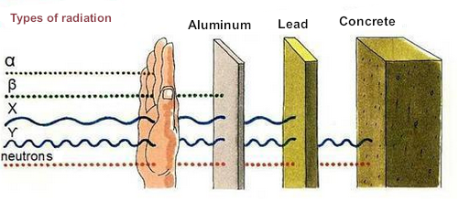
Figure 2: Experiment interface: Mode
We choose Advanced in Mode and then in Configuration we go experiment by experiment.
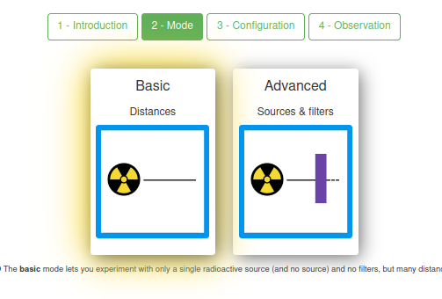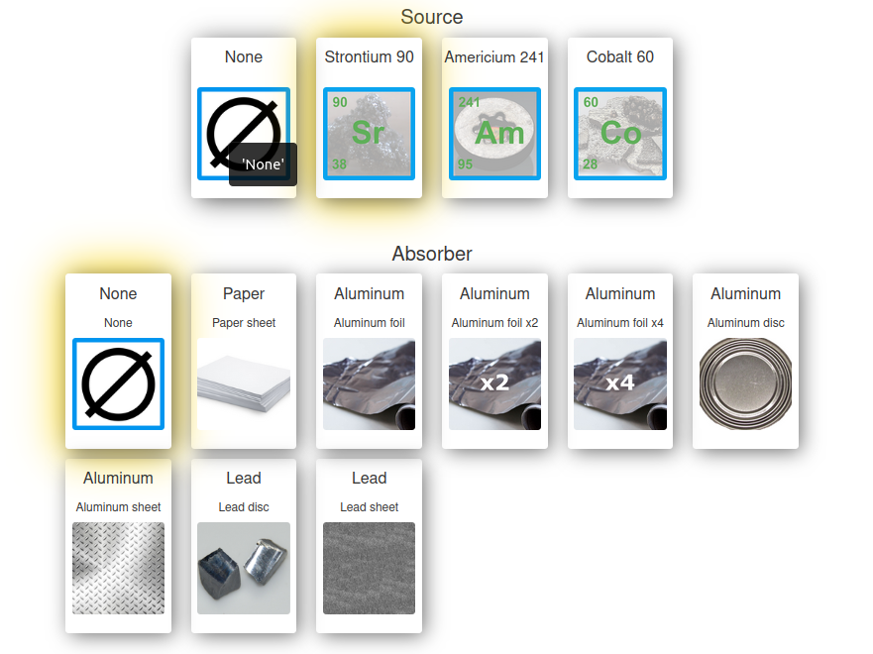

Figure 2: Experiment interface: Mode
We choose Nothing as absorber at 15 mm and for 5 seconds. Repeat the experiment three times.
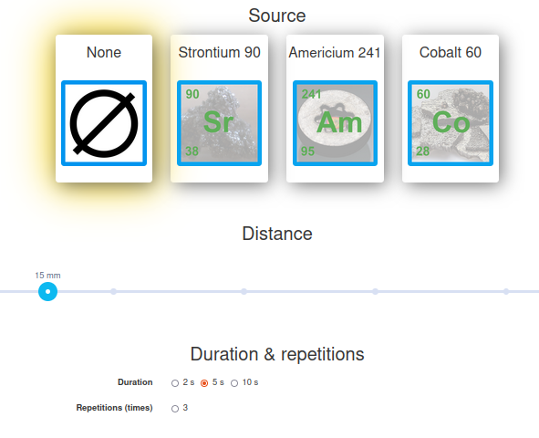
Figure 4: The results for the first experiment
The webcam video shows how some elements of the experiment move.
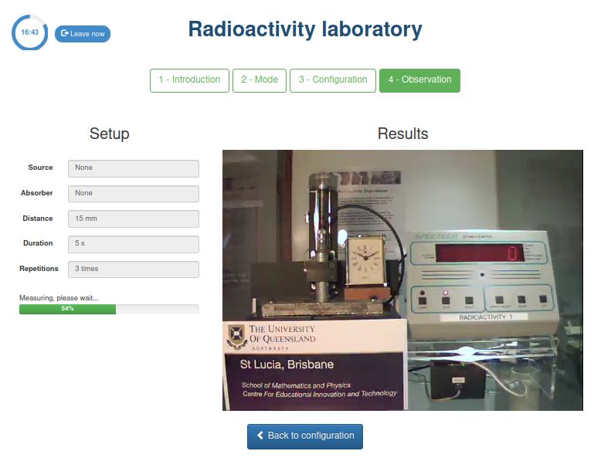
For Nothing with Nothing absorber gives that only 1 impact reaches the measurer (or none at all). It is logical, isn't it?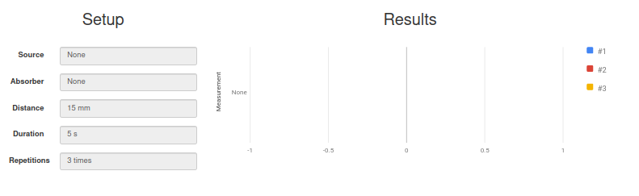
And for Strontium and with nothing between the material and the impact meter? About 300 impacts.
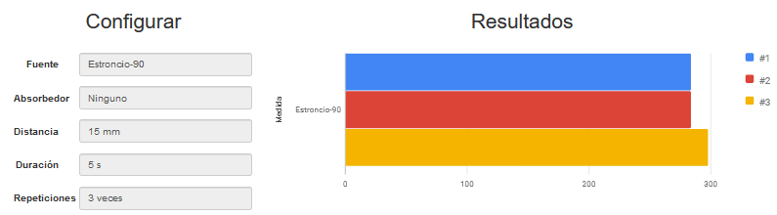
Maybe it's clearer to use an image like this one:
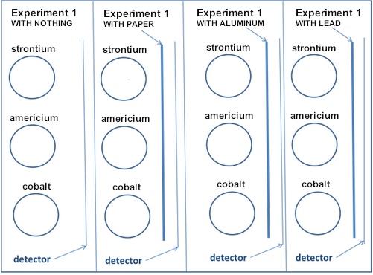

Evaluation and open questions
Looking at what you learned in the experiment, you may be able to answer some of the following questions.
When we have an X-ray, the body is exposed to X-rays. As it is for a short time it doesn't affect us much, but the people who work there are under the effect of X-rays all day long. That's why they wear a kind of apron. What do you think is inside the apron? Why isn't it closed at the back?
Search the Internet to find out how much radioactivity is involved in eating a banana.
Which other products we eat emit radioactivity?
When we have an X-ray, then our body receives radioactivity, which is not good, but it is not very bad either. Complete the following sentence: Having an X-ray is equivalent to eating .... bananas.
In the U.S. there are radioactivity detectors in airports. What happens if you carry a few bananas in your suitcase? Will the detector go off? Will you have problems? Do you think the same thing would have happened if the banana had emitted alpha radiation? Why?
Alexander Litvinenko was poisoned in 2006 with Polonium. Polonium was poured into the tea he was going to drink, what kind of radiation does polonium emit, alpha, beta or gamma? One clue, why didn't the people who carried the polonium in a canister die? And another clue why did they give it to him in a tea (in a liquid)?

Notes for the teacher
These are my results (for nothing as material you can't put any absorber)
 | Nothing | Paper | Aluminum Disk | Lead Disk
Nothing | 1
Strontium | 450 | 275 | 1 | 1
Cobalt | 55 | 45 | 45 | 40
Americium | 500 | 6 | 5 | 1

It can be completed in class with a table like this
 | Strontium | Americium | Cobalt
Nothing
Paper
Aluminum Disk
Lead Disk
% reduction Nothing-Paper
% reduction Paper-Aluminum
% reduction Aluminum-Lead
% reduction Nothing-Lead
Tipo de partícula emitida

It is seen that in Americium the impacts are stopped by the paper: ALPHA PARTICLES.
It is seen that in Strontium the impacts stop on the aluminum disk: BETA PARTICLES.
It is seen that in Cobalt the impacts do not disappear, they are reduced but do not disappear: GAMMA RADIATION

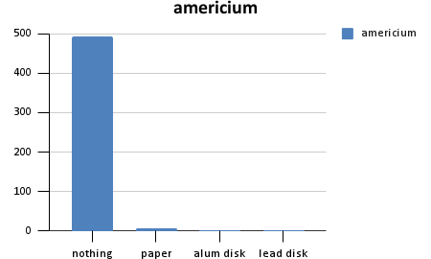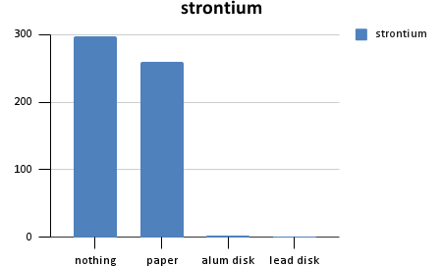
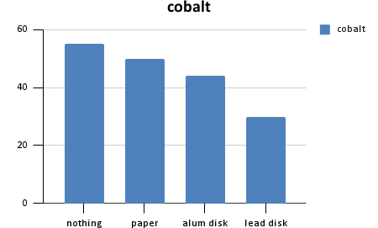
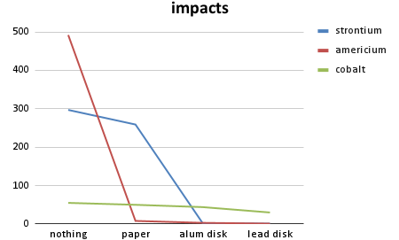

Other answers
There is a lot of information on the web about radioactivity: videos and images.
X-ray assistants wear a lead-lined apron. They do not need to wear anything behind them because the x-ray emitter is in front of them. Often the patient also wears lead "patches" so that the X-rays do not affect the whole body. Nowadays, lead aprons are rarely used; now the assistants are placed in a lead-lined room.
Bananas are used as a unit of measurement of radioactivity for people.BED (Banana Equivalent Dose, https://en.wikipedia.org/wiki/Banana_equivalent_dose). For example, an X-ray (radiography) is like eating about 200 bananas, and a dental x-ray is like eating about 50 bananas.
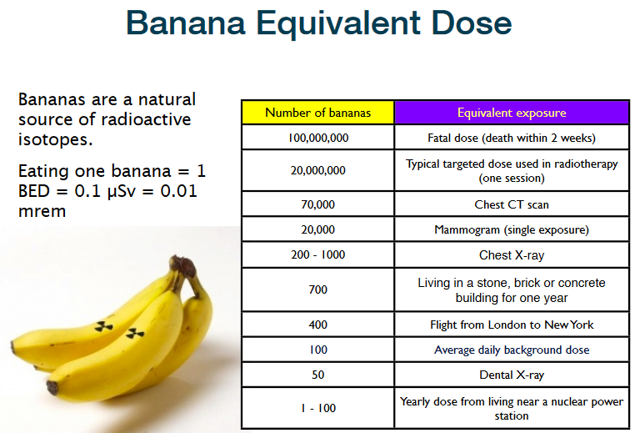
In the U.S. if you carry bananas they can set off the alarm of radioactivity detectors. Since potassium-40 emits beta rays, they pass through the suitcase quite well and therefore their radiation is detected. If it were to emit alpha radioactivity, then it would certainly not be detected because the particles would be stopped by the suitcase.
Alexander Litvinenko was poisoned with polonium. Polonium emits alpha particles, which are as large as dangerous and easy to stop. He was given it with tea because when he drank the tea the polonium went directly to his stomach and thus the emitted radiation directly damaged his stomach, lungs, pancreas, etc. In addition, the polonium, being radioactive alpha, could be transported without problems by the assassins by simply putting it in a metal canister and handling it carefully.

