

EXPERIENCE: RADIOACTIVITY II

Rev: 1.4 (Julio/2021)
Authors: Javier Garcia Zubía (zubia@labsland.com)
Unai Hernández (unai@labsland.com)
Luis Rodríguez Gil (luis@labsland.com)
Content

OBJECTIVES: 3
LEARNING OUTCOMES: 3
STRUCTURE OF THE DOCUMENT: 3
Introduction 4
Development of the experiment 5
Taking measurements and plotting the experiment 7
Analysis of the results of the experiment and evaluation 11
Comments for the teacher 19

We will study the linear or non-linear behaviour of natural phenomena. We will use the LabsLand radioactivity laboratory by selecting the advanced mode to carry out the radioactivity experiment and study these behaviours.

OBJECTIVES:
The objectives to be developed throughout this experiment are:
- To understand and observe the behaviour of the variables in an experiment.
- To understand the concept of linear and non-linear.
- To analyse the behaviour of the number of particle impacts as a function of time and distance.
- Analyse whether the number of impacts is linear or non-linear as a function of time and distance.
- Extrapolate what has been learned to any natural phenomenon or unknown situation.

LEARNING OUTCOMES:
Thanks to this experiment, the student will be able to:
- Analyse the behaviour of the number of particle impacts as a function of time.
- Analyse the behaviour of the number of particle impacts as a function of distance.
- Analyse whether the number of impacts is linear or not as a function of time.
- Analyse whether the number of impacts is linear or non-linear as a function of distance.
- Explain linearity or non-linearity as a function of experiment.
- Organisation of experimental work.
- Introduction of the scientific method.
- Data collection and graphical representation of data.
- Data analysis and drawing of conclusions.

STRUCTURE OF THE DOCUMENT:
This document is structured as follows:
- Introduction. Page 4.
- Experiment. Page 5.
- Taking measurements and plotting the experiment. Page 7.
- Evaluation and open questions. Page 11.
- Comments for the teacher. Page 19.

Introduction

In general, we tend to think that phenomena behave linearly in the face of changes in their variables.
For example:
- If in one hour I have driven 100 km in a car, in two hours I will have driven 200 km.
- If I have cracked 10 walnuts in 1 minute, it will take me 10 minutes to crack all 100 walnuts in the basket.
- If the tide has risen 50 cm in one hour on the beach, it will have reached me in two hours if I am 1 metre away from the water.
The first two are true (if the car maintains speed), but the third is not. The tide does not rise equally at the beginning and at the end.
The graph on the left is linear, and the one on the right is not.
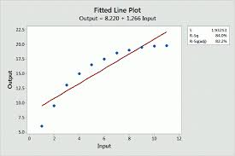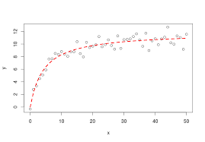
Following the above approach, if radioactivity is linear as a function of time, if in 2 seconds there are 100 impacts in 5 seconds there will be 250 impacts, more or less, and there will be about 500 impacts in 10 seconds.
If at a distance of 15 cm there are 100 impacts, at a distance of 60 cm there will be 25 impacts, more or less.

Are you sure? If yes, then radioactivity would be linear versus time and distance. And if not, how is the relationship?

Development of the experiment

The experiment is very simple but perfectly follows the scientific method. You have to select the LabsLand radioactivity lab, and then the advanced mode.
To find out whether or not a variable affects the observed phenomenon, then you have to SET the other variables and VARY the variable under study. If several variables are varied at the same time, then we will not know to which variable the change in the phenomenon is due.
Development of the experiment for the analysis of the behaviour of the time variable:
- Set the radioactive material (each time one of them), the distance (always 15cm), the absorber (none) and the number of times (3).
- Give values for the time: 2 seconds, 5 seconds and 10 seconds and record the average value of the hits.
- Record the number of impacts and graph them.
Conduct the experiment to analyse the behaviour of the distance variable:
- Set the radioactive material (strontium), the time (always 5 s), the absorber (none) and the number of times (3).
- Give values for the distance: 2 seconds, 5 seconds and 10 seconds and record the average value of the hits.
- Record the number of impacts and graph them.

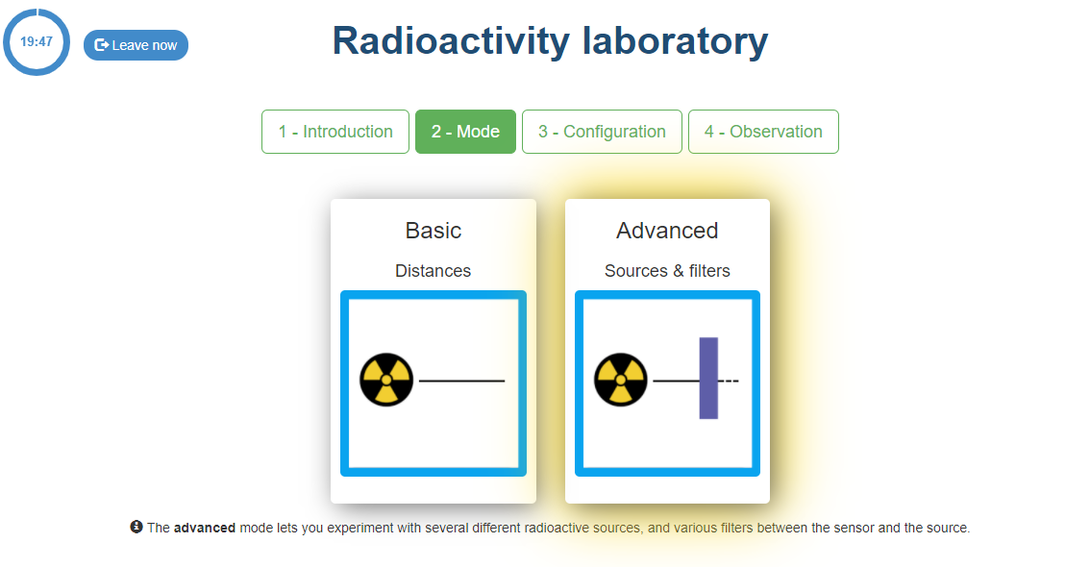
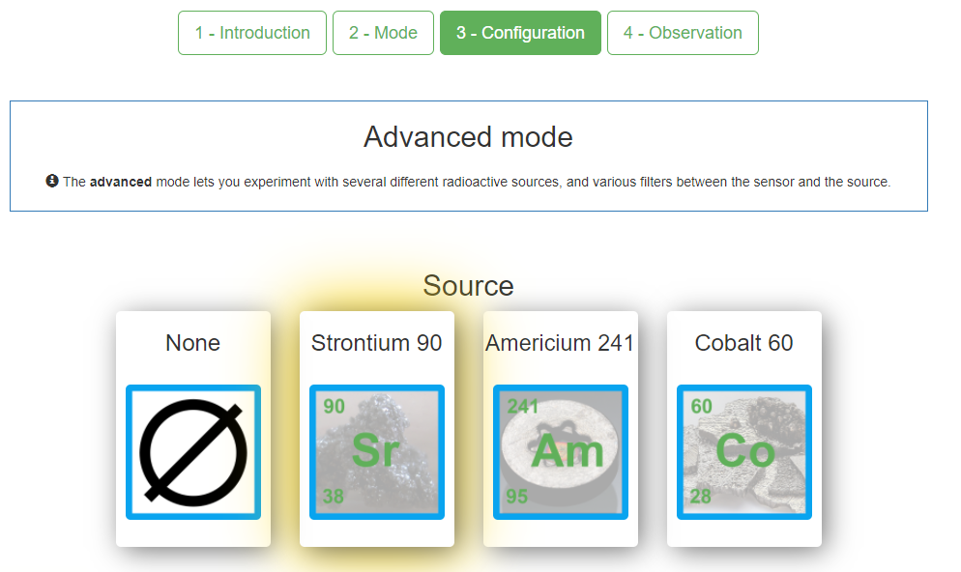
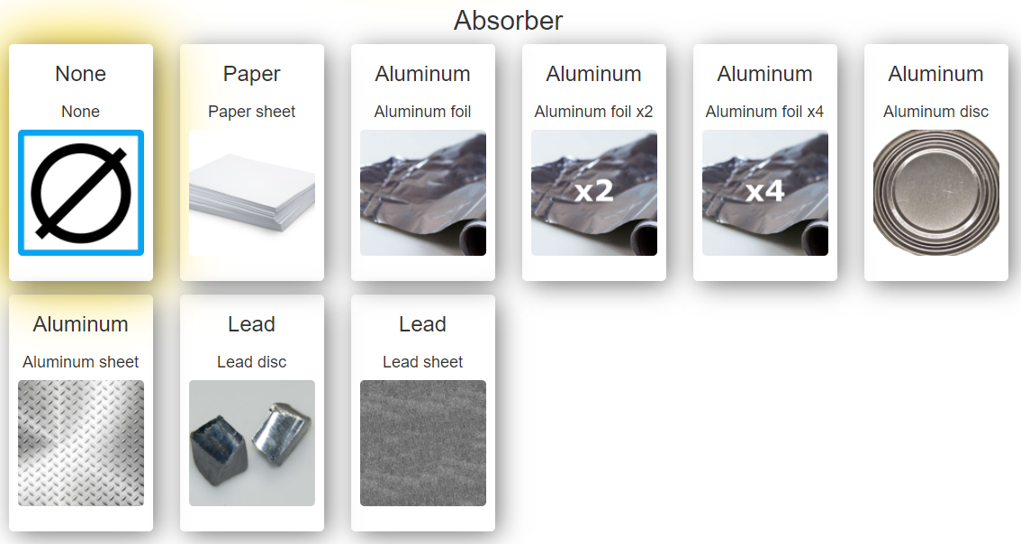
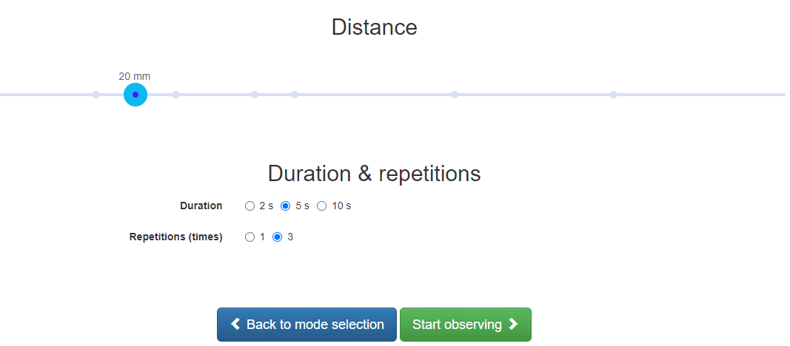

Taking measurements and plotting the experiment

Measurements and graphs for impacts versus time
Set the radioactive material (each time one of them), the distance (always 15cm), the absorber (none) and the number of times (3).
The following table allows you to collect the results. In each box, write down the number of hits according to the duration of the experiment.

Time | Strontium | Americium | Cobalt
2 s
5 s
10 s

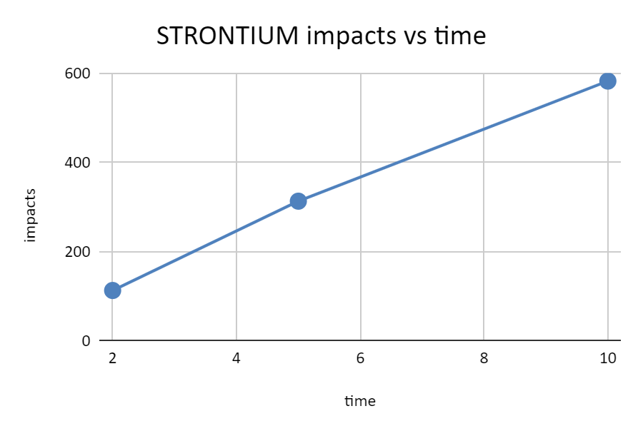
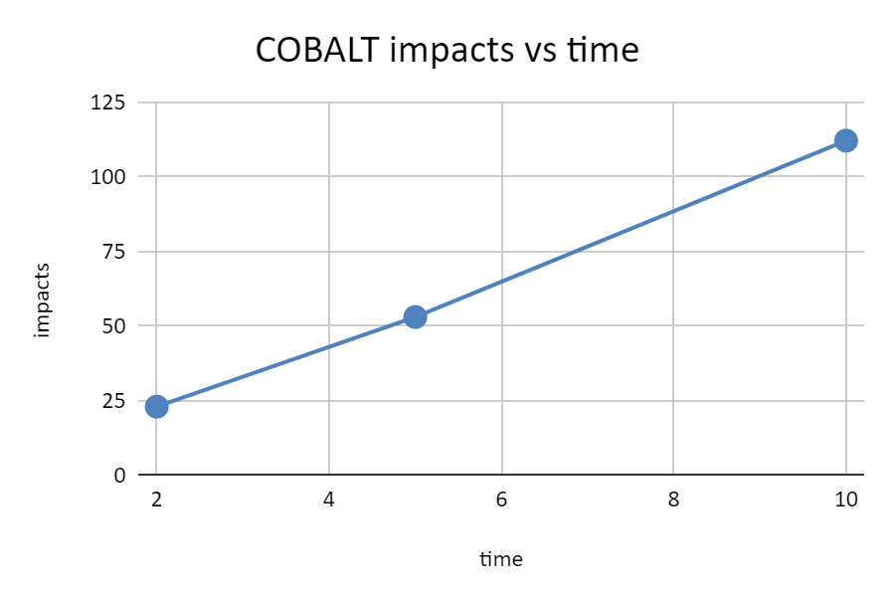
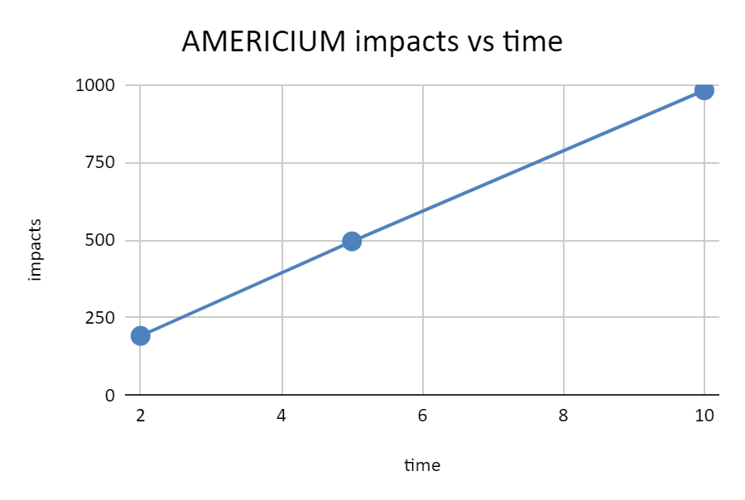
Now you have to plot the results. Below you can see the results obtained by me.
The question is: is the behaviour of the number of hits versus time linear? This can be answered graphically (visually) from the point of view of is it more or less a straight line?
If the answer is yes, then the relationship is linear and the impact ratio (which graphically is the slope of the line) can be calculated.
$rate=pend=\frac{∆impacts}{∆time}=\frac{580-110}{10-2}≅60 impacts/second$
This allows us to predict that for 60 seconds, 1 minute, the impacts will be about 3 600. This assumes, however, that the linear behaviour will be maintained as time increases.
The mathematical model of this behaviour can be obtained for strontium:
$impacts=60xseconds$
Measurements and graphs for impacts versus distance
Set the radioactive material (strontium), the time (always 5 s), the absorber (none) and the number of times (3).
Draw your data on the graph below and then calculate the ratios of each graph with your data. In each box write down the number of hits as a function of the distance from the detector.
For the distance we will always use strontium, 5 seconds and 5 repetitions. As there is a lot of data, you can share the work with your colleagues.
15 mm | 20 mm | 25 mm | 30 mm | 35 mm | 40 mm | 45 mm | 50 mm | 55 mm | 60 mm



Analysis of the results of the experiment and evaluation

The two basic questions are:
- Is the number of hits for any radioactive substance linear as a function of time?
Answer and justification:

- Is the number of impacts for strontium linear as a function of distance?
Answer and justification:

Questions about the prediction of the behaviour:
- Are you able to predict how many impacts there will be in 60 seconds for each radioactive substance? Can you check it somehow?
Strontium | Americium | Cobalt
- Can you write the mathematical model for each material? What are the ratios for americium and cobalt? In my case the ratio was 60 for strontium, but yours can and should be different (but not much).
Strontium | Americium | Cobalt
$impacts=rate x seconds$ | $impacts=rate x seconds$ | $impacts=rate x seconds$
- Can you predict how many impacts there will be at a distance of 10 cm and 100 cm for strontium? Can you check this in any way?
10 cm | 100 cm

New and advanced questions:
- The evolution of the number of impacts as a function of distance is not a straight line, what is it? Does it look like one of the curves seen in class?
Answer:

- It seems clear that the number of impacts does not behave linearly with distance. In principle, it seems that a particle is emitted in a straight line and therefore impacts, after a distance, with the impact detector. But it seems that this is not the case, that the particle does not go in a straight line. What trajectory does the particle follow when it is emitted? LOOK at question 8.
Answer and explanation:

- Is it possible to characterise the behaviour of the number of impacts versus distance? If you want, you can use the excel file to obtain the model automatically.
15 mm | 20 mm | 25 mm | 30 mm | 35 mm | 40 mm | 45 mm | 50 mm | 55 mm | 60 mm

- If you have obtained a mathematical representation of the above curve (the fitting curve) then you can predict the behaviour at new distances. Can you write down the number of impacts your mathematical model predicts and compare it with the actual laboratory result?
Distance | 60 mm | 65 mm | 70 mm | 75 mm | 80 mm | 85 mm | 90 mm | 95 mm
Model
Real
Error

- When you do the experiment, sometimes one of the five measures is very different from the others, can you remove that number of impacts from the calculation? why?
Answer:

- Why do you think I recommend using 5 reps instead of 3?
Answer:

- Draw only the impacts for distances ranging from 15 mm to 35 mm, both distances included - can you say that the relationship is linear? Is it a straight line? What is happening or what conclusion do you draw?
15 mm | 20 mm | 25 mm | 30 mm | 35 mm

Answer:

- Do you think the behaviour of cobalt and americium will follow the same pattern as that of strontium? Are you sure? Can you check? LABO I
Before completing the table, do not have any preconceived ideas of what the graph should give or what it should look like.
As a hint, here is a picture from the internet showing the emission trajectory of the different types of particles or rays.

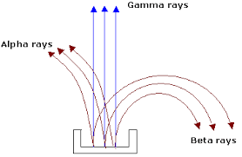
 | 15 mm | 20 mm | 25 mm | 35 mm | 40 mm | 60 mm | 80 mm
Cobalt
Americium

You can look for the evolution of the height of the sea as a function of the tide time. If you draw this height, you will see that the behaviour is not a straight line, nor a parabola, but a XXXXX.
It is said that if a tide rises 12, the first hour rises 1; the second, 2; the third, 3; the fourth, 3; the fifth, 2 and the sixth, 1. And the same when the tide goes down, so the total gives 12, if you draw it: 1_2_3_3_3_2_2_1_(-1)_(-2)_(-3)_(-3)_(-2)_(-1) you will see a XXXXX behaviour.

Comments for the teacher

This teaching activity focuses on analysing the behaviour of different variables to see if they are linear or not. Students tend to think that all relationships are linear and that a rule of three can always be used. This experiment with radioactivity helps them to overcome this misconception.
In addition, students take measurements and graphs as in other activities, but in this case they are also asked to obtain a mathematical model. The teacher will decide whether or not this is an objective of the course.
As this is a real experiment, the numbers obtained in the classroom may differ from those presented later, but not much.
For graphing you can use the given graphs. Excel can also be used, depending on the teacher's wishes.
It is repeated five times because at large distances the number of impacts may differ. It can also be done with 3 repetitions, but it is safer with five.
If one value differs a lot from the other four, then it is good to remove it, otherwise the number of hits can be very distorted. These are real experiments.
My results are:
For the time variable. The behaviour is linear and the ratios are 60 hits/sec for strontium, 11 hits/sec for cobalt and about 100 hits/sec for americium.

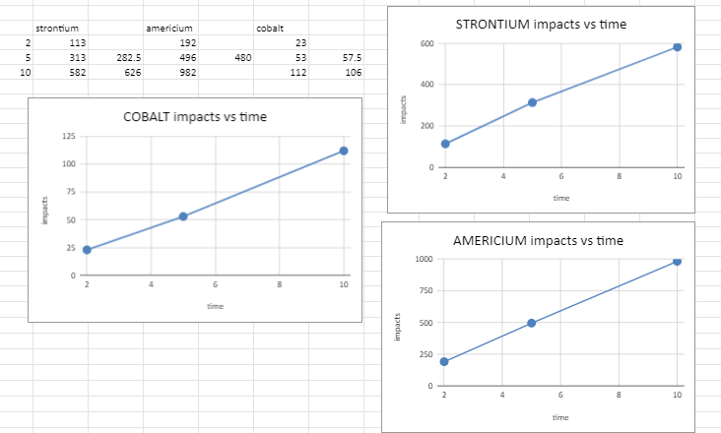
For the distance variable the behaviour is not a straight line, it is a parabola.
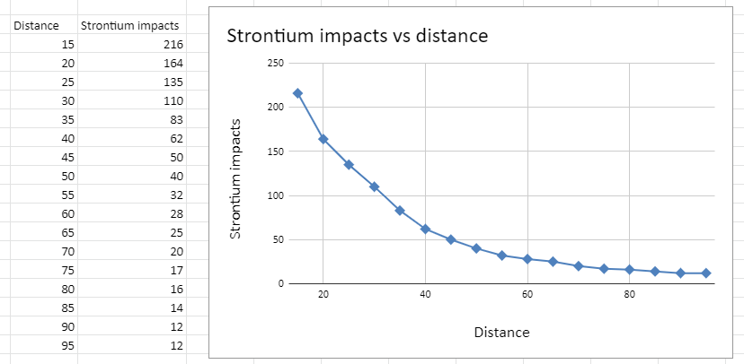
However, if few distance values are taken then it is the appearance of the graph that encourages one to say that the behaviour is linear, when in fact it is not.
If only the impacts for low distances are plotted, then by pooling these results it may appear that the behaviour is linear. In this case an error would be made. The graph shows the strontium hits for distances up to 35 cm.
It looks like a straight line:
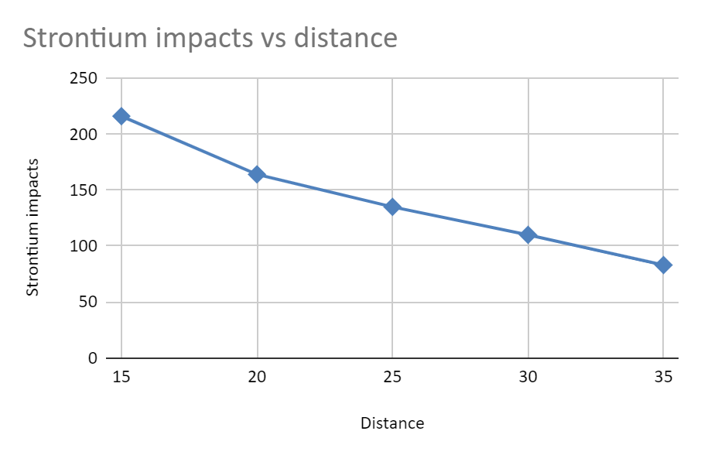

The good thing about models in physics, chemistry etc. is that they are generally not just based on measurements but on proven laws and models, not just on data.
The picture shows that the alpha particle is not emitted rectilinearly, but parabolically. Therefore, the further away the detector is, the more likely it is that the alpha particle avoids the detector. It is even more so for beta particles, and yet for gamma rays the relationship will be more linear.

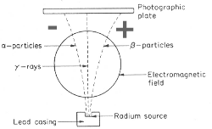

The mathematical model representing the behaviour can be obtained directly from excel. Right click on the graph (on the points) and select "add trend curve". In the figure there are two settings: exponential and potential. Better is the one whose R is closer to 1; in this case the potential.
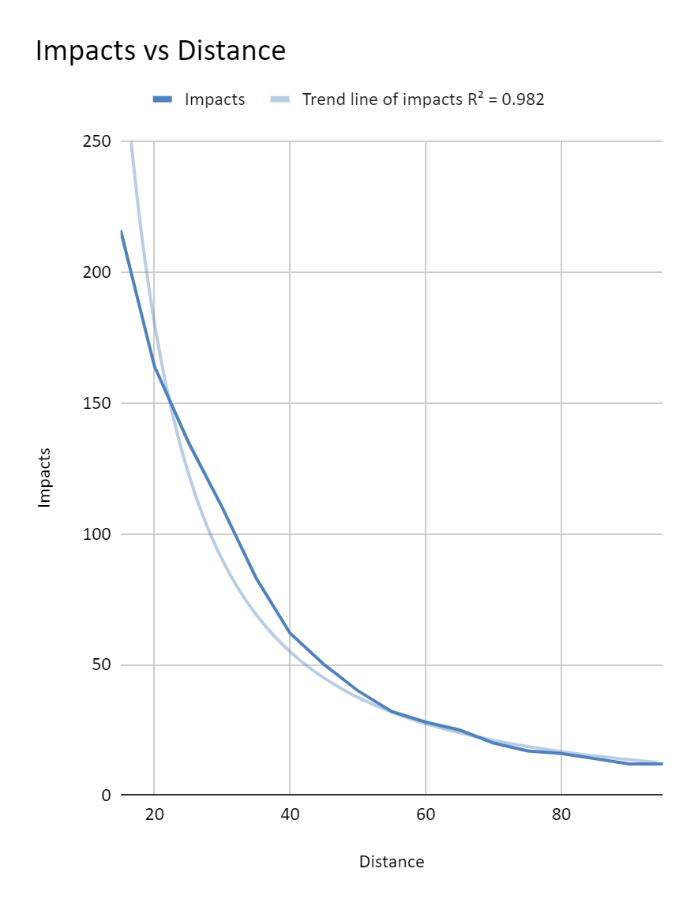

The behaviour predicting the number of impacts according to the potential model is as follows.
Distance | 60 mm | 65 mm | 70 mm | 75 mm | 80 mm | 85 mm | 90 mm | 95 mm
Model | 33 | 28 | 23 | 19 | 16 | 13 | 11 | 9
Real | 28 | 25 | 20 | 17 | 16 | 14 | 12 | 12
Error | 5 | 3 | 3 | 2 | 0 | -1 | -1 | -3

The error performance of the models is shown in the table below.
Distance | Impacts | Potential model | Potential model error | Exponential model | Exponential model error
15 | 216 | 296 | 80 | 176 | -40
20 | 164 | 180 | 16 | 146 | -18
25 | 135 | 123 | -12 | 122 | -13
30 | 110 | 90 | -20 | 101 | -9
35 | 83 | 69 | -14 | 84 | 1
40 | 62 | 55 | -7 | 70 | 8
45 | 50 | 45 | -5 | 58 | 8
50 | 40 | 37 | -3 | 48 | 8
55 | 32 | 32 | 0 | 40 | 8
60 | 28 | 27 | -1 | 33 | 5
65 | 25 | 24 | -1 | 28 | 3
70 | 20 | 21 | 1 | 23 | 3
75 | 17 | 19 | 2 | 19 | 2
80 | 16 | 17 | 1 | 16 | 0
85 | 14 | 15 | 1 | 13 | -1
90 | 12 | 14 | 2 | 11 | -1
95 | 12 | 12 | 0 | 9 | -3

In my case I have chosen a polynomial fit of degree 2 (a parabola), but any other can be chosen.
The table below shows the impacts for americium and cobalt AND also the graphs. For americium, the impacts disappear abruptly, as the beta particles come out "more twisted" and therefore less likely to hit the detector.
Distance | Cobalt impacts | Americium impacts | Strontium impacts
15 | 54 | 483 | 216
20 | 40 | 264 | 164
25 | 32 | 7 | 135
35 | 20 | 5 | 83
40 | 15 | 3 | 62
60 | 10 | 3 | 28
80 | 5 | 3 | 16
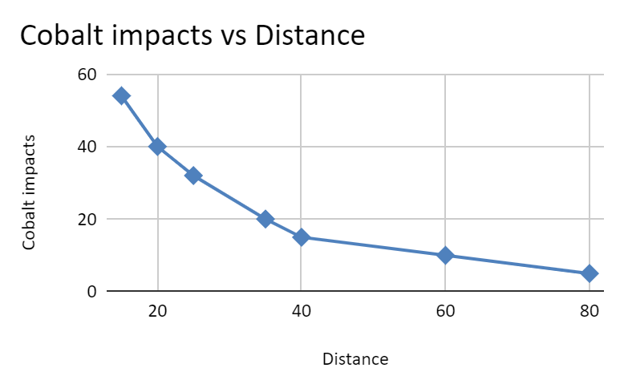
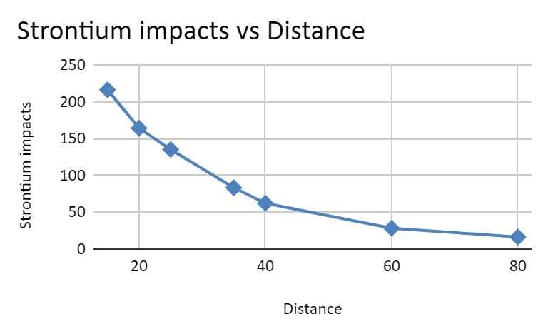
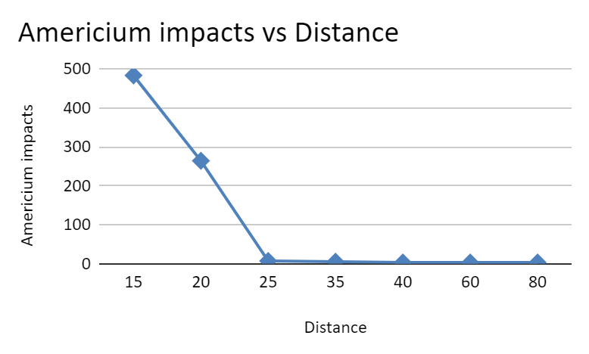
The height of a tide has a sinusoidal behaviour. The image shows a tide in San Vicente de la Barquera in 2003.
