

EXPERIENCE: RADIOACTIVITY I

Rev: 1.4 (July/2021)
Authors: Javier Garcia Zubía (zubia@labsland.com)
Unai Hernández (unai@labsland.com)
Luis Rodríguez Gil (luis@labsland.com)

Content

OBJECTIVES: 3
LEARNING OUTCOMES: 3
STRUCTURE OF THE DOCUMENT: 3
Introduction 4
Development of the experiment and theory 4
Taking measurements of the experiment 7
Graphical representation of data 10
Analysis of experiment results 10
Evaluation and open questions 11
Comments for the teacher 12

We will study radioactivity and the particles that support it. We will bombard different materials with radioactivity (alpha, beta and gamma particles). To do this, we will use the LabsLand radioactivity laboratory, and we will select the advanced mode.

OBJECTIVES:
The objectives of this laboratory experience are:
- To complete a scientific experience with a strong enquiry load.
- To introduce radioactivity, its types and its dangers.

LEARNING OUTCOMES:
Thanks to this experiment, the student will be able to learn about:
- Radioactivity and the particles that support it.
- The different types of radioactivity and their dangerousness.
- Ways of stopping radioactivity according to its type.
- Organisation of experimental work.
- Introduction of the scientific method.
- Data collection and graphical representation of data.
- Data analysis and drawing conclusions.

STRUCTURE OF THE DOCUMENT:
This document is structured as follows:
- Introduction. Page 4.
- Development of the experiment and theory. Page 4.
- Taking measurements of the experiment: period of the pendulum. Page 7.
- Graphical representation of the data. Page 10.
- Analysis of the results of the experiment. Page 10.
- Evaluation and open questions. Page 11.
- Comments for the teacher. Page 12.

Introduction

The emission of radioactivity in nature is constant. Watch this video.
https://www.youtube.com/watch?v=OLdDKb9Bago
Are we at risk when we eat a banana? No. Why?
Atoms of some elements spontaneously emit radioactivity. For example, bananas have potassium (K-40), and K-40 atoms give off radioactivity. The good thing is that a banana does not emit much radioactivity.
What is important is that we distinguish between the different types of radioactivity: alpha, beta and gamma. The K-40 isotope of the banana emits beta radiation, so?

Development of the experiment and theory

Radioactivity is everywhere and its effect depends on its type: alpha, beta or gamma.
A bit of theory:
- An alpha particle is a helium nucleus with two protons and two neutrons. Spontaneous alpha radiation emits helium nuclei.
- A beta particle is an electron. An electron is on the order of thousands of times smaller than a nucleus (depending on the nucleus), so beta radiation "sneaks" more easily between atoms. It's like comparing a person (beta) to a truck (alpha).
- A gamma particle is a photon and therefore sneaks through even more than an electron, although it can also be stopped.
In the figure we see the different types of radioactivity and which materials stop them.
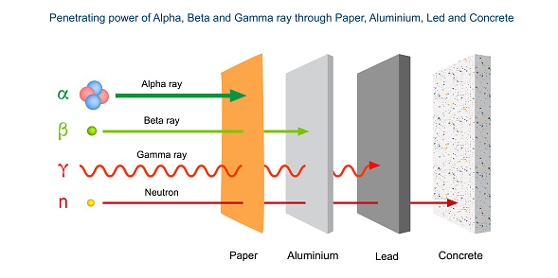
The figure shows that clothes are enough to stop alpha radiation, a metal such as aluminium is needed to stop beta and at least lead is needed to stop gamma rays (and X-rays).
The experiment we are going to carry out consists of bombarding a particle detector with three materials (strontium, americium and cobalt). Between the material and the detector we will put paper, an aluminium disc, a lead disc or nothing, of course.
The particle detector receives impacts and then counts them. It is like a picture of impacts.
The question is which particles are mainly emitted by americium, cobalt and strontium?
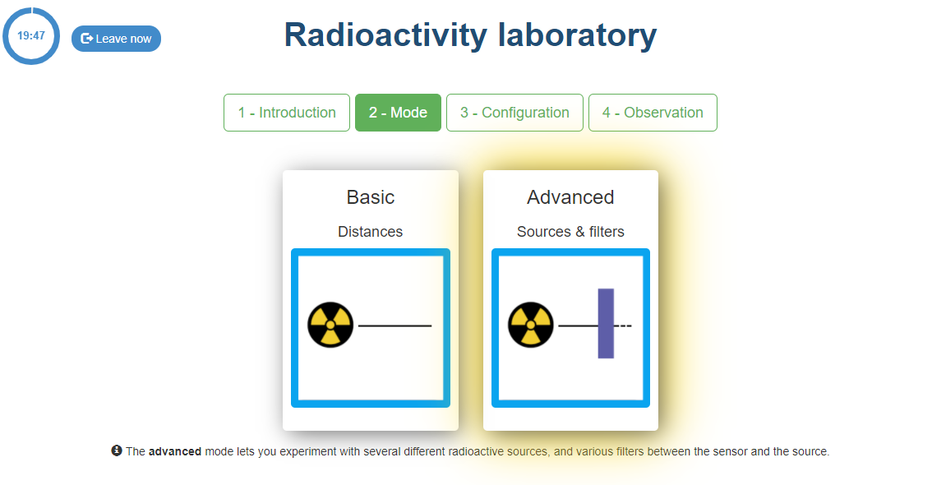
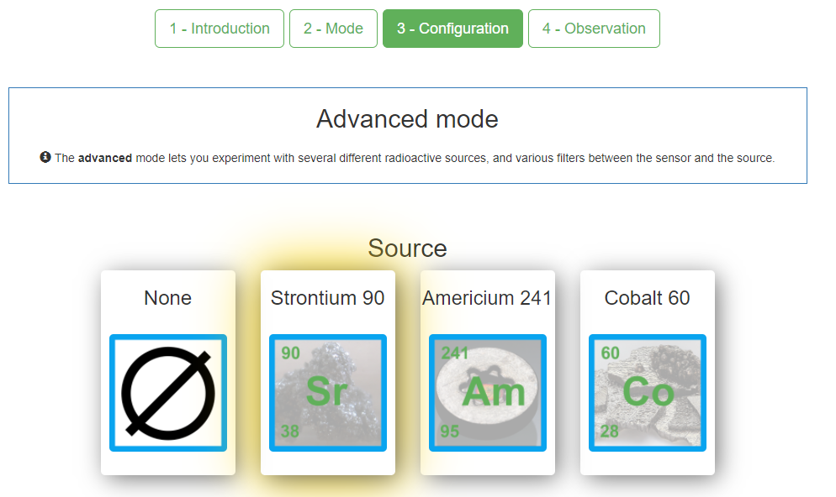
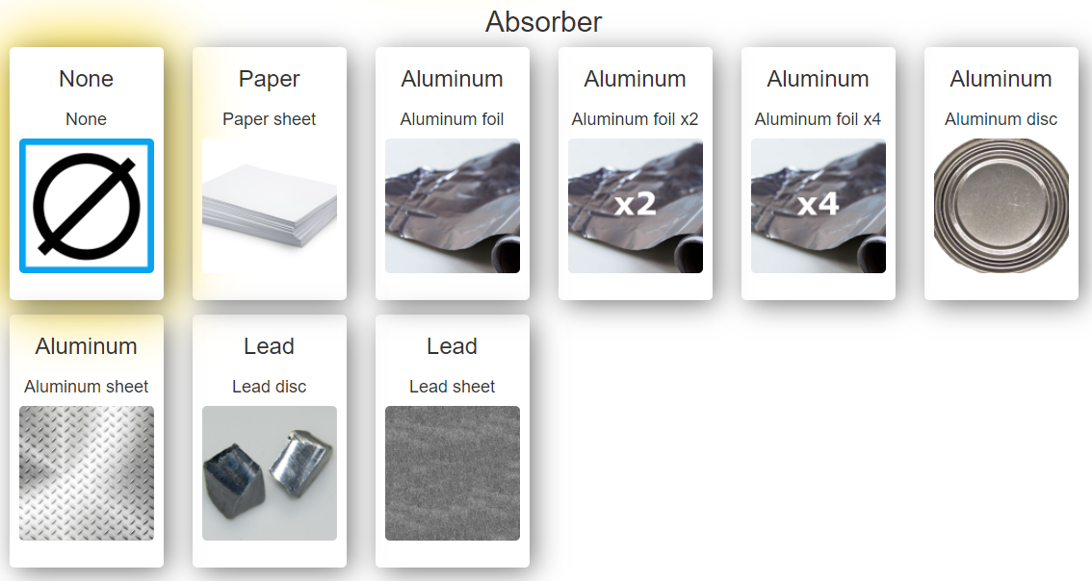
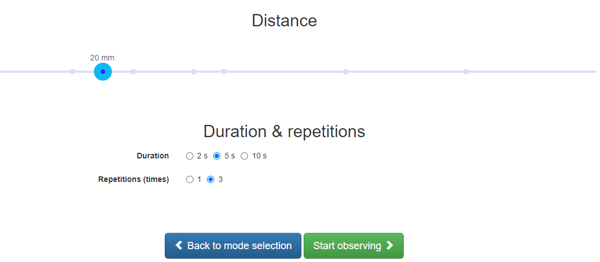

Taking measurements of the experiment

Well, it is time to experiment. For example, for strontium:
- First we bombard the detector with nothing in front of it. And we count the hits.
- Then we bombard the detector with paper in front of it. And we count the hits.
- We repeat the same for aluminium and lead discs. And we count the hits.
- We look at the number of hits in each case and answer the question in which case there is a clear drop in the number of hits? The answer is the solution.
Before we start, we have to make some clarifications of the experiment:
- You have to choose a distance, always the same one. For example, 15 cm. You can change it to another distance, but it has to be the same for all bombardments, otherwise the results are not comparable.
- You have to choose the time during which the bombardments are counted. For example, 5 seconds. With the same comment as above.
- Repeat the experiment a number of times. For example, 3. Keep in mind that it is a real experiment and therefore changes with each bombardment. By repeating the experiment 3 times we can have more information to see how many impacts there have been.
- In addition, there are two different underlying equipment in this experiment, Radioactivity-1 and Radioactivity-2, and the results may not be very consistent with each other. Remember that the important thing is to see in which material the radioactivity stops.
For example, let's see what happens to strontium with no absorber.
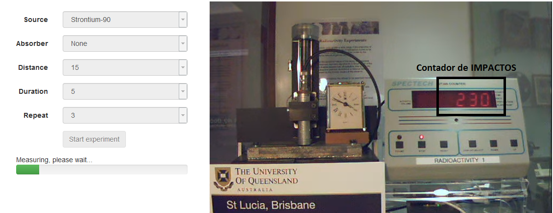
Looking at the results we can say that Radioactivity-1 has counted about 225 hits (maximum 250, minimum 200, so about 200 hits) when subjecting the detector to a strontium bombardment at a distance of 15 cm for 5 seconds.
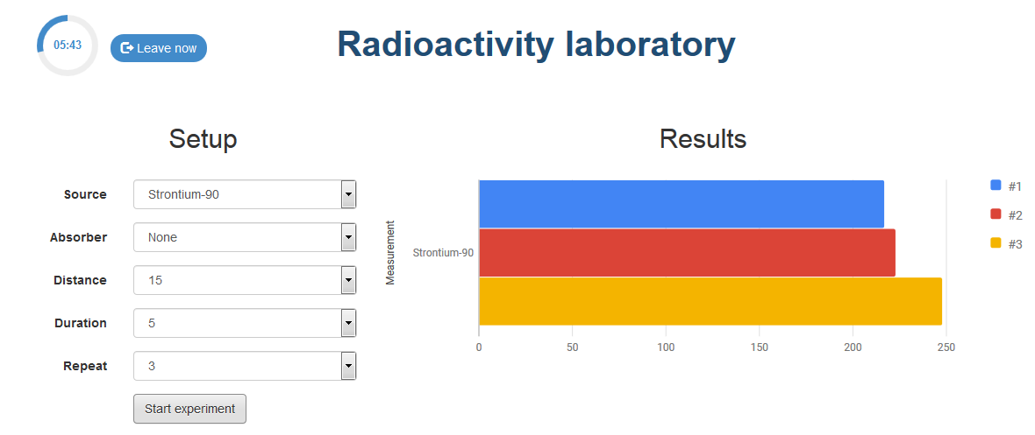
Let us now do the same test with paper between the strontium and the impact detector.
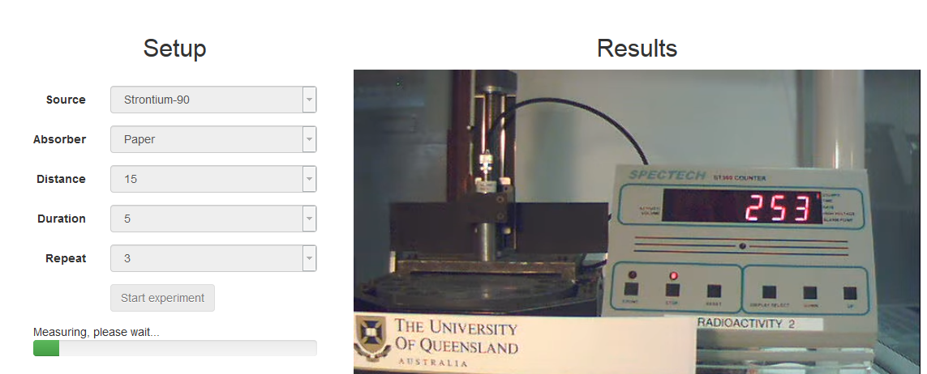
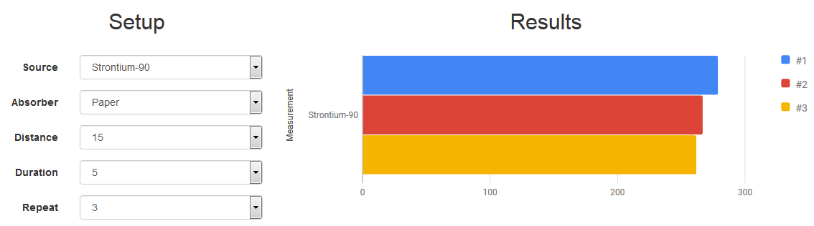
I have put this case because here you can see a strange result. The impacts are about 250, can there be more impacts with paper than without paper? The answer is no, but we have to take into account that in this case the equipment was Radioactivity-2. So you have to realise but it is not very important because when asked the question: did the particles stop in front of the paper? The answer is NO.

Graphical representation of data

Complete the table below carefully. Perhaps it is a good idea to do this as a group or as a whole class: each person or pair bombards with a material and an absorber in front of it.
Taking into account that the data may vary, the question is, at which material does the radioactivity stop?
 | With nothing | With paper | With aluminum disc | With lead disc
Strontium | 250 | 225
Americium
Cobalt

Analysis of experiment results

The three questions are:
- Americium is radioactive and emits TYPE particles/radiation.....
- Cobalt is radioactive and emits TYPE particles/radiation.....
- Strontium is radioactive and emits particles/radiation of TYPE.....
To support the three statements above, complete the following sentences:
- Strontium emits particles/radiation type ......
- Without absorber the detector counted 250 hits, with paper as an absorber it counted 225, with aluminium disc as an absorber it counted …. and with lead disc as an absorber it counted …..
- When going from ...... to ....... The reduction was ...%.
- Americium emits particles/radiation type .......
- Without absorber the detector counted …. hits, with paper as an absorber it counted …., with aluminium disc as an absorber it counted …. and with lead disc as an absorber it counted …..
- When going from ...... to ....... The reduction was ...%.

- Cobalt emits particles/radiation type .......
- Without absorber the detector counted …. hits, with paper as an absorber it counted …., with aluminium disc as an absorber it counted …. and with lead disc as an absorber it counted …..
- When going from ...... to ....... The reduction was ...%.
In this way you have not only expressed the conclusion of an experiment but also supported it with data.

Evaluation and open questions

Looking at what you have learned in the experiment, you may be able to answer some of the following questions.
When we have an X-ray, X-rays pass through our bodies. As it is only for a short time, it doesn't affect us much, but the people who work there are under the effect of X-rays all day long. That's why they wear a kind of apron. What do you think is inside the apron? Why isn't it closed at the back?
Look up on the internet how much radioactivity is involved in eating a banana.
What other products that we eat or drink emit radioactivity?
When we have an X-ray, then our body receives radioactivity, which is not good, but it is not very bad either. Complete the following sentence: Having an X-ray is equivalent to eating .... bananas.
In the USA there are radioactivity detectors in airports. What happens if you carry a few bananas in your suitcase? Will the detector go off? Will you get into trouble? Do you think the same thing would have happened if the banana had emitted alpha radiation? why?
Alexander Litvinenko was poisoned in 2006 with Polonium. Polonium was poured into the tea he was about to drink - what kind of radiation does polonium emit? alpha, beta or gamma? One clue: why didn't the people who carried the polonium in a canister die? And another clue, why did they give it to him in a tea (in a liquid)?

Comments for the teacher

The results obtained are shown in the table below (each value is the rounded average of the three measurements made).
 | Nothing | Paper | Alum disc | Lead disc
Strontium | 297 | 259 | 2 | 1
Americium | 492 | 8 | 3 | 1
Cobalt | 55 | 50 | 44 | 30

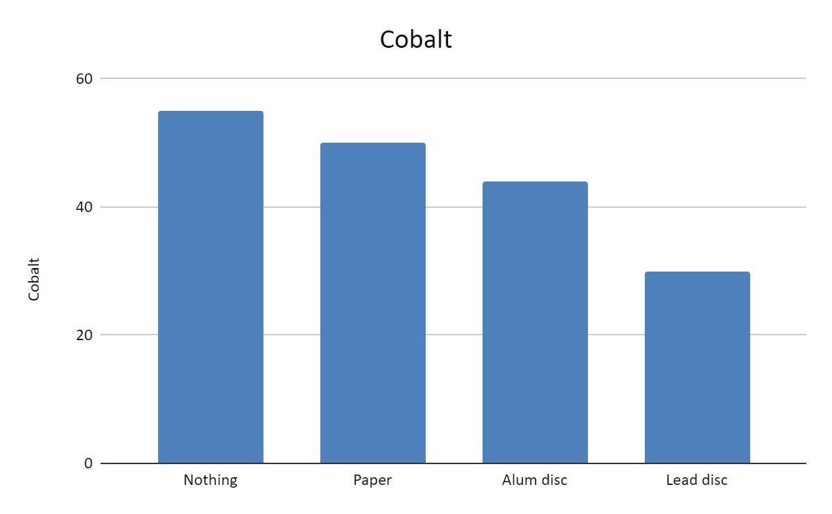
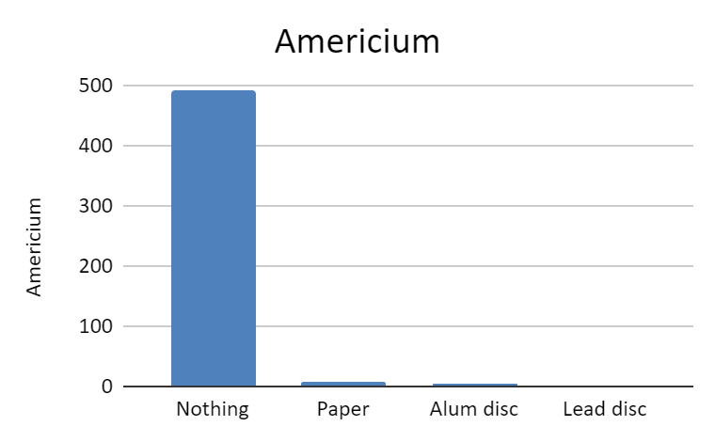
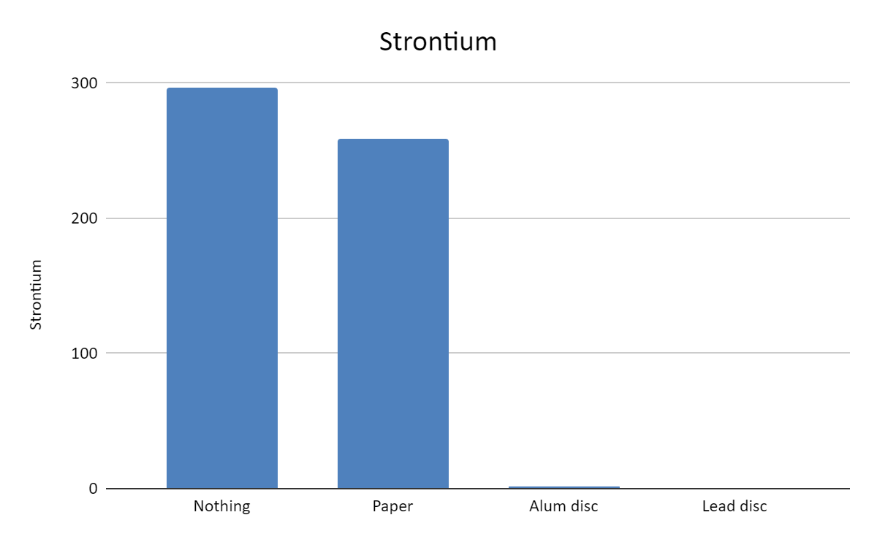
Represented in excel:
It is seen that in americium the impacts stop with the paper: ALPHA PARTICLES
It is seen that in strontium the impacts stop on the aluminium disc: BETA PARTICLES
You can see that in cobalt the impacts do not disappear, they are reduced: GAMMA RADIATION
In the attached image you can see all the data together.

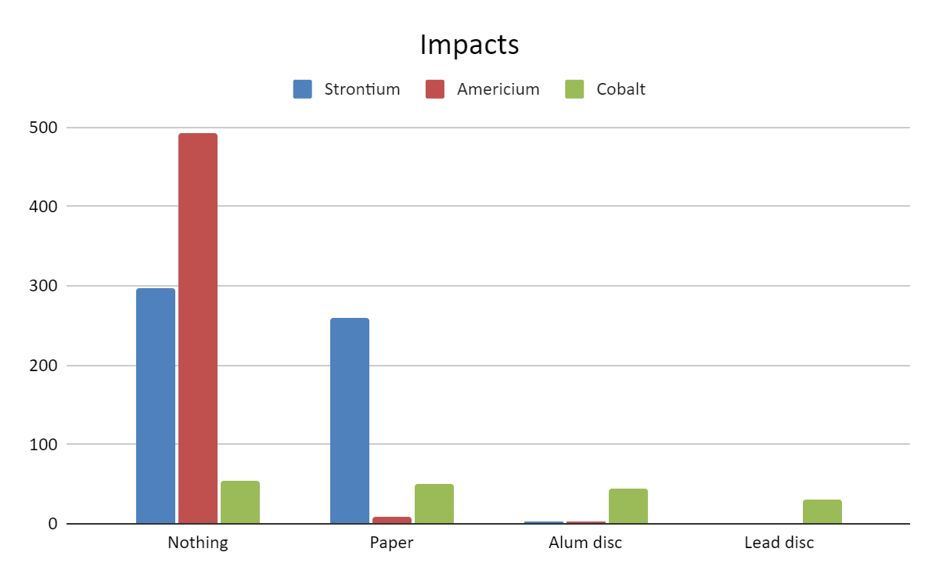
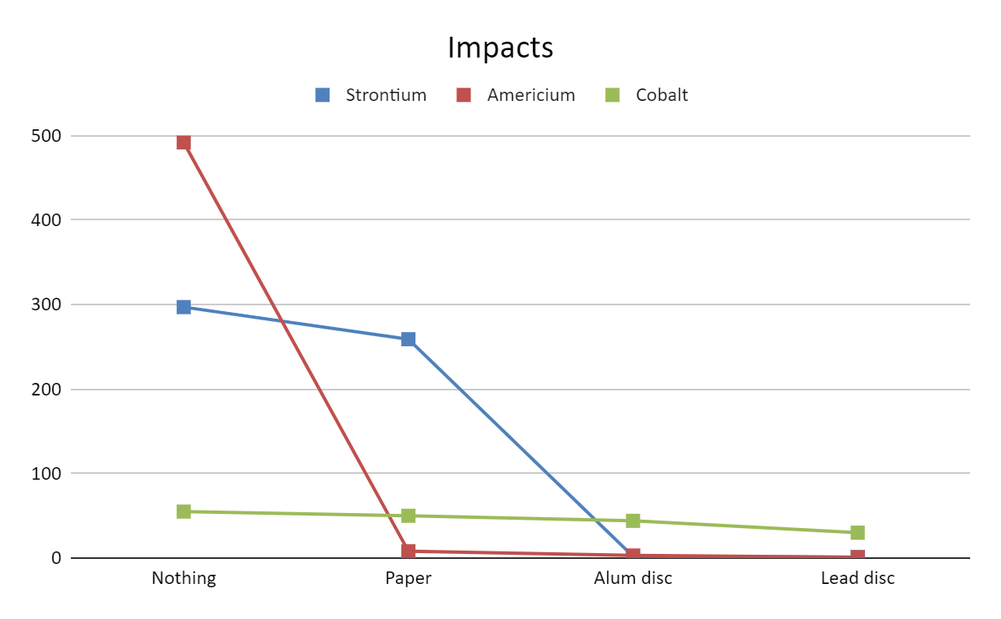

There is a lot of information about radioactivity on the web: videos and cool pictures.
X-ray assistants wear a lead-lined apron. They don't need to wear anything behind them because the x-ray emitter is in front of them. Often the patient also wears lead "patches" so that the x-rays do not affect the whole body. Nowadays, lead aprons are hardly used any more; the assistants are now placed in a lead-lined room.
Bananas are used as a unit of measurement of radioactivity for people, BED (Banana Equivalent Dose), https://en.wikipedia.org/wiki/Banana_equivalent_dose. I don't remember how much radioactivity a banana has, but it is used for comparison. For example, an x-ray (radiography) is like eating about 200 bananas, and a dental x-ray is about 50 bananas.
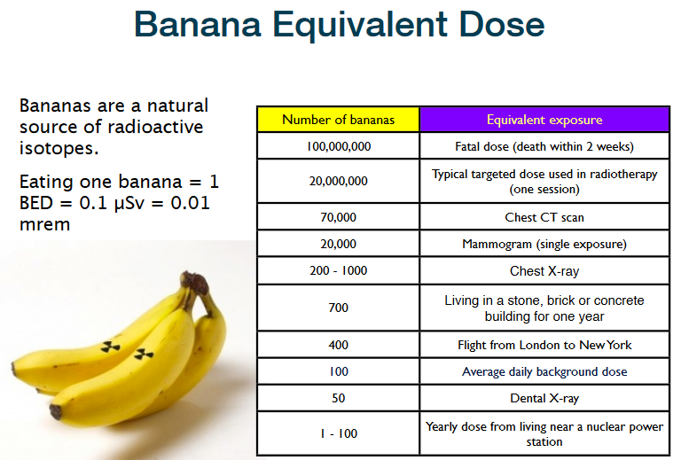
In the US, if you carry bananas, they can set off the alarm of radioactivity detectors. Since potassium-40 emits beta rays, they pass through the suitcase quite well and therefore their radiation is detected. If it emitted alpha radioactivity, then it would probably not be detected because the particles would be stopped by the suitcase, etc.
Alexander Litvinenko was poisoned with polonium. Polonium emits alpha particles, which are as large as they are dangerous and easy to stop. He was given it with tea because when he drank the tea the polonium went directly to his stomach and thus the radiation emitted directly damaged his stomach, lungs, pancreas, etc. Moreover, the polonium, being radioactive alpha, could be transported without any problems by the assassins by simply putting it in a metal canister and handling it with care.

