

EXPERIENCE: RADIOACTIVITY
contact@labsland.com

Authors: Silvia Zulueta

Content

Introduction 3
Development of the experiment and theory 3
Taking measurements of the experiment 6
Conduct of the experiment 6
Analysis of experiment results 8

Introduction

The emission of radioactivity in nature is constant. Watch this video.
https://www.youtube.com/watch?v=OLdDKb9Bago
Are we at risk when we eat a banana? No. Why?
Atoms of some elements spontaneously emit radioactivity. For example, bananas have potassium (K-40), and K-40 atoms give off radioactivity. The good thing is that a banana does not emit much radioactivity.
What is important is that we distinguish between the different types of radioactivity: alpha, beta and gamma. The K-40 isotope of the banana emits beta radiation, so?

Development of the experiment and theory

Radioactivity is everywhere and its effect depends on its type: alpha, beta or gamma.
A bit of theory:
- An alpha particle is a helium nucleus with two protons and two neutrons. Spontaneous alpha radiation emits helium nuclei.
- A beta particle is an electron. An electron is on the order of thousands of times smaller than a nucleus (depending on the nucleus), so beta radiation "sneaks" more easily between atoms. It's like comparing a person (beta) to a truck (alpha).
- A gamma particle is a photon and therefore sneaks through even more than an electron, although it can also be stopped.
In the figure we see the different types of radioactivity and which materials stop them.
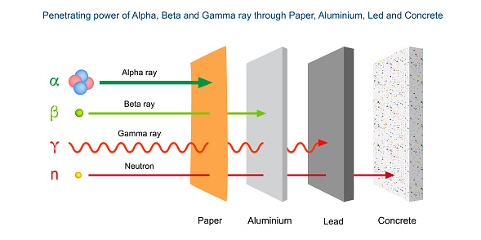
The figure shows that clothes are enough to stop alpha radiation, a metal such as aluminium is needed to stop beta and at least lead is needed to stop gamma rays (and X-rays).
The experiment we are going to carry out consists of bombarding a particle detector with three materials (strontium, americium and cobalt) by putting in between (between the material and the detector) paper, an aluminium disc and a lead disc or nothing, of course.
The particle detector receives impacts and then counts them. It is like a picture of impacts.
The question is which particles are mainly emitted by americium, cobalt and strontium?
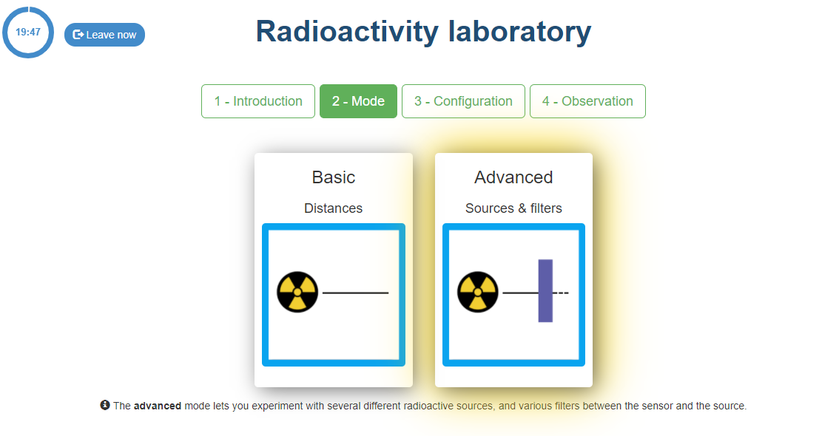
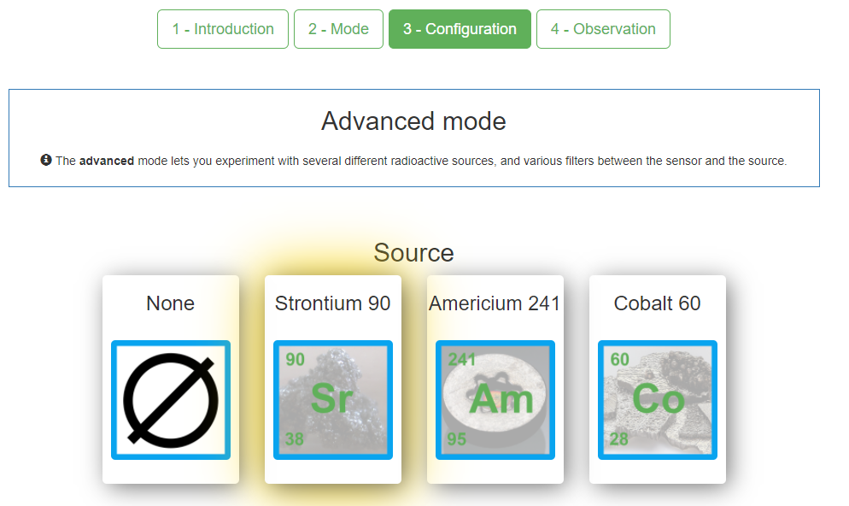
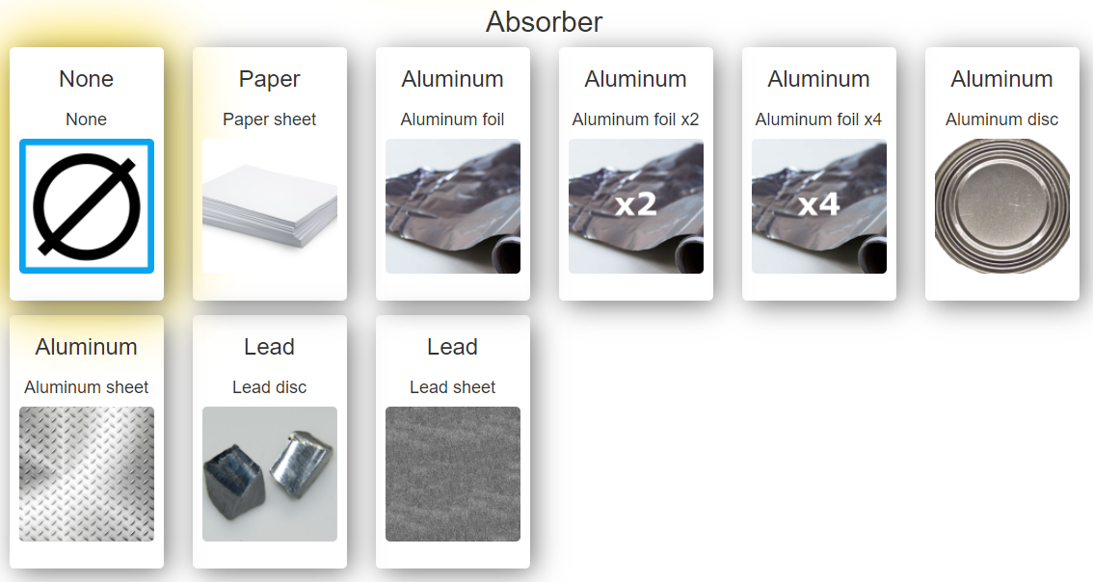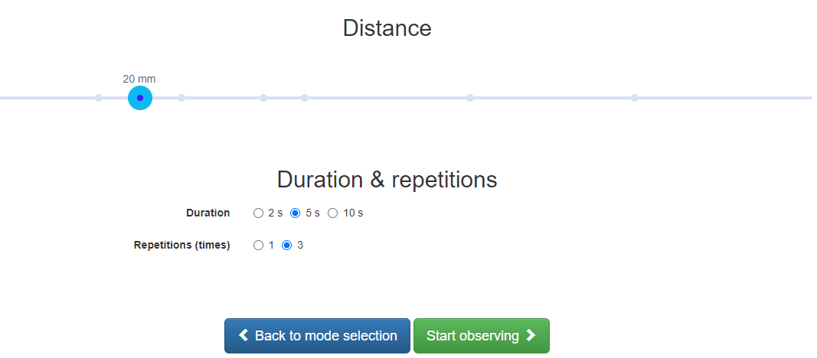

Taking measurements of the experiment

Well, it is time to experiment. For example, for strontium:
- First we bombard the detector with nothing in front of it. And we count the hits.
- Then we bombard the detector with paper in front of it. And we count the hits.
- We repeat the same for aluminium and lead discs. And we count the hits.
- We look at the number of hits in each case and answer the question in which case there is a clear drop in the number of hits? The answer is the solution.
Before we start, we have to make some clarifications of the experiment:
- You have to choose a distance, always the same distance. For example, 15 cm. You can change it to another distance, but it has to be the same for all bombardments, otherwise the results are not comparable.
- You have to choose the time during which the bombardments are counted. For example, 5 seconds. With the same comment as above.
- Repeat the experiment a number of times. For example, 3. Keep in mind that it is a real experiment and therefore changes with each bombardment. By repeating the experiment 3 times we can have more information to see how many impacts there have been.
- In addition, this experiment has two different teams, Radioactivity-1 and Radioactivity-2, and the results may not be very consistent with each other. Remember that the important thing is to see in which material the radioactivity stops.

Conduct of the experiment

You will do the calculation on a sheet of paper, but first you must capture the laboratory results. In each case do a single test, 5 seconds long.

Material: STRONTIUM-90  Absorber: None  Distance: 20 mm | Number of impacts:
Material: STRONTIUM-90  Absorber: Paper  Distance: 20 mm | Number of impacts:
Material: STRONTIUM-90  Absorber: Aluminium Disc  Distance: 20 mm | Number of impacts:
Material: STRONTIUM-90  Absorber: Lead Disc  Distance: 20 mm | Number of impacts:
Material: AMERICIUM-241  Absorber: None  Distance: 20 mm | Number of impacts:
Material: AMERICIUM-241  Absorber: Paper  Distance: 20 mm | Number of impacts:
Material: AMERICIUM-241  Absorber: Aluminium Disc  Distance: 20 mm | Number of impacts:
Material: AMERICIUM-241  Absorber: Lead Disc  Distance: 20 mm | Number of impacts:
Material: COBALT-60  Absorber: None  Distance: 20 mm | Number of impacts:
Material: COBALT-60  Absorber: Paper  Distance: 20 mm | Number of impacts:
Material: COBALT-60  Absorber: Aluminium Disc  Distance: 20 mm | Number of impacts:
Material: COBALT-60  Absorber: Lead Disc  Distance: 20 mm | Number of impacts:

Analysis of experiment results

The three questions are:
- Americium is radioactive and emits TYPE particles/radiation.....
- Cobalt is radioactive and emits TYPE particles/radiation.....
- Strontium is radioactive and emits particles/radiation of TYPE.....
To support the three statements above, you have to look at the number of hits that occur when Americium, Cobalt or Strontium is used with each absorber, to see when it is reduced by a large amount.
For example, with X material and no absorber, 200 hits are detected. With paper, these hits are reduced to 7 (which is understood as practically 0 due to the large reduction of hits) and so it would be concluded that these are alpha particles.

