




SNELL’S LAW ACTIVITY
INSTRUCTOR’S VERSION

Index

Introduction 3
Objectives 3
Educational stage and duration 3
Pre-requisites 3
Theory 4
Procedure 5
Questions 7

Introduction

This activity consists of an initial experimental exercise and some practical exercises to discuss the results. This is the instructor’s handbook with example solutions.

Objectives

- Study Snell’s law by measuring incidence and refraction angles.

- To characterize materials by the refraction of light:
  - Calculate the refraction index of a material.
  - Identify a material by its refractive index.

- Introduce the student to remote experimentation.

Educational stage and duration

This activity can be carried out by any student who has had an introductory course to optics and Snell’s Law (High School, Level A, College, or University students). It can be easily finished in a single session of around 60 minutes if the student has read and understood the document before starting the session and knows what to do. Even if the student cannot finish everything in class, as long as the Procedure section is finished the last Questions section can be done as homework since it does not require any new lab measurement.

Pre-requisites

- Basic knowledge of trigonometry: sin, cos, tan and their inverse functions.

- Basic knowledge about light and its speed through different materials.

- Basic knowledge about the elements that partake in Snell’s Law: incidence and refraction angles, light paths, refractive index, etc.

- Brief explanation of the devices used to carry out the experiment.

Theory

In optics, Snell’s law is an equation that describes how the direction of a ray of light changes when it passes from one uniform material to another. Named by Dutch astronomer and mathematician Willebrord Snellius, it relates the incidence and refraction angles and the speed of light through the materials it is going through. In practice, since the speeds of light are uncomfortable to work with due to their magnitude and most of the times only ratios between them are needed, refractive indexes (n) are used instead:

$n = \frac{c}{v}$ (1)

Where c is the speed of light in vacuum and v is the speed of light through a given material.

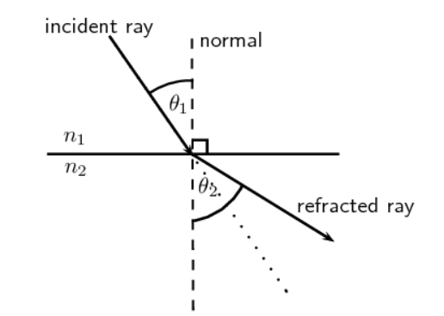
Figure 1: Diagram of the refraction of a ray of light from material 1 to material 2.

Snell's law states that, for a given pair of media, the ratio of the sines of the angle of incidence $θ_{1}$and angle of refraction $θ_{2}$ is equal to the ratio of phase velocities (v₁ / v₂) in the two media, or equivalently, to the refractive indices (n₂ / n₁) of the two media:

$\frac{sinθ_{1}}{sinθ_{2}}= \frac{v_{1}}{v_{2}} = \frac{n_{2}}{n_{1}}$ (2)

Procedure

- Enter the Snell’s Law laboratory and click the “Access” option.
- Choose the Solid Lens option.
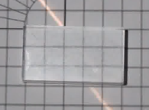
- Consider the solid block 2.9 squares high. Use the square grid and trigonometry to approximate the angle of refraction by counting how many squares to the right the light exits the block compared to where it enters. Example:

Light path
2.9 squares
Approximately 1.4 squares across
θ₂

In this case, the angle of refraction:
$$θ_{2}= arctan(\frac{1.4}{2.9}) = {25.8}^{o}$$

It is an approximation, do not worry if the results are not completely accurate.

- Repeat the calculation for different angles (five different angles of your choice) and for each of them calculate the refractive index of the block using Snell’s Law (2) (n_{air} = 1):

Table 1: Results obtained from the diffraction angle by measuring the number of squares for different angles of a solid lens.
$$θ_{1}$$ | $$θ_{2}$$ | $$n_{2}=\frac{n_{1}sin θ_{1} }{sin θ_{2} }$$
10 | arctan(0.4/2.9) = 7.9 | 1.27
20 | arctan(0.7/2.9) = 15.4 | 1.46
30 | arctan(1.1/2.9) = 20.7 | 1.4
40 | arctan(1.4/2.9) = 25.8 | 1.48
50 | arctan(1.9/2.9) = 33.2 | 1.4

- Go back and repeat the process for the Water-filled Lens. Consider the water block 6.9 squares high.

Table 2: Results obtained from the diffraction angle by measuring the number of squares for different angles of a water lens.
$$θ_{1}$$ | $$θ_{2}$$ | $$n_{2}=\frac{n_{1}sin θ_{1} }{sin θ_{2} }$$
10 | arctan(0.9/6.9) = 7.4 | 1.35
20 | arctan(1.8/6.9) = 14.6 | 1.35
30 | arctan(2.8/6.9) = 22.1 | 1.33
40 | arctan(3.8/6.9) = 28.8 | 1.33
50 | arctan(4.8/6.9) = 34.8 | 1.34

- As you probably noticed, the values you obtained for each angle are different due to the measurement error. Use the average of the values calculated before as the refractive index of the material. (Optional: calculate the standard deviation.)
n_{solid} = 1.40 (± 0.07)
n_{water} = 1.34 (± 0.01)

NOTE: If the standard deviation is calculated, it is recommended to remind the students a small standard deviation does not mean that the result is accurate. It just means that the results were more or less consistent, even though they could be completely wrong.
NOTE: The results of the students may vary depending on how they count the squares. It is completely fine and expected as long as they followed the procedure and made the calculations correctly.

Questions

- The real value of the refractive index of water is 1.333. How close is the value you calculated to the real value? (Give the difference as a percentage).

SOLUTION:
In this case the results are very similar.

$$\frac{(1.34-1.333) ⋅ 100}{1.333} ≃ 0.5\%$$

The difference between the calculated and theoretical values is about 0.5%.

- Find a list of the refractive indices (the Solids at Room Temperature section of the table at https://en.wikipedia.org/wiki/List_of_refractive_indices, for example). According to the refractive index you calculated for the solid lens, what could it be made of? How close is the value you calculated to the real value? (Give the difference as a percentage).

SOLUTION:
According to the Solids at Room Temperature section of the table at the link above, the solid lens is probably made of fused silica (n = 1.458).

$$\frac{(1.458-1.4) ⋅ 100}{1.458} ≃ 4\%$$

The difference between the calculated and theoretical values is about 4%.

- Calculate the speed of light through both materials. How much slower does light travel through them compared to vacuum?

SOLUTION:
For a speed of light in the vacuum of $c=3⋅{10}^{8} m/s$, using equation 1:

For the solid:

$$v_{solid}=\frac{3⋅{10}^{8} m/s}{1.458}=2.06⋅{10}^{8} m/s$$

That means that light travels through the fused silica at about 69% of its speed in vacuum.

For water:

$$v_{water}=\frac{3⋅{10}^{8} m/s}{1.333}=2.25⋅{10}^{8} m/s$$

That means that light travels through water at about 75% of its speed in vacuum.

Due to their tighter atomic structure, light usually is slower through solids compared to liquids. The result makes sense.

- Until now, we have only been focusing on the first boundary between the air and the material. However, the light travels through two of such boundaries in this experiment. There is an angle that we have not talked about yet: the angle at which the beam of light exits the material. Use Snell’s Law (2) to prove that the emergent angle is always the same as the initial incidence angle.

SOLUTION:

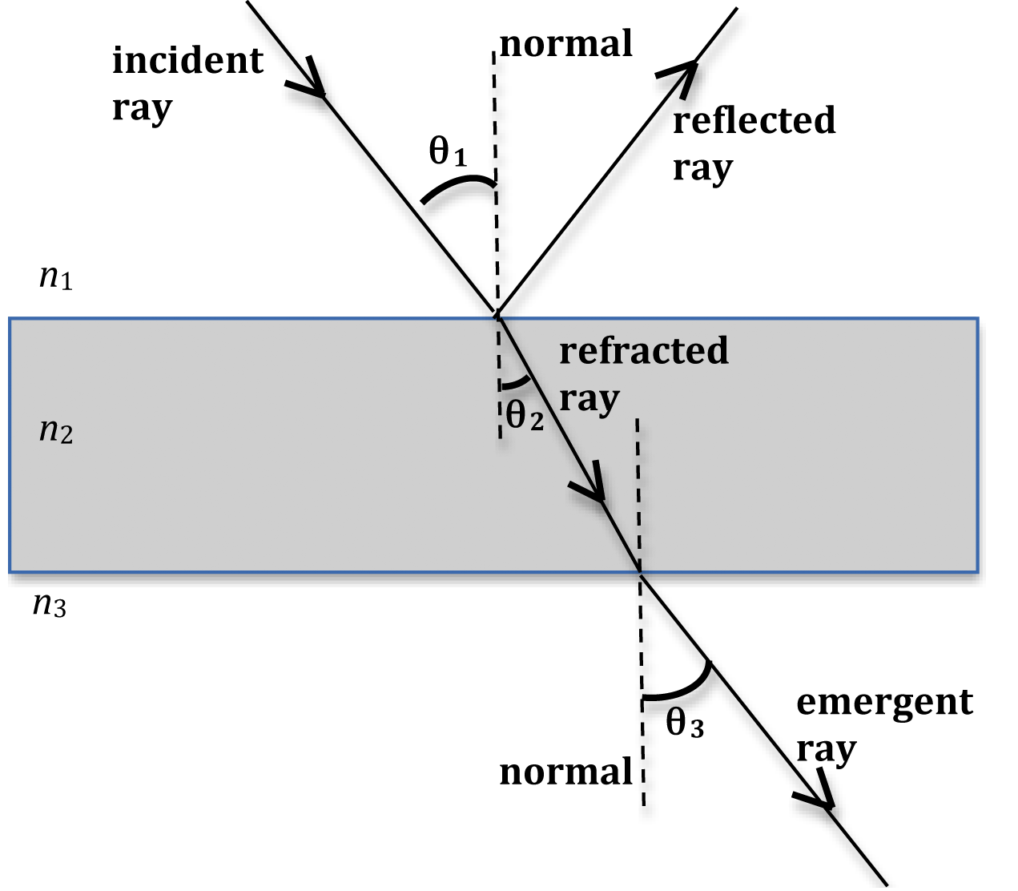
The angle of refraction of the first boundary is the same as the angle of incidence of the second boundary. Using Snell’s Law (2),

from the first boundary $n_{1}sinθ_{1}=n_{2}sinθ_{2}$
from the second $n_{2}sinθ_{2}=n_{3}sinθ_{3}$

Since the block is surrounded by air, n₁=n₃=1.

$$sinθ_{1}=n_{2}sinθ_{2}=sinθ_{3}$$

Thus, $θ_{1}=θ_{3}$. In fact, that equality will be true as long as $n_{1}=n_{3}$, no matter the materials.

- As you have already seen, there are measurement errors that affect the accuracy of the results. What could we do to increase that accuracy?

SOLUTION:
There are different possible answers to this question. It is mainly directed, however, to the fact that the way the angles were measured by counting squares is not very accurate. Possible suggestions are to decrease the square sizes of the grid so that the grid is tighter, or to directly measure the angle with a protractor.

- Write your conclusions briefly.

SOLUTION: (Example)
In this experiment we studied Snell’s law by measuring the angle of refraction of two different materials for different incidence angles. We calculated refractive indices of 1.34 for the water lens and 1.4 for the solid lens (which we identified as fused silica). The values we calculated differ from the real values by 0.5% and 4% respectively. Those refractive indices mean that the speed of light through those materials is 0.69% for the solid lens and 0.75% for the water lens. Even if the results may seem good, measuring the angles by counting squares in a grid is not very accurate. The accuracy of the measurements could be increased by reducing the size of the squares or, ideally, by directly using a protractor to measure the angles.

