




SNELL’S LAW ACTIVITY
FOR THE VERIFICATION CONFIGURATION

Index

Introduction 3
Objectives 3
Educational stage and duration 3
Pre-requisites 3
Theory 4
Procedure 5
Questions 7

Introduction

This activity consists of an initial experimental exercise and some practical exercises to discuss the results. This version includes a small activity that requires the verification configuration. The students will be able to verify their results with it.

Objectives

- Study Snell’s law by measuring incidence and refraction angles.
- Learn to characterize materials by the refraction of light:
  - Calculate the refraction index of a material.
  - Identify a material by its refractive index.
- Learn to use previous results to make new predictions.
- Introduce the student to remote experimentation.

Educational stage and duration

This activity can be carried out by any student who has had an introductory course to optics and Snell’s Law (High School, Level A, Bachelor or University students). It can be easily finished in a single session of around 60 minutes if the student has read and understood the document before starting the session and knows what to do. Even if the student cannot finish everything in class, as long as the Procedure section is finished the last Questions section can be done as homework since it does not require any new lab measurement.

Pre-requisites

- Basic knowledge of trigonometry: sin, cos, tan and their inverse functions.
- Basic knowledge about light and its speed through different materials.
- Basic knowledge about the elements that partake in Snell’s Law: incidence and refraction angles, light paths, refractive index, etc.
- Brief explanation of the devices used to carry out the experiment.

Theory

In optics, Snell’s law is an equation that describes how the direction of a ray of light changes when it passes from one uniform material to another. Named by Dutch astronomer and mathematician Willebrord Snellius, it relates the incidence and refraction angles and the speed of light through the materials it is going through. In practice, since the speeds of light are uncomfortable to work with due to their magnitude and most of the times only ratios between them are needed, refractive indexes (n) are used instead:

$n = \frac{c}{v}$ (1)

Where c is the speed of light in vacuum and v is the speed of light through a given material.

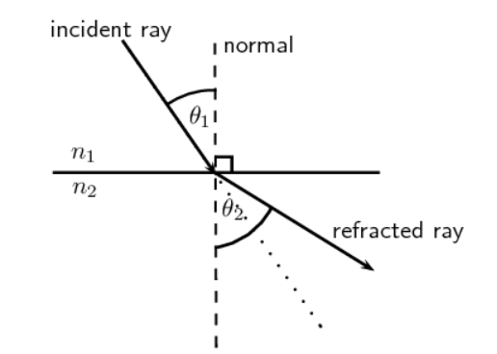
Figure 1: Diagram of the refraction of a ray of light from material 1 to material 2.

Snell's law states that, for a given pair of media, the ratio of the sines of the angle of incidence θ₁ and angle of refraction θ₂ is equal to the ratio of phase velocities (v₁ / v₂) in the two media, or equivalently, to the refractive indices (n₂ / n₁) of the two media:

$\frac{sinθ_{1}}{sinθ_{2}}= \frac{v_{1}}{v_{2}} = \frac{n_{2}}{n_{1}}$ (2)

Procedure

- Enter the Snell’s Law laboratory and click the Access option.
- Choose the Solid Lens option.
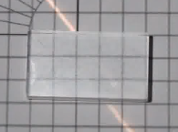
- Consider the solid block 2.9 squares high. Use the square grid and trigonometry to approximate the angle of refraction by counting how many squares to the right the light exits the block compared to where it enters. Example:

Light path
2.9 squares
Approximately 1.4 squares across
θ₂
In this case, the angle of refraction:
$$θ_{2}= arctan(\frac{1.4}{2.9}) = {25.8}^{o}$$

- Repeat the calculation for different angles (five different angles of your choice) and for each of them calculate the refractive index of the block using Snell’s Law (2) (n_{air} = 1):

Table 1: Results obtained from the diffraction angle by measuring the number of squares for different angles of a solid lens.
$$θ_{1}$$ | $$θ_{2}$$ | $$n_{2}=\frac{n_{1}sin θ_{1} }{sin θ_{2} }$$

- Go back and repeat the process for the Water-filled Lens. Consider the water block 6.9 squares high.

Table 2: Results obtained from the diffraction angle by measuring the number of squares for different angles of a water lens.
$$θ_{1}$$ | $$θ_{2}$$ | $$n_{2}=\frac{n_{1}sin θ_{1} }{sin θ_{2} }$$

- As you probably noticed, the values you obtained for each angle are different due to the measurement error. Use the average of the values calculated before as the refractive index of the material. (Optional: calculate the standard deviation.)
n_{solid} =
n_{water} =

- Verify your results by using Snell’s Law (2) to calculate the expected angle of refraction for an angle you have not used before and compare it with the measurements in the Verification tab (click Show diagram with data). Do it for two angles for each lens type.

Table 3: Results obtained from the diffraction angle by measuring the number of squares for different angles of a water and solid lens and comparing them with the laboratory verification mode.
Lens type | $$θ_{1}$$ | $$θ_{2}=arcsin(\frac{n_{1}sin θ_{1} }{n_{2}})$$ | Measured $θ_{2}$ | Difference
Solid
Water

Questions

- Are the calculated and the measured angles similar?
- The real value of the refractive index of water is 1.333. How close is the value you calculated to the real value? (Give the difference as a percentage).

- Find a list of the refractive indices (the Solids at Room Temperature section of the table at https://en.wikipedia.org/wiki/List_of_refractive_indices, for example). According to the refractive index you calculated for the solid lens, what could it be made of? How close is the value you calculated to the real value? (Give the difference as a percentage).

- Calculate the speed of light through both materials. How much slower does light travel through them compared to vacuum?

- Until now, we have only been focusing on the first boundary between the air and the material. However, the light travels through two of such boundaries in this experiment. There is an angle that we have not talked about yet: the angle at which the beam of light exits the material. Use Snell’s Law (2) to prove that the emergent angle is always the same as the initial incidence angle.

- As you have already seen, there are measurement errors that affect the accuracy of the results. What could we do to increase that accuracy?

- Write your conclusions briefly.

