

EXPERIENCE: BOYLE’S LAW

Content

Objective of the document 3
Learning objectives 3
Pre-requisites 3
Approximate time 3
Boyle’s Law 3
Development of the experiment 4
Results analysis 6
Questions 8

Objective of the document
The aim of this document is to provide a guide to conducting Boyle's experiment.

Learning objectives
To know Boyle's law, which establishes a relationship between the pressure and volume of a gas by keeping the temperature and the amount of substance constant.

Pre-requisites
To know the concepts of pressure and volume.

Approximate time
The experiment is estimated to require 30-50 minutes.

Boyle’s Law
Boyle's law is commonly studied in physics and chemistry and allows the behaviour of gases to be analysed.
This law allows the pressure of a gas to be compared to its volume when other parameters such as temperature and the amount of substance are kept constant.
Mathematically it can be expressed as:
$P×V=k$ (Equation 1)
Where k is constant if the temperature remains constant.
There are several ways to verify the fulfilment of Boyle's law. In this experiment it will be shown that, for a given quantity of gas, the pressure is inversely proportional to the volume. In other words, as the volume of gas decreases, the pressure increases.

This can be seen in the following relationship:
$P_{1}×V_{1}=P_{2}×V_{2}$ (Equation 2)
If the initial volume of gas is 20 mL and during the experiment the pressure varies from 85 kPa to 120 kPa, what would be the final volume?
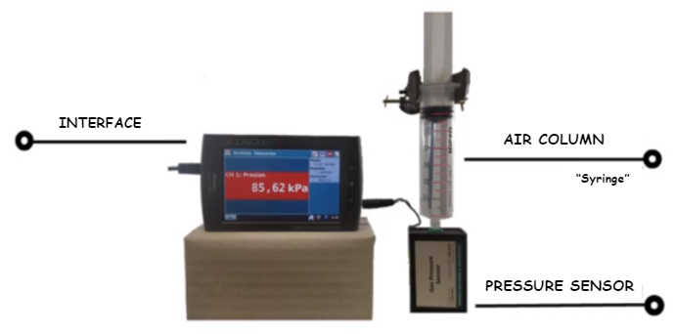
This experiment uses an air column containing nitrogen coupled to a pressure sensor. It also uses an interface where the pressure value is observed. The experiment is carried out at a constant room temperature (25°C), so an isotherm will be obtained in the graphical analysis.
Figure 1

Development of the experiment
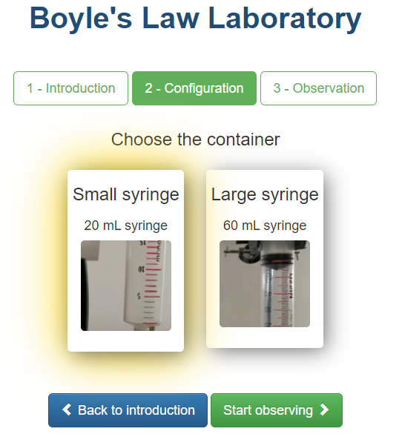
After entering the laboratory, you can choose between two syringes: 20 or 60 mL.
Figure 2

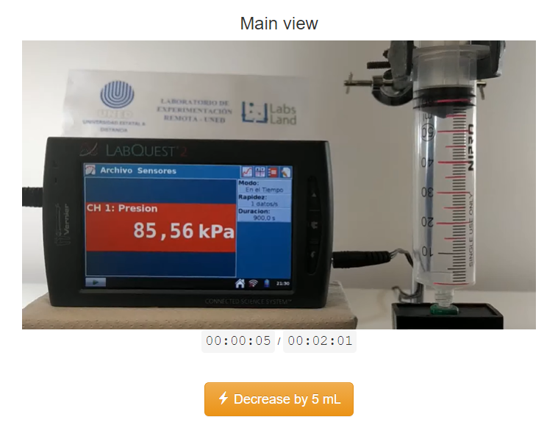
After setting up the experiment, the observation stage starts. If, for example, the 60 mL syringe is selected, the following will appear on the display:
Figure 3
The initial volume of gas is determined by the size of the chosen syringe (in this case 60 mL). The initial pressure value is shown on the display (in this case 85.93 kPa). When you perform this step, write down the value obtained in your notebook.
Pressing the Decrease button by 5 mL decreases the volume by 5 mL. Because of the relationship between volume and pressure, decreasing the volume will increase the pressure. This change in pressure can be seen in the values shown on the display. This new pressure value should also be recorded in a notebook.
The step of decreasing the volume is carried out until a final value of 20 mL is reached. At each step, the volume and pressure data obtained are recorded.
When the volume of 20 mL is reached, the pressure can be released by pressing the Release Pressure button, which causes the volume to increase to the initial value (60 mL). Due to the relationship between pressure and volume, as the volume increases the pressure will decrease.
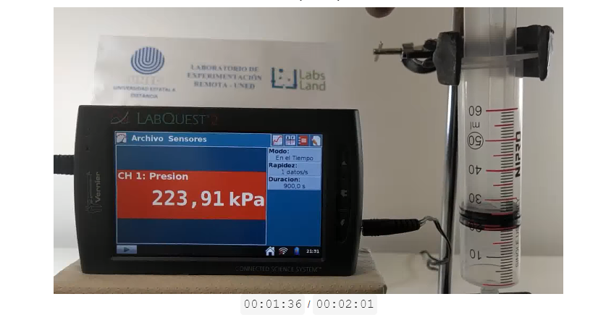
Figure 4

Results analysis
Make a table with the volume values and the corresponding pressure values obtained during the experiment.
Volume | Pressure
60 mL | 85,93
55 mL | 93,71
50 mL | 102,73
45 mL | 115,35
40 mL | 128,77
35 mL | 148,84
30 mL | 170,32
25 mL | 204,38
20 mL | 223,91
Table 1: Volume and pressure data
From the data in the table, make a graph plotting pressure versus volume (kPa vs mL) and another plotting pressure as a function of the inverse of volume (kPa vs 1/mL).

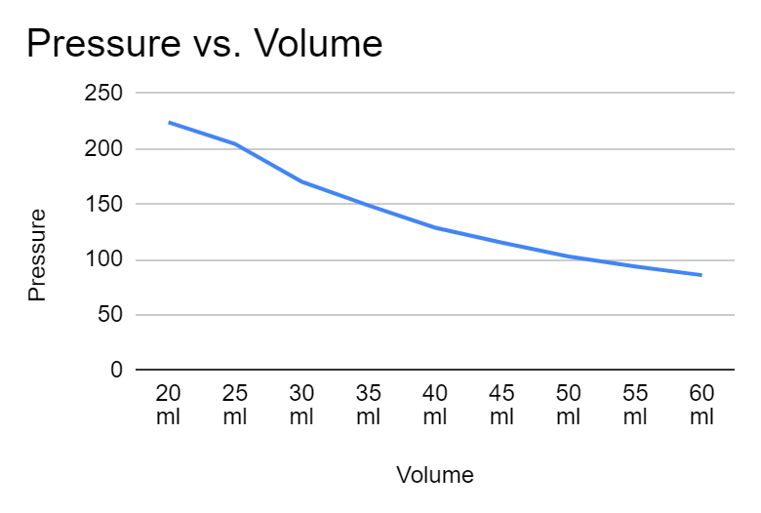
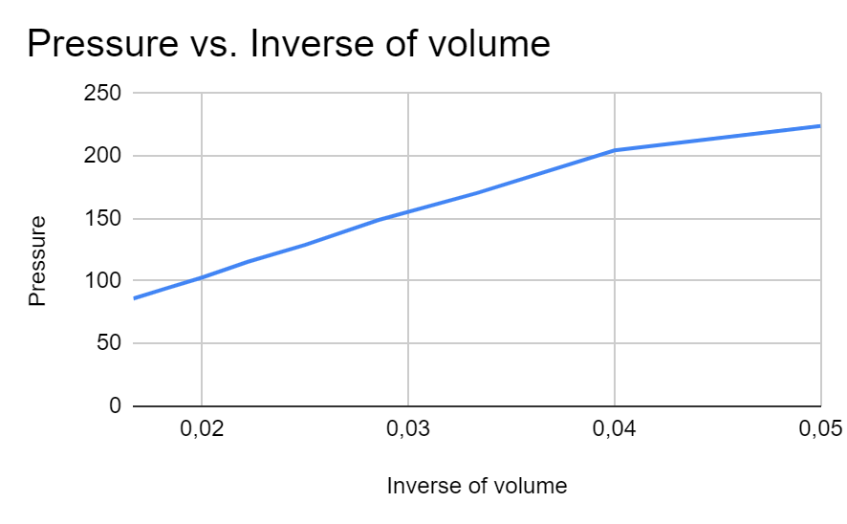
Graph 1: Pressure versus volume
Graph 2: Pressure versus inverse of volume

Questions
- Before conducting the experiment, what do you think will happen to the pressure if the volume of gas in the syringe decreases? Make a hypothesis. After conducting the experiment, compare your hypothesis with the results obtained.
Answer and justification:
As the volume of gas in the syringe decreases, the molecules will move closer together, causing the pressure to increase.

- How would you describe the relationship between the change in pressure and the change in volume of a gas?
Answer and justification:
I would describe the relationship as an inverse relationship, since as the pressure increases the volume decreases and vice versa.

- If you double the volume of a gas while keeping the temperature constant, what happens to the pressure?
Answer and justification:
If the volume is doubled, the pressure is reduced by half. This is because pressure and volume are inversely proportional to each other.

- What is the independent variable in this experiment? What is the dependent variable?
Answer and justification:
The independent variable is the variable that the operator controls. The dependent variable is the variable that changes as a function of the variation of the independent variable.
In the graph, the independent variable is represented on the abscissa axis (x-axis) and the dependent variable on the ordinary axis (y-axis).

- What are the control variables and how much are they worth?
Answer and justification:
Control variables are those variables that must be controlled during the experiment so that they remain constant. In this case they are the temperature and the amount of substance. The temperature is 25ºC and the amount of substance (moles) can be calculated with the ideal gas law.

- What kind of graphs are obtained, what is the advantage of each of them?
Two types of graphs can be obtained:
- Pressure versus volume (kPa vs mL). A hyperbola is obtained, where the pressure decreases as the volume increases.
Pressure
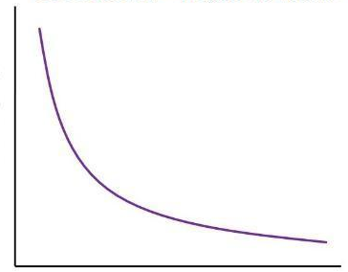
Volume
Graph 3: Pressure versus volume
- Pressure versus inverse of volume (kPa vs 1/mL). A straight line is obtained, the slope of which gives the value of k.
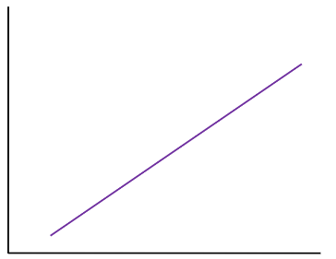
Pressure
1/Volume
Graph 4: Pressure versus inverse of volume

- Could the experiment have been performed by measuring the values in other units? If so, in which ones?

Answer:
Pressure can be expressed in kiloPascal (kPa) (as is done in this experiment) but can also be measured in Bars (bar), in Atmospheres (atm), in kg/cm2, in cm w.c. (millimetres column of water), in mmhg (millimetres column of mercury), and in PSI (pounds per square inch).

Volume can also be measured in cubic metres.

