
EXPERIENCE: GAY-LUSSAC’S LAW
(ANSWER)

Index

Objective of the document 3
Learning objectives 3
Pre-requisites 3
Approximate time 3
Gay-Lussac’s law 3
Development of the experiment 4
Questions 4
Exercises 7

Objective of the document
The aim of this document is to provide a guide to develop the Gay-Lussac`s experiment.

Learning objectives
Study the behavior of gasses. Relating the pressure of the gas and the temperature, while keeping constant other parameters such as volume or the amount of substance.

Pre-requisites
- To know the general characteristics of gasses.
- Know the basic concepts such as pressure, temperature, volume... and know how to define them.

Approximate time
The experiment is estimated to last between 30 and 40 minutes.

Gay- Lussac’s law
This law is named after the French chemist and physicist Joseph Gay-Lussac. Gay-Lussac formulated it in the early 1800s, but it was actually a formal statement of the relationship between temperature and pressure described by the French physicist Guillaume Amonton in the late 17th century.
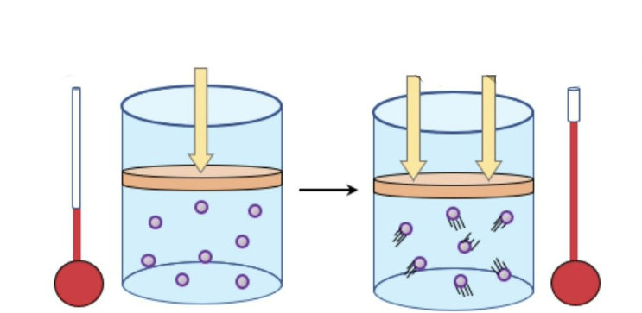
Gay-Lussac's law states, that the absolute temperature and pressure of an ideal gas are directly proportional, under conditions of constant mass and volume. This means that, when we increase the temperature of a gas, which is in a sealed container, it will cause an increase of his pressure, while cooling it down will cause its pressure to decrease. The reason for this is the thermal kinetic energy generated by the temperature; therefore, as the temperature increases the speed of the molecules increases, causing them to collide more frequently against the walls of the container; this will be considered as an increase in pressure.
P₁ < P₂
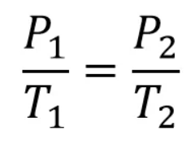

Figure 1: Representation of the increase in pressure with increasing temperature
Formula of Gay-Lussac

Development of the experiment
For this experiment, a closed Erlenmeyer flask is filled with ethanol at 0.014 moles. This Erlenmeyer flask is suspended over a precipitation beaker with tempered water inside, which is heated by a heating plate. The container with ethanol is heated in a water bath, which will gradually increase the temperature of the ethanol. To measure the temperature and pressure, a sensor has been added to the system to see the changes in the ethanol.
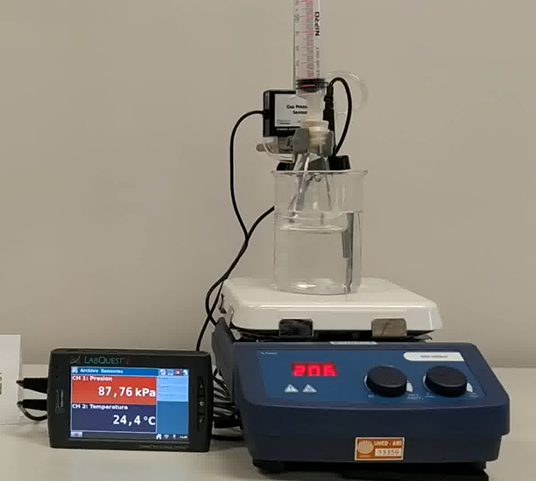

Erlenmeyer with ethanol

Precipitation beaker with temperated water

Heating plate
Temperature and pressure measuring system
Experiment setup

Questions
- Taking into account theory, why should an aerosol not be stored in hot conditions? What would happen if they were disposed of by burning them?
Storing them in hot conditions or at an elevated temperature will cause the pressure of the gas inside to increase. This could cause the can to burst. As the heat increases, they will explode.
- Why shouldn't a car's tire pressure be measured in hot conditions? What will happen to the tyre pressure when it is cold?
Tire pressure drops and rises depending on whether it is a hot or cold day. If a tire pressure measurement on a hot day indicates that the tires are at an adequate pressure, the tires will deflate in cold weather.
Conversely, if too much air is introduced on a cold day, the tires may become overinflated on subsequent normal temperature days.
- Name another everyday example where Gay-Lussac's law could be applied.
Another common example where Gay-Lussac's law could be used is the pressure cooker. Applying heat increases the pressure inside the vessel and this causes the boiling point of the water to shorten; shortening the cooking or boiling times. Also, as the vessel is sealed the flavours are not lost in the air with steam.
- In the experiment performed, what is the controlled variable? What gas is used?
The controlled variable is the constant volume. The gas used is ethanol at 0.014 moles.
- Create a graph from the data obtained in the above experiment. What is the relationship between temperature and pressure?
TABLE 1:

Gay-Lussac`s law
Time (min) | Temperature (ºC) | Pressure  (KPa)
0 | 24.2 | 87.76
0,30 | 25.5 | 88.15
1 | 26.7 | 88.53
1,30 | 28.9 | 89.18
2 | 31.2 | 90.27
2,30 | 34.3 | 91.36
3 | 37.6 | 92.84

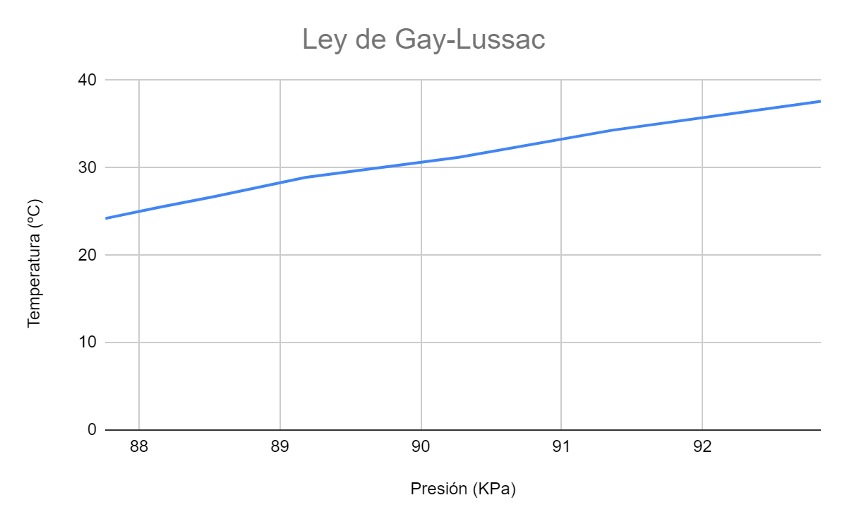

Looking at the graph we can say that the relationship between temperature and pressure is directly proportional. This means that as the temperature increases, the pressure will increase.

Exercises: We will see the 4 most common types of exercises applied to this physical law.
- In this type of exercise, the question asked is: What is the final temperature of the gas after an increase or decrease in pressure?
A gas at a pressure of 2000 mmHg and a temperature of 100°C is compressed to 10.000 mmHg. What will be the final temperature of this gas?

Answer and justification:
From the formula P₁/T₁ = P₂/T₂, the final temperature can be taken away. The equation becomes T₂=(P₂-T₁)/P₁.
*It should be noted that the temperature in Celsius is never used in the exercises. We always use Kelvin. Therefore the initial temperature will be 100º C + 273 K = 373 K
T₂= (10.000mm Hg - 373 K)/2.000 mmHg = 1865 K
The final temperature in Celsius will be 1865 - 273 = 1592 ºC.

- Ein this type of exercise the question asked is: What is the final pressure of the gas?
A gas is at a pressure of 25 atmospheres and a temperature of 500 K. What will the pressure be if the temperature is increased to 1400 K?

Answer and justification:
The first step will be to state the Gay-Lussac`s equation. P₁/T₁ = P₂/T₂, clearing the final pressure from it. (P₂ = P₁-T₂)/T₁
P₂= (25 atm - 1400 K)/ 500 K = 70 atm

- In this type of exercise, the question asked is: What is the initial pressure of the gas?
A gas is at a temperature of 900 K when it is cooled to 400 K, at this temperature its pressure is 100 psi. What was the initial pressure?

Answer and justification:
The first step is to state the Gay-Lussac´s equation. P₁/T₁ = P₂/T₂, clearing the initial pressure from it. (P₁ = P₂-T₂)/T₂
P₁= (100 psi - 900 K)/400 K= 225 psi

- Finally, we will calculate the initial temperature of the gas.
A gas at a pressure of 20 bar and an unknown initial temperature is heated to 850 K, at this temperature its pressure is 85 bar. What was the initial temperature?

Answer and justification:
The first step will be to state the Gay-Lussac`s equation P₁/T₁ = P₂/T₂, clearing the initial temperature from it. T₁=(P₁-T₂)/P₂
T₁= (20 bar - 850 K)/ 85 bar = 200 K

