




KNOWLEDGE AREA:
MATTER AND MATERIALS

FORMAL ASSESSMENT:
HEATING AND COOLING CURVE OF WATER

Content

Aim of the experiment 3
Pre-requisites 3
Duration 3
Learning objectives 3
Apparatus to be used 3
Theory 4
Method 5
Results and analysis 6
Conclusion for this experiment 13

Aim of the experiment
To investigate the phase change of water at high heating, low heating and the cooling curve of hot water.

Pre-requisites
In order to carry out this activity correctly, the teacher might first explain a series of concepts:
- What a state of matter is.
- What a gradient of a graph is.
- What are the apparatus to be used and how do they contribute to the experiment.

Duration
To carry out this activity, a dedication of a single 60 minutes session is suggested.

Learning objectives
With these experiment the student will learn:
- The characteristics of each state of matter: solid, liquid and gas.
- Three changes of matter state: boiling point, melting point and freezing point.
- How to calculate the gradient of a graph.

Apparatus to be used

- Two video cameras with tripod stands.
- Beaker.
- Crushed ice.
- Hot plate/ Bunsen burner.
- Thermometer.
- Retort Stand and clamp.

Theory

Matter exists in one of these three states: solid, liquid and gas. A solid has a fixed shape and volume. A liquid takes on the shape of the container that it is in. A gas completely fills the container that it is in.

Matter can change between these states by either adding heat or removing heat; this is known as a change of state. As we heat an object (e.g. water) it goes from a solid to a liquid to a gas. As we cool an object it goes from a gas to a liquid to a solid.

The changes of state that you should know are:
- Melting point
The temperature at which a solid changes its phase or state to become a liquid. The process is called melting.
- Freezing point
The temperature at which a liquid changes its phase to become a solid. The process is called freezing.
- Boiling point
The temperature at which a liquid changes its phase to become a gas. The process is called evaporation

If we know the melting and boiling point of a substance then we can say what state (solid, liquid or gas) it will be in at any temperature.

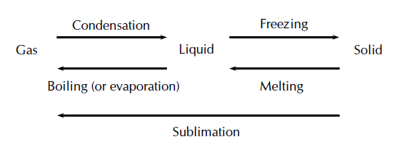
Figure 1: Phase changes in matter

Method

A prerecorded video was conducted using two cameras, 1st camera was focused on the “beaker with ice screen” the 2nd camera was on the thermometer screen. The following steps were followed in setting up the perspectives on both screens.

Heating at high heat
- A mass of ice was placed in a beaker.
- A thermometer was placed inside the ice oriented towards the “perspective screen of the thermometer” and held firmly.
- A hot spot was used as a heat source, heating the ice beaker to maximum temperature.
- The thermometer we had previously placed inside recorded the temperature as the phase change took place.
- Another camera was used to capture this display simultaneously with the perspective of the thermometer.

Heating at low heat
The same method mentioned above was employed adjusting the heat to low.

Cooling of water
- A beaker with hot water was inserted inside a tub of ice bath. This is visible through a camera..
- Simultaneously, a thermometer was inserted inside the hot water beaker and arranged. “thermometer perspective” is captured through another camera.
- Water is allowed to cool.

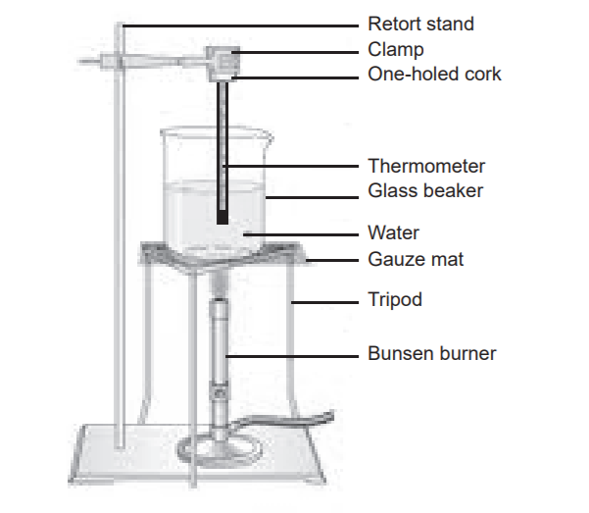

Figure 2: Pictorial representation of heating of water set up

Results and analysis

- Draw a table and record your results as follows:

TABLE 1: Heating at high heat

HEATING OF ICE
Time(min) | Temperature (in ͦ C) | Phase of matter
0
2
4
6
etc.

TABLE 2: Heating at low heat

HEATING OF ICE
Time(min) | Temperature (in ͦ C) | Phase of matter
0
2
4
6
etc.

TABLE 3: Cooling of water

COOLING OF WATER
Time(min) | Temperature (in ͦ C)
0
2
4
6
etc.

- Plot a graph of time (independent variable, x-axis) against temperature (dependent variable, y-axis) for the cooling of water and the boiling water.

Cooling water: time vs temperature graph

Heating water at high heat: time vs temperature graph

Heating water at low heat: time vs temperature graph

- What was the controlled variable in this experiment?
Answer and justification:

- During which time interval is the water boiling?
Answer and justification:

- The gradient of the graph measures the change in temperature per minute (or the rate of change in temperature). Write down a formula that can be used to determine the gradient of a graph.
Formula:

- Calculate the gradient of the graph for these time intervals. Show the relevant points that you used for these calculations on the graph.
  - While water is warming up from its melting point to its boiling point.
Calculations:

  - While the water is boiling.
Calculations:

- Describe the shape of the cooling curve of water.
Description:

- What does the shape of this curve tell us about the rate at which water cools down? Explain briefly.
Brief explanation:

Conclusion for this experiment

Conclusion:

