

EXPERIENCE: SIMPLE FREE FALL

Rev: 1.2 (January/2020)
Authors: Javier Garcia Zubía (zubia@labsland.com)
Unai Hernández (unai@labsland.com)
Luis Rodríguez Gil (luis@labsland.com)

Contents

OBJECTIVES 3
LEARNING OUTCOMES 3
DOCUMENT STRUCTURE 3
Introduction 4
Experiment development and theory 5
Taking measurements and graphing the experiment 6
Analysis of experimental results and evaluation 10
Comments to the teacher 13

OBJECTIVES
The objectives to develop during this experiment are:
- To understand the free fall of an object.
- To understand the concept of linear and non-linear.
- To understand and observe the behaviour of the variables in an experiment.
LEARNING OUTCOMES
Thanks to this experiment, the student will be able to:
- Analyse the behaviour of the fall of an object.
- Characterise and measure in a non-linear experiment.
- Calculate the g constant.
- Organise the experimental work.
- Begin to become familiar with the scientific method.
- Take data and represent them graphically.
- Analyse data and draw conclusions.
DOCUMENT STRUCTURE
This document is structured in the following way:
- Introduction. Page 4.
- The experiment. Page 5.
- Taking measurements and graphing the experiment. Page 6 .
- Evaluation and open questions. Page 9.
- Comments for the teacher. Page 11

Introduction
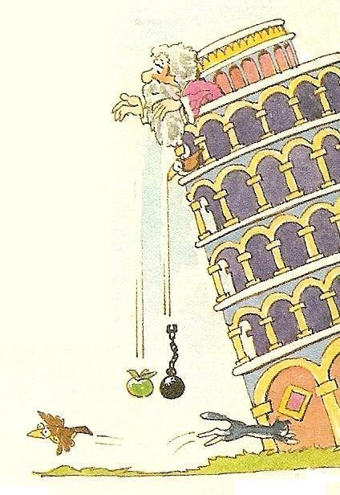
Galileo lived between the 16th and 17th centuries and he has an eminent place among scientists not only for his discoveries but also for the way he demonstrated or explained them. Galileo used and exalted the scientific method together with mathematics. He conducted experiments, measured variables and then analysed the results.
Aristotle, in the 4th century BC, theorised about the behaviour of Nature, devoting part of his work to motion. One of his proposals was that an object fell faster if its mass was greater. Thus, according to him, a stone would fall before a rag ball and a cannonball before a bird's feather.

Galileo agreed with Aristotle's approach, but said that an experiment was needed to prove it. Since Galileo lived in Pisa, he saw that the leaning tower of this city was a perfect place to complete an experiment that would scientifically confirm this. He climbed the tower, threw two different objects and then measured the time it took to fall. That was the hard part for him. He found that this time was identical in both cases, but he thought he had done something wrong and he repeated it. However, the same thing happened: different objects were giving the same fall times. What was going on?
He then spent time on objects falling down in inclined planes, because these allowed him to measure the time better. In these experiments he found results that confirmed his theories, but he also found others that did not.
Would you like to do some research on falling objects?

Experiment development and theory

The experiment is quite simple: place an object on a plane, incline it a few degrees, throw the object and measure the time it takes to fall down the plane. The experiment has several sensors that indicate how much time has passed from the moment the object starts to fall until it passes in front of each sensor.
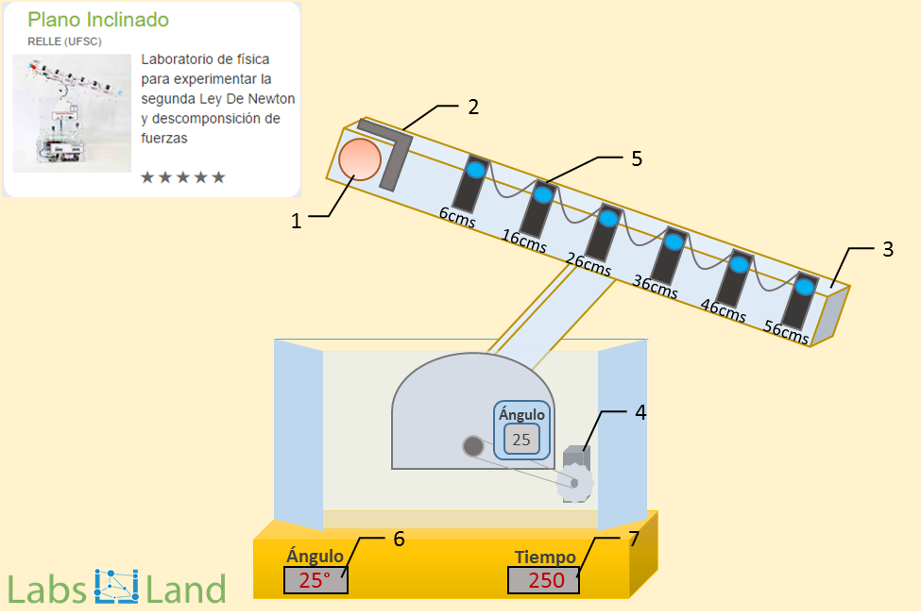

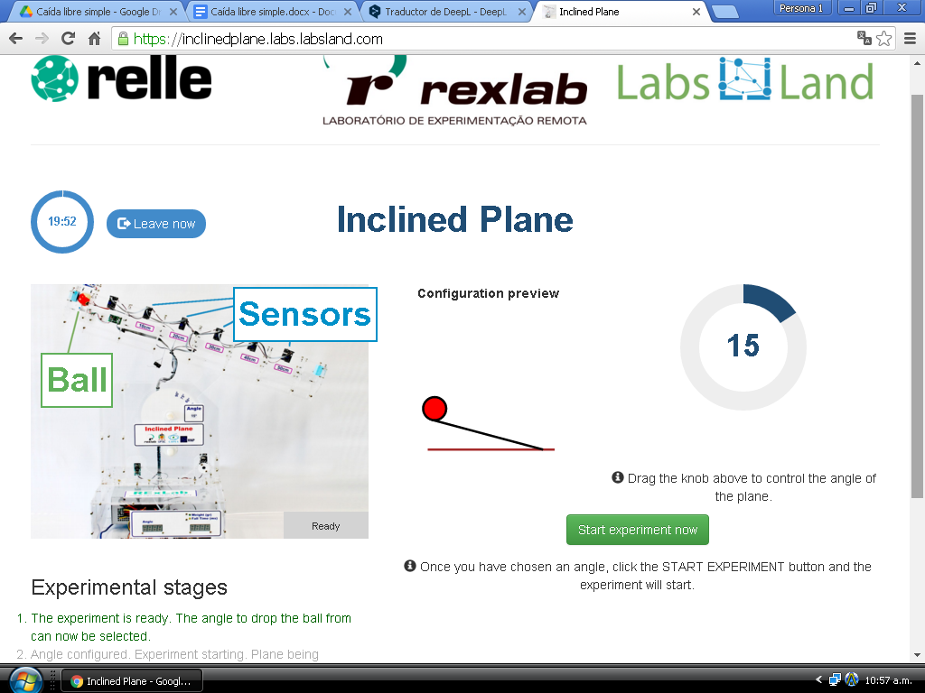
On the other hand, physics tells us that for a Uniformly Accelerated Rectilinear Motion (UARM) the space travelled by an object when it is released is:
$h=e\left(t\right)=\frac{1}{2}·a·t^{2}$
Where a is the acceleration that the object supports when it is released. In Galileo's case the object was released and attracted by the force of gravity, which accelerates the object with a value g. How much is g? Let's calculate g and draw further conclusions.
Taking measurements and graphing the experiment

Measuring the free fall of an object and calculating the acceleration g.
The inclined plane can be used to make a free fall. For this, it is simply necessary to position the inclined plane at an angle of 90°. In this configuration the ball can be considered to have no rolling friction, and is therefore a free fall.
We launch the object and note the results. In this case we are going to repeat the experiment three times to try to mitigate errors in the experiment. In class, each group of students can do one experiment and then share the results with each other. Also, if one result differs a lot from the others, then its results could be eliminated. The data must be analysed.
The sensors are at six distances measured in centimetres: 6, 16, 26, 36, 46 and 56 cm.

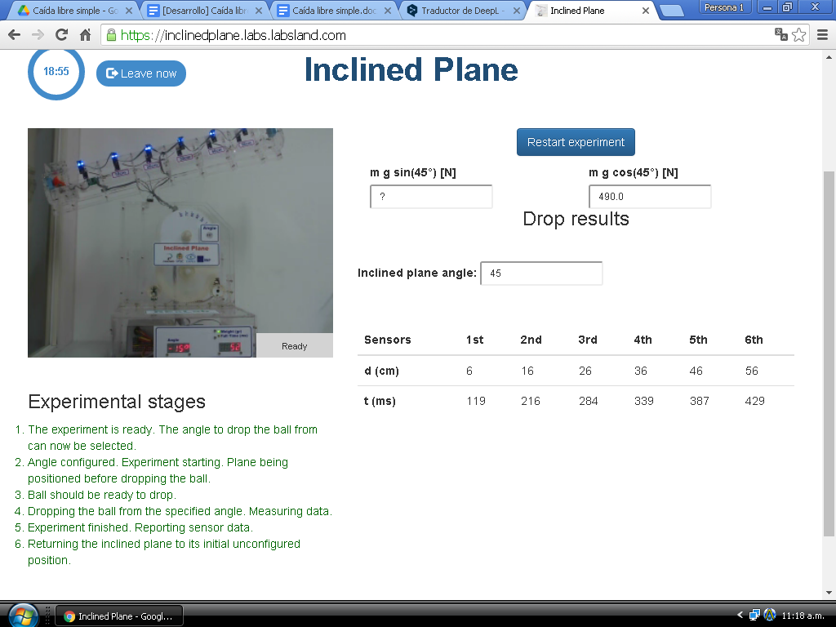

Time at each distance | 0 cm | 6 cm | 16 cm | 26 cm | 36 cm | 46 cm | 56 cm
Experiment 1 | 0 ms | 71 ms | 158 ms | 220 ms | 267 ms | 306 ms | 340 ms
Experiment 2 | 0 ms | 72 ms | 158 ms | 219 ms | 265 ms | 304 ms | 338 ms
Experiment 3 | 0 ms | 78 ms | 163 ms | 224 ms | 270 ms | 309 ms | 343 ms
Media | 0 ms | 73,67 ms | 159,66 ms | 221 ms | 267,33 ms | 306,33 ms | 340,33 ms

At this point, to analyse the above data, the problem can be approached mathematically, by the formula or graphically. Let's do it the second way.
Dist. in m | t in s | $t^{2}$ in s²
0 | 0 | 0
0,06 | 0,07367 | 0,00542727
0,16 | 0,15966 | 0,02549132
0,26 | 0,221 | 0,048841
0,36 | 0,26733 | 0,07146533
0,46 | 0,30633 | 0,09383807
0,56 | 0,34033 | 0,11582451

The above data can be graphed as distance vs time, or maybe better still distance vs time squared. In this way we see that the relationship is linear which allows us to reaffirm what has already been said with the formula, that distance is linear with the square of time

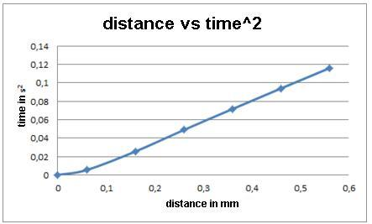
What is the slope of the above line? Considering the straight line with respect to t², then:
$slope=\frac{∆e}{∆t}=\frac{0,56-0,06}{0,1158-0,0054}=4,53 m/s^{2}$
Taking the formula back and bearing in mind that in free fall the acceleration is g:
$h=e\left(t\right)=\frac{1}{2}·a·t^{2}, so g=2x\frac{∆e}{∆t^{2}}$
$g=2x\frac{0,56-0,06}{0,1158-0,0054}=9,06 m/s^{2}$
However, if we take the full table, from o cm and 0 s, then

$g=2x\frac{0,56-0}{0,1158}=9,67 m/s^{2}$
The result is good and is close to the theoretical 9.81 m/s² in both cases..

Analysis of experimental results and evaluation

- Complete your table, draw your graph, and get the value of g.
Time\Distance | 0 cm | 6 cm | 16 cm | 26 cm | 36 cm | 46 cm | 56 cm
Experiment 1 | 0 ms
Experiment 2 | 0 ms
Experiment 3 | 0 ms
Media | 0 ms
t² | 0 ms

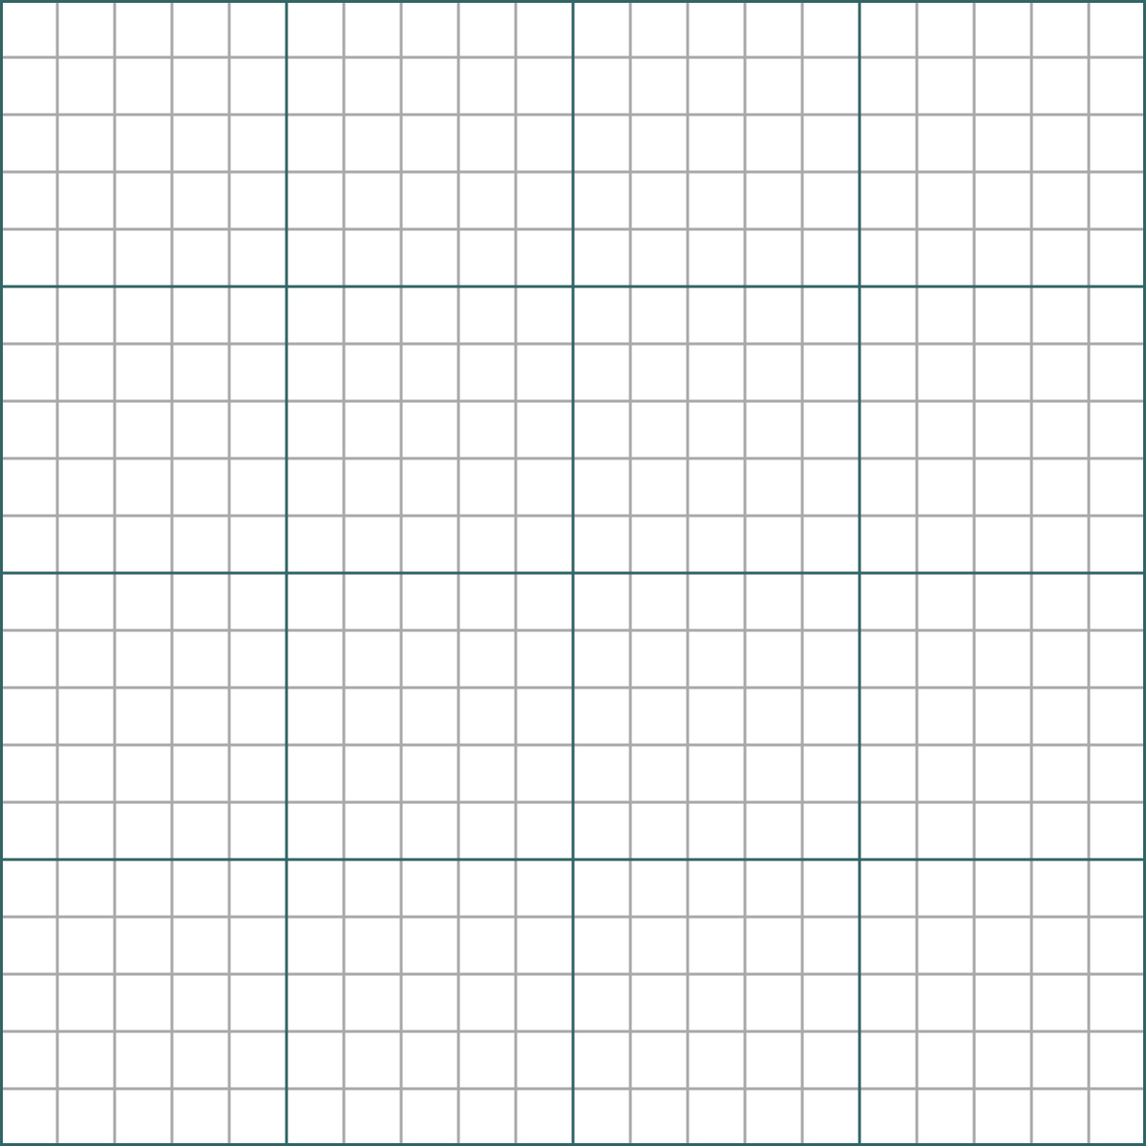
Does the value obtained look like the theoretical value of 9.81 m/s²?

- Write down the value obtained by at least four of your classmates and discuss the results together. Is it the same value? How much more or how much less? What is the average value of g? If you use the whole class, what will happen to the value of g?

 | g  (yours) | g  (classmate 1) | g  (classmate 2) | g  (classmate 3) | g  (classmate. 4) | g  (classmate. 5)
Value
Error

Total average value:
Answer and justification:

- If the ball has taken 0.340 seconds to fall 56 centimetres, how long will it take to fall 112 centimetres? Does it take approximately twice as long?

Answer and justification:

- As you can see, in none of the previous activities has the mass appeared. Does the velocity of an object or the acceleration g depend on the mass of the object in question?
Watch the following video: https://youtu.be/E43-CfukEgs Is this video real or fake? Do you believe it?
In a survey, when asked the question: which falls first, a baseball or a marble? 90% said baseball, 10% said both at the same time, and no one said the marble fell first. Which group do you place yourself in?

Comments to the teacher

The data obtained by me are.

Time at each distance | 0 cm | 6 cm | 16 cm | 26 cm | 36 cm | 46 cm | 56 cm
Experiment 1 | 0 ms | 71 ms | 158 ms | 220 ms | 267 ms | 306 ms | 340 ms
Experiment 2 | 0 ms | 72 ms | 158 ms | 219 ms | 265 ms | 304 ms | 338 ms
Experiment 3 | 0 ms | 78 ms | 163 ms | 224 ms | 270 ms | 309 ms | 343 ms
Media | 0 ms | 73,67 ms | 159,66 ms | 221 ms | 267,33 ms | 306,33 ms | 340,33 ms
t² in seconds | 0 | 0,00544054 | 0,02549132 | 0,048841 | 0,07146533 | 0,09383807 | 0,11582451

If we draw distance in cm versus time in seconds.
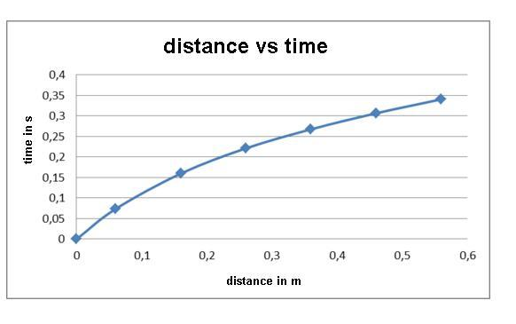
If we draw the distance versus time squared, we see that the relationship is linear.
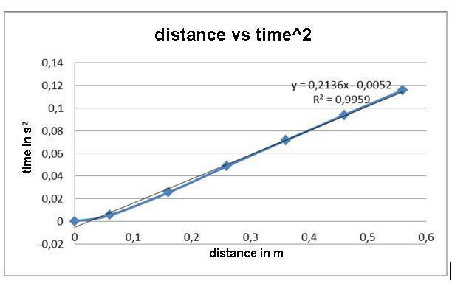
According to this
$slope=\frac{0,56-0}{0,11582}=4,835 m/s^{2}$
Therefore g is 9.67 m/s², which is very close to the ideal value of 9.81 m/s².

$g=2·slope=9,67 m/s^{2}$
The value of g has been obtained by calculating the incremental quotient of all the values, but one also could have used only the last ones, or any subset of them.

$g=slope·2=\frac{0,56-0,46}{0,11582-0,093838}·2=9,0983 m/s^{2}$
This value of 9.0983 m/s² is still further away from the ideal of 9.81 m/s².
As a complement to the video, it may be interesting to work with the virtual (not real) laboratory accessible at:
http://go-lab.gw.utwente.nl/production/gravityDrop/build/gravityDrop.html?preview

