

EXPERIENCE: COMPLETE FREEFALL

Rev: 1.0 (July /2019)
Authors: Javier Garcia Zubía (zubia@labsland.com)
Unai Hernández (unai@labsland.com)
Luis Rodríguez Gil (luis@labsland.com)

Contents

OBJECTIVES 3
LEARNING OUTCOMES 3
DOCUMENT STRUCTURE 3
Introduction 4
Experiment development and theory 5
Taking measurements and graphing the experiment. 6
Analysis of experimental results and evaluation 9
Comments to the teacher 13

OBJECTIVES
The objectives to develop during this experiment are:
- To understand the free fall of an object.
- To understand the concept of linear and non-linear.
- To understand and observe the behaviour of the variables in an experiment.
LEARNING OUTCOMES
Thanks to this experiment, the student will be able to:
- Analyse the behaviour of the fall of an object.
- Characterise and measure in a non-linear experiment.
- Calculate the g constant.
- Organise the experimental work.
- Begin to become familiar with the scientific method.
- Take data and represent them graphically.
- Analyse data and draw conclusions.

DOCUMENT STRUCTURE
OCThis document is structured in the following way:

- Introduction. Page 4.
- The experiment. Page 5..
- Taking measurements and graphing the experiment. Page 6.
- Evaluation and open questions. Page 9.
- Comments for the teacher. Page 13.

Introduction

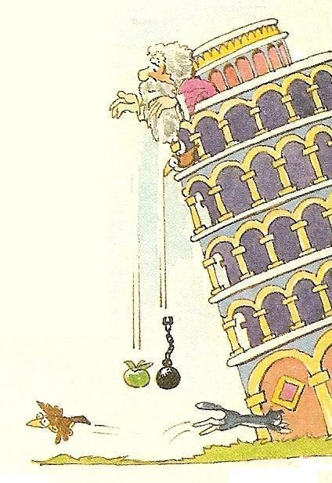
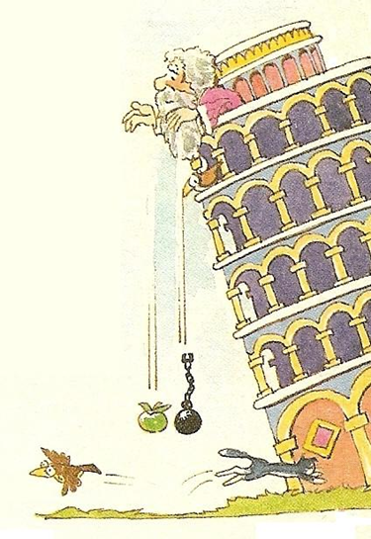
Galileo lived between the 16th and 17th centuries and he has an eminent place among scientists not only for his discoveries but also for the way he demonstrated or explained them. Galileo used and exalted the scientific method together with mathematics. He conducted experiments, measured variables and then analysed the results.
Aristotle, in the 4th century BC, theorised about the behaviour of Nature, devoting part of his work to motion. One of his proposals was that an object fell faster if its mass was greater. Thus, according to him, a stone would fall before a rag ball and a cannonball before a bird's feather.

Galileo agreed with Aristotle's approach, but said that an experiment was needed to prove it. Since Galileo lived in Pisa, he saw that the leaning tower of this city was a perfect place to complete an experiment that would scientifically confirm this. He climbed the tower, threw two different objects and then measured the time it took to fall. That was the hard part for him. He found that this time was identical in both cases, but he thought he had done something wrong and he repeated it. However, the same thing happened: different objects were giving the same fall times. What was going on?
He then spent time on objects falling down in inclined planes, because these allowed him to measure the time better. In these experiments he found results that confirmed his theories, but he also found others that did not.
Would you like to do some research on falling objects?

Experiment development and theory

The experiment is quite simple: place an object on a plane, incline it a few degrees, throw the object and measure the time it takes to fall down the plane. The experiment has several sensors so that it indicates how much time has passed from when the object starts to fall until it passes in front of each sensor.
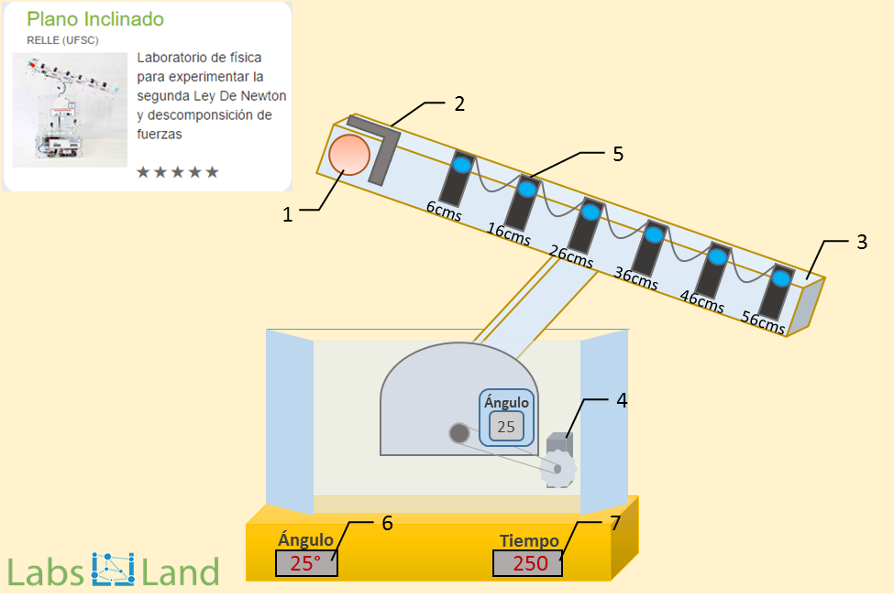
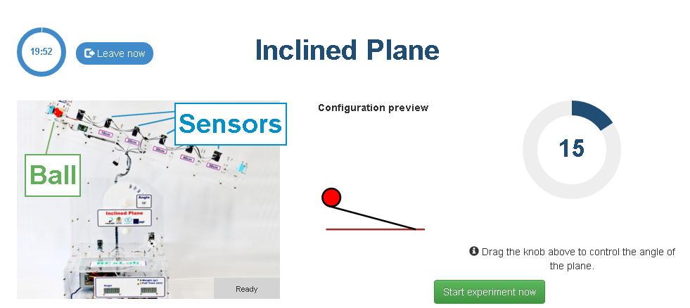
On the other hand, physics tells us that for a Uniformly Accelerated Rectilinear Motion (UARM) the space travelled by an object when it is released is:
$h=e\left(t\right)=\frac{1}{2}·a·t^{2}$
Where a is the acceleration that the object supports when it is released. In Galileo's case the object was released and attracted by the force of gravity, which accelerates the object with a value g. How much is g? Let's calculate g and draw further conclusions.
Taking measurements and graphing the experiment.

Measuring the free fall of an object and calculating the acceleration g.
The inclined plane can be used to make a free fall. For this, it is simply necessary to position the inclined plane at an angle of 90°. In this configuration the ball can be considered to have no rolling friction, and is therefore a free fall.
We launch the object and note the results. In this case we are going to repeat the experiment three times to try to mitigate the errors in the experiment. In class, each group of students can do one experiment and then share the results with each other. Also, if one result differs a lot from the others, then its results can be eliminated. The data must be analysed.
The sensors are at six distances measured in centimetres: 6, 16, 26, 36, 46 and 56 cm.
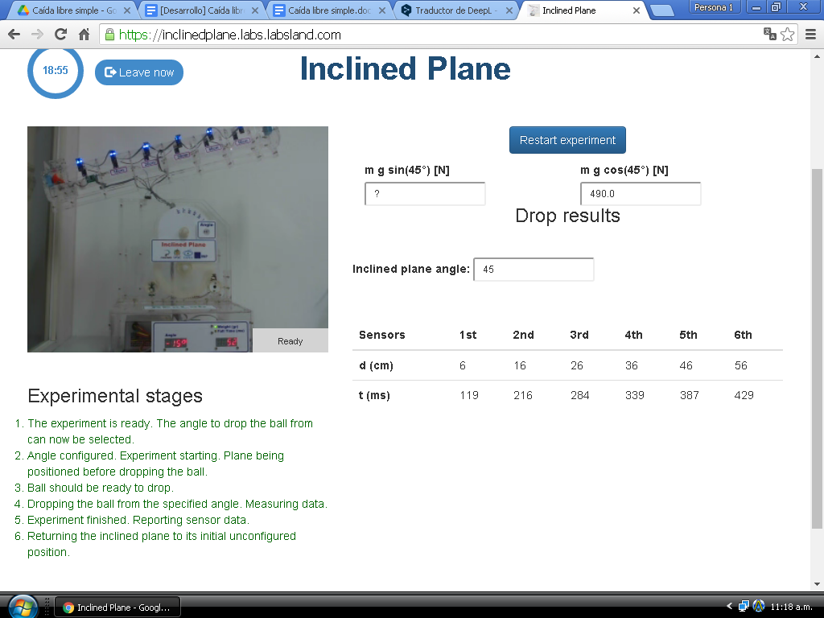

Time at each distance | 0 cm | 6 cm | 16 cm | 26 cm | 36 cm | 46 cm | 56 cm
Experiment 1 | 0 ms | 71 ms | 158 ms | 220 ms | 267 ms | 306 ms | 340 ms
Experiment 2 | 0 ms | 72 ms | 158 ms | 219 ms | 265 ms | 304 ms | 338 ms
Experiment 3 | 0 ms | 78 ms | 163 ms | 224 ms | 270 ms | 309 ms | 343 ms
Mean | 0 ms | 73,67 ms | 159,66 ms | 221 ms | 267,33 ms | 306,33 ms | 340,33 ms

At this point, to analyse the above data, the problem can be approached mathematically, by the formula or graphically. Let's do it the second way.
Dist. in m | t in s | $t^{2}$ in s²
0 | 0 | 0
0,06 | 0,07367 | 0,00542727
0,16 | 0,15966 | 0,02549132
0,26 | 0,221 | 0,048841
0,36 | 0,26733 | 0,07146533
0,46 | 0,30633 | 0,09383807
0,56 | 0,34033 | 0,11582451

The above data can be graphed as distance vs time, or maybe better still distance vs time squared. In this way we see that the relationship is linear which allows us to reaffirm what has already been said with the formula, that distance is linear with the square of time
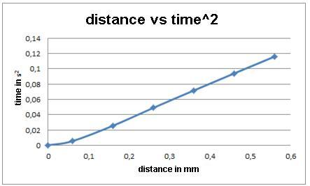
What is the slope of the above line? Considering the straight line with respect to t², then:
$slope=\frac{∆e}{∆t}=\frac{0,56-0,06}{0,1158-0,0054}=4,53 m/s^{2}$
Taking the formula back and bearing in mind that in free fall the acceleration is g:
$h=e\left(t\right)=\frac{1}{2}·a·t^{2}, so g=2x\frac{∆e}{∆t^{2}}$
$g=2x\frac{0,56-0,06}{0,1158-0,0054}=9,06 m/s^{2}$
However, if we take the full table, from 0 cm and 0 s, then

$g=2x\frac{0,56-0}{0,1158}=9,67 m/s^{2}$
The result is good and is close to the theoretical 9.81 m/s² in both cases..

Analysis of experimental results and evaluation

- Complete your table, draw your graph, and get the value of g.

Time at each distance | 0 cm | 6 cm | 16 cm | 26 cm | 36 cm | 46 cm | 56 cm
Experiment 1 | 0 ms
Experiment 2 | 0 ms
Experiment 3 | 0 ms
Mean | 0 ms
t² | 0 ms

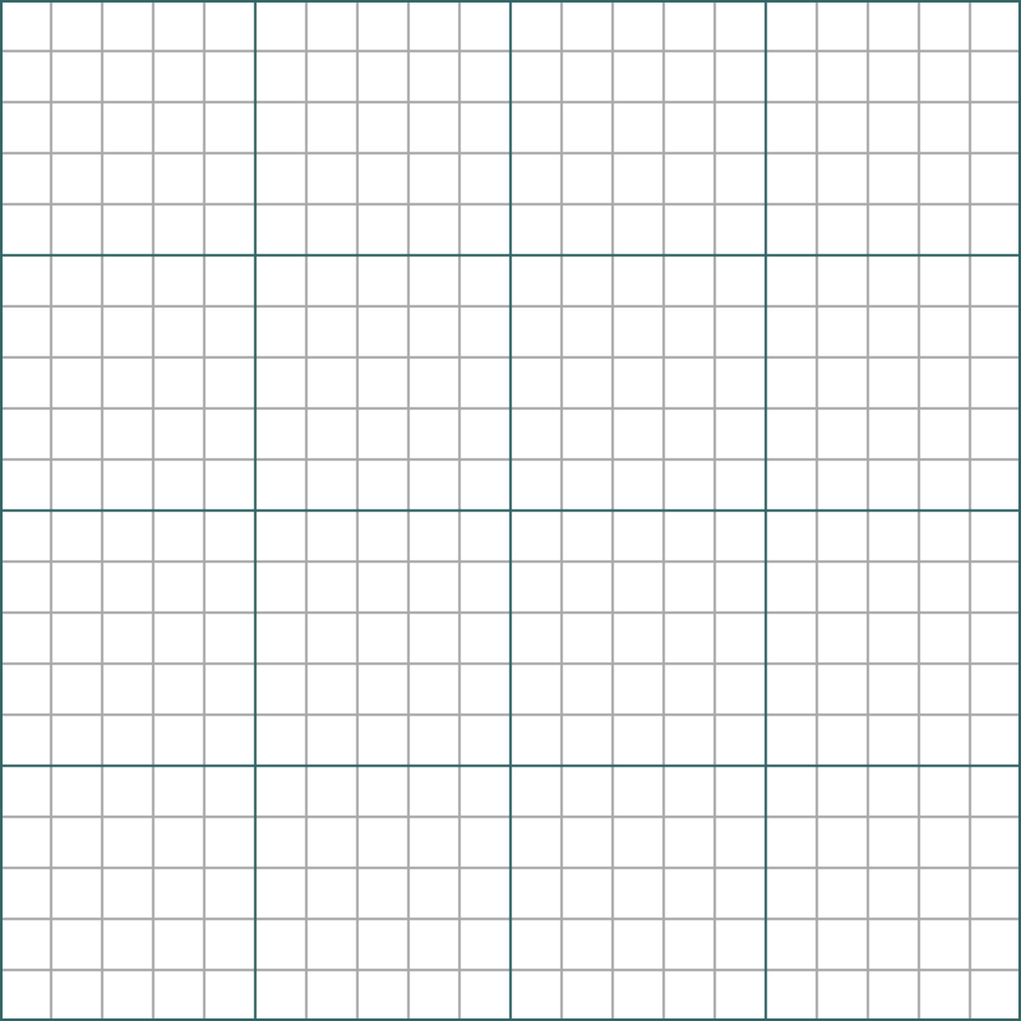
Does the value obtained look like the theoretical value of 9.81 m/s²?

- Probably the value you have obtained for g is not exact. Modify the instant when the ball reaches 56 cm so that the result becomes 9.8 m/s² or almost the same value. In other words, cheat: invent the value of t that makes g 9.81. Have you modified the value of t by 56 cm a lot? how do you assess the effect of t on g? Did you expect it? why is that?
Answer and justification:

- If the ball has taken 0.340 seconds to fall 56 centimetres, how long will it take to fall 112 centimetres? Does it take approximately twice as long?
Answer and justification:

- What is the speed of the ball at each point? Remember that the velocity is obtained by differential calculus, which can be approximated by incremental calculus.

$v=\frac{de}{dt}=\frac{∆e}{∆t}$
 | 0 cm | 0,06 m | 0,16 m | 0,26 m | 0,36 m | 0,46 m | 0,56 m
Time in s
Velocity in m/s | 0 m/s

How did you do the calculation?

- The following expressions express the velocity for an MRUA object as a function of position and instant. Can you check how far the experimental calculation is from the velocities calculated according to the mathematical model?
$At any given moment v=a·t=g·t$
$In a given position v=\sqrt{2·g·d}$
 | 0 cm | 0,06 m | 0,16 m | 0,26 m | 0,36 m | 0,46 m | 0,56 m
Time in s
Experimental velocity in m/s | 0 m/s
Velocity of t in m/s
Velocity of d in m/s
Experimental error I
Experimental error II

The first formula for v uses the value 9.81 m/s² for g and the experimentally obtained t-value.
The second formula uses the value 9.81 m/s² for g and the value of d from the table (0.06-0.16...)
- As you can see, in none of the previous activities has the mass been shown. Does the speed of an object or the acceleration g depend on the mass of the object in question?
Watch the following video: https://youtu.be/E43-CfukEgs Is it a real video, or is it a fake? Do you believe it?
In a survey, when asked the question: "Which falls first, a baseball ball or a marble? 90% said the baseball ball, 10% said both at the same time, and no one said the marble fell first. Which group would you place yourself in?

Comments to the teacher

The data obtained by me are.

Time at each distance | 0 cm | 6 cm | 16 cm | 26 cm | 36 cm | 46 cm | 56 cm
Experiment 1 | 0 ms | 71 ms | 158 ms | 220 ms | 267 ms | 306 ms | 340 ms
Experiment 2 | 0 ms | 72 ms | 158 ms | 219 ms | 265 ms | 304 ms | 338 ms
Experiment 3 | 0 ms | 78 ms | 163 ms | 224 ms | 270 ms | 309 ms | 343 ms
Media | 0 ms | 73,67 ms | 159,66 ms | 221 ms | 267,33 ms | 306,33 ms | 340,33 ms
t² in seconds | 0 | 0,0054405 | 0,0254913 | 0,048841 | 0,0714653 | 0,0938381 | 0,1158245

If we draw distance in cm versus time in seconds.

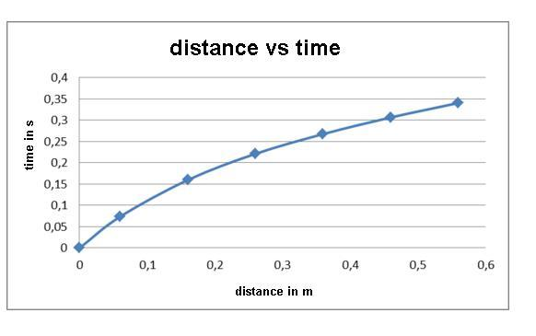
If we draw the distance versus time squared, we see that the relationship is linear.
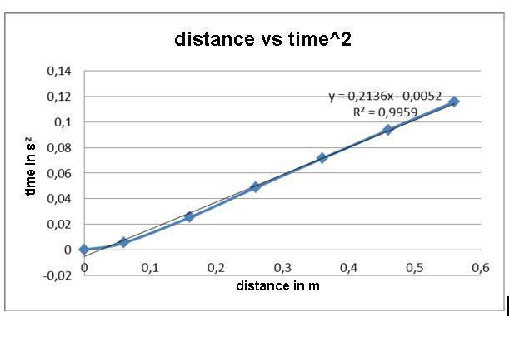

According to this
$slope=\frac{0,56-0}{0,11582}=4,835 m/s^{2}$
Therefore g is 9.67 m/s², which is very close to the ideal value of 9.81 m/s².

$g=2·slope=9,67 m/s^{2}$
The value of g has been obtained by calculating the incremental quotient of all the values, but one also could have used only the last ones, or any subset of them.

$g=slope·2=\frac{0,56-0,46}{0,11582-0,093838}·2=9,0983 m/s^{2}$
This value of 9.0983 m/s² is still further away from the ideal of 9.81 m/s²
The question is how much should the value of t${}^{2}$ have to change for the calculated value to be closer to the ideal? If we change the final time by 0.11452 then
$g=slope·2=\frac{0,56-0,46}{0,11452-0,093838}·2=9,67 m/s{}^{2}$
A change of 1.3 milliseconds has resulted in the g obtained being the same as before. This difference of 1.3 ms can be seen as a sensor error, etc.
In falling 112 cm it will not take twice as long, 0.23164 s, because the ball is accelerated by gravity. In this case we have to use the expression

$h=e\left(t\right)=\frac{1}{2}·a·t^{2}, 1,12=\frac{1}{2}·9,81·t^{2}, t=0,4778 s$

Using our data we have to look at the linear behaviour of t${}^{2}$. As it is linear we can now say that the ball will take twice as long as s2 to travel twice the distance, from 0.56m to 1.12m.

$t^{2}=0,11582·2 and therefore t=\sqrt{0,11582·2}=0,4813 s$
Both results are very similar. The first is the ideal and the second is extrapolated from the experiment data.
To calculate the velocity from the measurements, just remember that velocity is a differential calculation that can be expressed incrementally. The above expression must be applied for each 10 cm section.

$v=\frac{dx}{dt}=\frac{∆x}{∆t}$

Time at each distance | 0 cm | 6 cm | 16 cm | 26 cm | 36 cm | 46 cm | 56 cm
Experiment 1 | 0 ms | 71 ms | 158 ms | 220 ms | 267 ms | 306 ms | 340 ms
Experiment 2 | 0 ms | 72 ms | 158 ms | 219 ms | 265 ms | 304 ms | 338 ms
Experiment 3 | 0 ms | 78 ms | 163 ms | 224 ms | 270 ms | 309 ms | 343 ms
Media | 0 ms | 73,67 ms | 159,66 ms | 221 ms | 267,33 ms | 306,33 ms | 340,33 ms
t² in seconds | 0 | 0,00544054 | 0,02549132 | 0,048841 | 0,07146533 | 0,09383807 | 0,11582451
Velocity |  | 0,8144428 | 1,1629259 | 1,6302576 | 2,1584287 | 2,56410256 | 2,9411765

Ideally, these sections should be 1 cm, or better than that, they should be infinitesimal. In any case, it can be seen that the velocity is increasing at the rate of the acceleration g.
It makes sense to look at the differences between the experimentally measured velocity and the velocity calculated according to the following two expressions. Both expressions should give the same value, but they do not, as they use experimental values for the time. In the table it can be seen that the error becomes smaller and smaller as the ball accelerates further.

 | 0 cm | 6 cm | 16 cm | 26 cm | 36 cm | 46 cm | 56 cm
Time in s | 0 | 0,07376 | 0,15966 | 0,221 | 0,26733 | 0,30633 | 0,34033
Experimental velocity in m/s |  | 0,813449024 | 1,16414435 | 1,63025758 | 2,15842866 | 2,56410256 | 2,94117647
Velocity of t in m/s | 0 | 0,7235856 | 1,5662646 | 2,16801 | 2,6225073 | 3,0050973 | 3,3386373
Velocity of d in m/s | 0 | 1,084988479 | 1,77177877 | 2,25858363 | 2,65766815 | 3,00419706 | 3,31469456
Experimental error I |  | -0,08986342 | 0,40212025 | 0,53775242 | 0,46407864 | 0,44099474 | 0,39746083
Experimental error II |  | 0,271539455 | 0,60763441 | 0,62832605 | 0,49923949 | 0,4400945 | 0,37351809

As a complement to the video, it may be interesting to work with the virtual (not real) laboratory which is accessible at:
http://go-lab.gw.utwente.nl/production/gravityDrop/build/gravityDrop.html?preview

