

FREE FALL

Original author: Eduardo Arias Navarro (UNED)
Adapted by: LabsLand

Index

Introduction 3
Objectives 3
Educational stage and estimated time 3
Contextualization 4
Introductory exercise 8
Procedure 10
Data treatment 13
Discussion 16
References 17

Introduction
This activity is made up of an initial analytical exercise and four practical assumptions for their subsequent discussion. Each assumption has different characteristics that will indicate different results. This version includes example solutions and additional information for the instructor.

Objectives
- Study free fall motion by varying height and falling objects’ characteristics.
- Determine the experimental value of gravity for different objects in free fall.
- To treat correctly treat data and calculate the respective experimental errors.
- Introduce the student to remote experimentation in deferred mode.

Educational stage and estimated time
This activity is aimed at University Degree, Bachelor, Level A and High school students. It has a duration of approximately 180 minutes. It can be done in a single session, separate sessions or even shorter sessions if the student has the option to finish calculations as homework.

Contextualization
The study of motion in Physics is known as kinematics. This area includes the analysis of different types of movement. In this activity, we will focus on free fall.
In 1638 the physicist-astronomer Galileo Galilei (1594-1642)¹ proved that Aristotelian theory was incorrect. This theory considered that bodies accelerate proportionally to their weight. Therefore ,Galileo argued the following sentence:
The constant acceleration of a body in free fall is called the acceleration due to gravity, and we denote its magnitude by the letter “g”. Therefore, on the earth's surface, an approximate value is considered to be:
$$g=9.80 m/s^{2} = 980 cm/s^{2}= 32 ft/s^{2}$$
Motion equations
To ideally understand this movement, kinematics (the study of movement) require that objects describe a constant acceleration, exerted by gravity along the earth's surface, considering that this may also vary over time (Wilson et al ., 2007). In this way, objects restricted to one dimension, that is, a rectilinear motion with constant acceleration, mathematically describe their equations as follows.

Scalar equation of speed (E1) | Scalar equation of position (E2)
$$v_{}\left(t\right)=v_{0}+a t$$ | $$x\left(t\right)=x_{0}+v_{0}t+\frac{1}{2}a t^{2}$$
v_{x}(t): : Velocity at a given point as a function of time (or final position).  v_{o}: Initial speed.  a: Acceleration (or gravity) exerted in the movement.  t: Time that the movement lasts. | x(t): Position at a given point as a function of time (or final position).  x₀: Initial position.  v_{o}: Initial speed.  t: Time that the movement lasts.  a: Acceleration (or gravity) exerted in the movement.

¹You can find out more about this scientist at:: https://en.wikipedia.org/wiki/Galileo_Galilei

If the time that elapses is not known, E3 (equation 3) can be used, which is extracted from E1 and E2 by clearing “t ” as follows in E1:
$v\left(t\right)=v_{0}+a t ⇒ t=\frac{v - v_{o}}{a}$
$$x(t)=x_{o}+v_{0}⋅\frac{v -{ v}_{o}}{a}+\frac{1}{2}a⋅{\left(\frac{v-v_{o}}{a}\right)}^{2}$$
$$x(t)-x_{o}=(v_{0}+\frac{1}{2}a\frac{v -{ v}_{o}}{a})⋅(\frac{v -{ v}_{o}}{a})$$
$$x(t)-x_{o}=\frac{1}{2}a⋅{\left(\frac{v-v_{o}}{a}\right)}^{2}$$
$$\left(\frac{Δx⋅2}{a}\right)={\left(\frac{v-v_{o}}{a}\right)}^{2}$$
$$\frac{Δx·2·a}{a^{2}}=\frac{v^{2}-v_{0}^{2}}{a^{2}}$$
Thus, obtaining the following equation (E3):
Equation with the time variable cleared (E3)
$v^{2}-v_{0}^{2}=2aΔx$
$Δx=x-x_{0}$
Δx: Difference in position between the final position or determined in a time minus the initial one.
You can also have an equation in which the acceleration (or gravity) is not reflected (E5).
Scalar equation of the average speed (E4) | Speed equation (E5)
$$\underline{v}=\frac{v +{ v}_{o}}{2}$$ | $x-x_{0}=\left(\frac{v_{0}+ v}{2}\right)t$
$\underline{v}$: Average speed.  v_{o}: Initial speed.  v: Final speed or at a certain point. | x: Position at a given point as a function of time (or final position).  x₀: Initial speed.  v: Final speed or at a certain point.  t: Time that the movement lasts.
For an object in free fall, it will be delimited $x$ as $y$, in addition an acceleration will be considered $a_{y}=-g$, from the above the equations can be rewritten as:
$v_{(t)}=v_{0}-gt$ (E1’) | $y(t)=y_{0}+v_{0}t-\frac{1}{2}gt^{2}$ (E2’)
$v^{2}=v_{0}^{2}-2g\left(y-y_{0}\right)$ (E3’) | $y-y_{0}=\left(\frac{v_{0}+ v}{2}\right)t$ (E5’)
In this way, with the previous equations it is possible to analyze the free fall of an object. For this reason, for the determination of the time it takes for an object to fall a height $h$ in free fall, starting from rest, it depends on the gravitational acceleration $g$ the height $h$ from it falls.
This relationship is E6, which is achieved from equation E2', and taking into account that:
- The initial position (y₀) is the height (h).
- The final position (y) is 0.
- Acceleration is gravity (g) and is negative.
- The initial speed (v₀) is null. Remember that here the object has Potential Energy, not Kinetic Energy. The latter will begin to increase as you drop the ball.
$$y(t)=y_{0}+v_{0}t-\frac{1}{2}gt^{2}⇒ 0=h+0-\frac{1}{2}gt^{2}$$
$$-h=-\frac{1}{2}gt^{2}⇒h=\frac{1}{2}gt^{2}$$
Free fall equation according to gravity, height and time (E6)
$$g=\frac{2h}{t^{2}}$$

Data processing and error propagation:
In this experiment it is important to consider the uncertainty of the measurements and state it clearly in the results. Manufacturers usually report the range of error of the instrument in its data sheet. If this is not the case, the smallest value that the instrument is capable of measuring is used as the measurement error range. For example, rules have an error of ±0.001m because they are capable of measuring millimeters with precision.
In order to reduce measurement errors and external factors, they are usually made multiple times and then an average is calculated (standard derivation).
When the relationship between magnitudes is direct, the relationship between errors will be the same. For example, if we want to calculate the error of equation E1' (considering that g is a known constant, v₀ is null and that the measured time t has an error of Δt), the error of the speed is:
Error equation (E7):
$$Δv=gΔt$$

However, equations are more complex, there are more than one parameter with an associated error. For example, the error of g (Δg) in the equation E6 is calculated as:

Error equation (E8)
$∆g$=$\left|\frac{∂g}{∂h}\right|∆h$+$\left|\frac{∂g}{∂t}\right|∆t$
$$∆g=\frac{2∆h}{t^{2}}-\frac{2h∆t}{t^{3}}$$

All of those errors must be correctly written: the magnitude ± error style. The error must be rounded to the first significant number, and the magnitude must have exactly the same number of decimal places as the error. For example, if we measure a value of 0.59 and calculate its error to be 0.15, the correct way to present it as a result is 0.6 ± 0.2. Examples:
Incorrect: 0.61 ± 0.2, 0.60 ± 0.2, 0.5 ± 0.0002, 10.5 ± 2.
Correct: 0.6 ± 0.2, 0.5000 ± 0.0002, 11 ± 2.

Introductory exercise
Free fall on a different planet
On planet X, a 25kg stone is dropped from rest and its speed is measured at various times. Then, the obtained data is used to construct the graph of its speed “v” as a function of time “t” (see figure). Using the information from the graph, answer the following questions:
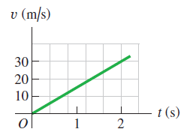
a) Make a diagram or sketch of the situation described on planet X
b) What is the acceleration due to gravity on planet X?
c) An astronaut drops a piece of equipment from rest outside the lander 3.5 m above the surface of planet X. How long will it take this piece to reach the ground, and how fast will it reach the ground?
d) How fast must an astronaut throw an object vertically upward to reach a height of 18 m above the point of release, and how long will it take to reach that height?

Table 1. Idea of ​​technical information to collect in the previous work.
Problem solution | b) t= 2s; v= 30m s ⁻¹ ; - g= a; ¿g?  The data of time, final velocity is provided and we are asked to calculate the acceleration/gravity that affects the object. E1' is used in which the acceleration can be solved with the previous data:  $$v_{(t)}=v_{0}-gt$$  30m· s⁻¹ = 0 - g· 2s  g = 15m· s⁻²  c₁ ) x ₀ = 3.5m ; g = 15m s⁻² ; ¿t?  The initial position (height) is indicated and the acceleration exerted is known from the previous section. The E6 interrelates both data and allows to obtain the time:  $$g=\frac{2h}{t^{2}}$$  t² = 2h/g  t² = 2· 3,5m/ 15m·s⁻²  t = 0,683s  c ₂ )¿ v?  To calculate the speed, the previous data is known and the time has been obtained, so E1' will be applied, as in section b):  $$v_{(t)}=v_{0}-gt$$  v = 0 - 15m· s⁻² · 0,683s  v = 10,245m· s⁻¹  d) h = 18m; g = 15m s⁻² ; v = 0 m s ⁻¹; ¿v ₀ ?  This section is similar to b) and c₂ ) since the speed is requested. However, it should be noted that the initial velocity is requested and that the velocity at the highest point will be zero (remember that the kinetic energy is maximum at the beginning of the movement and that as the object rises, the potential energy increases until it is at the highest point. Here the kinetic energy will be zero, since it has been transformed into potential energy). E6 will be used first to obtain the time that the movement will last and then E1'
  $$g=\frac{2h}{t^{2}}$$  t² = 2h/g  t² = 2· 18m/ 15m· s⁻²  t = 1,549s | $$v_{(t)}=v_{0}-gt$$  0 = v₀ - 15m· s⁻² · 0,683s  v₀ = 23,235m· s⁻¹
Diagram sketch | 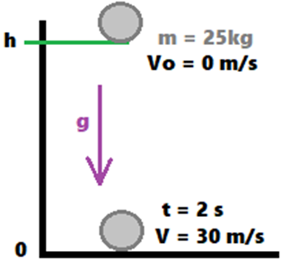

Procedure
- Access the deferred free fall laboratory platform in LabsLand and press the “Access” option.
- Explore the lab seeing the different settings. Observe that there are several different spheres: filled, hollow and colored with their respective report of mass and diameter measurements. See Figure 1 for reference.
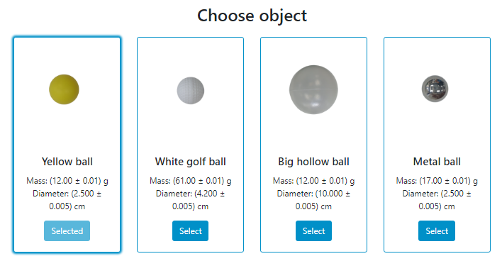
Figure 1. Example of different spheres or balls in the deferred free fall laboratory interface.
- In practice, we will work with three of the spheres in order to analyze the behavior of the free fall of each of these objects.
- Before starting, proceed to write the mass values of each ball in table 2.
Note: Consider making the conversion factors as required in Table 2 and note the associated uncertainty values.

Table 2. Data of the spheres to determine the density.
Ball | Mass m (g) | Mass uncertainty m (g) | Diameter (cm) | Diameter uncertainty (cm)
Yellow | 12 | 0,01 | 2,5 | 0,005
White golf | 64 | 0,01 | 4,2 | 0,005
Big hollow | 12 | 0,01 | 10 | 0,005
Metallic | 17 | 0,01 | 2,5 | 0,005
- Then, choose the yellow ball to start the experiment, then choose a height of 1.3 m by sliding the bar to the right, as shown in figure 2.
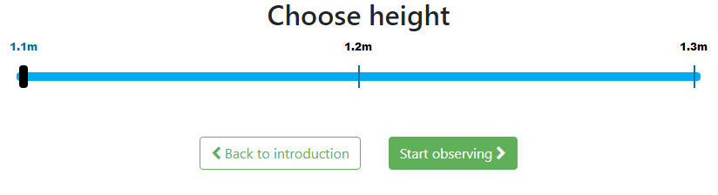
Figure 2. Slide bar to choose the desired height for the spheres or balls in the laboratory interface.
- Once this option is selected, click on "start observing", this will take you to a new page where you will see two screens, a front one with the free fall device with the height and the object that you configured at rest and another screen view showing an accessory connected to the initial device that allows you to record the fall time.
- Next, by clicking on “start”, the time will begin to run until the object falls.
- Once the object has fallen, a fall time for the selected object will appear (see figure 3). Record this value in table 3, which represents the fall time for the yellow ball at a height of 1.3 m.
Note: The laboratory allows access to full screen if you want to observe the falling object or any other detail in detail.
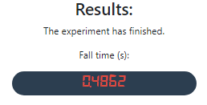
Figure 3. Fall time screen once the object hit the ground.
- Repeat this experiment three more times for the yellow ball at the same height and record the fall time results reported by the laboratory in table 3.
- Once the 3 times have been recorded, proceed to calculate an average time and record its value in table 3.
- Proceed again to configure the laboratory with the yellow ball, but this time selecting a height of 1.2 m, repeat the experiment three times. Write down for each case its time of fall and determine the average time.
- Repeat the previous point but this time at a height of 1.1 m.

Table 3. Fall time experimental data for the yellow ball.
Height h (m)  ± 0,05 m | Time t₁ (s)  ± 0,0001s | Time t₂ (s)  ± 0,0001s | Time t₃ (s)  ± 0,0001s | Average time t (s)
1,3 | 0.5225 | 0.5155 | 0.5260 | 0.521±0.004
1,2 | 0.5029 | 0.4994 | 0.4999 | 0.501±0.002
1,1 | 0.4804 | 0.4931 | 0.4807 | 0.485±0.006
- Select another sphere and repeat the configuration again from the height of 1.3 m until completing the fall times of 1.1 m. Record the results in table 4.
Table 4. Fall time experimental data for the second selected ball.
Selected ball: White (Golf)
Height h (m)  ± 0,05 m | Time t₁ (s)  ± 0,0001s | Time t₂ (s)  ± 0,0001s | Time t₃ (s)  ± 0,0001s | Average time t (s)
1,3 | 0.5475 | 0.5312 | 0.5588 | 0.55±0.01
1,2 | 0.5110 | 0.5172 | 0.5125 | 0.514±0.003
1,1 | 0.5076 | 0.5035 | 0.5008 | 0.504±0.003
- Repeat the experiment once more for another sphere and record all your results in table 5.
Table 5. Fall time experimental data for the third selected ball.
Selected ball: Metallic
Height h (m)  ± 0,05 m | Time t₁ (s)  ± 0,0001s | Time t₂ (s)  ± 0,0001s | Time t₃ (s)  ± 0,0001s | Average time t (s)
1,3 | 0.5128 | 0.5127 | 0.5209 | 0.515±0.004
1,2 | 0.5001 | 0.4990 | 0.5001 | 0.4997±0.0005
1,1 | 0.4724 | 0.4725 | 0.4725 | 0.4725±0.0001

Data treatment
- Based on the results obtained in tables 3, 4 and 5, determine the speed of the balls just before they hit the ground (equation E1’ y E6) and record the results in table 6.
- Using equations 5 and 6, respectively, the value of experimental gravity and its uncertainty (E8) are determined, after which the results are recorded in table 6.
- Make a graph for the yellow ball of height as a function of time. Don't forget to attach titles, labeled axes, trend line, and function to your charts. Attach the image in table 6. The fact that the curve passes the point (0, 0) can be used to increase accuracy.
Note: It is recommended to draw the 2h vs t² graph and to use a linear regression to calculate g. If h vs t or 2h vs t is directly drawn and a quadratic regression is used instead the results will not be good because of the small number of data points available.
- Again, make the other two graphs for the other two balls that were used and attach their image to table 6.
- Determine an average value for the experimental gravity obtained in table 6 for each ball and record your results in table 7.
- Then, with the equation obtained from each graph (equation E2’), determine the value of the graphed experimental gravity. Record the results in table 7.
- Determine the percentage of error for each of the cases carried out by comparing the theoretical value with the experimental gravity and the theoretical value with the graphed experimental gravity. Record the results in table 7.
$$error (\%) = \frac{\left|theoretical value - experimental value\right|⋅100}{theoretical value}$$

Table 6. Results of each of the spheres used.
Ball | Height h (m)  ± 0,05 m | Average time t (s) | Final velocity v_{y} (m/s) | Experimental gravity g_{exp} (m/s²) | Experimental gravity uncertainty g_{exp} (m/s²)
Yellow | 1,3 | 0.521±0.004 | 5.12±0.04 | 9.6 | 0.3
Yellow | 1,2 | 0.501±0.002 | 4.92±0.02 | 9.6 | 0.4
Yellow | 1,1 | 0.485±0.006 | 4.76±0.06 | 9.4 | 0.3
White  (Golf) | 1,3 | 0.55±0.01 | 5.4±0.1 | 8.6 | 0.2
White  (Golf) | 1,2 | 0.514±0.003 | 5.05±0.03 | 9.1 | 0.3
White  (Golf) | 1,1 | 0.504±0.003 | 4.95±0.03 | 8.7 | 0.3
Metallic | 1,3 | 0.515±0.004 | 5.06±0.04 | 9.8 | 0.3
Metallic | 1,2 | 0.4997±0.0005 | 4.907±0.005 | 9.6 | 0.4
Metallic | 1,1 | 0.4725±0.0001 | 4.640±0.001 | 9.9 | 0.4
Yellow Ball graph:
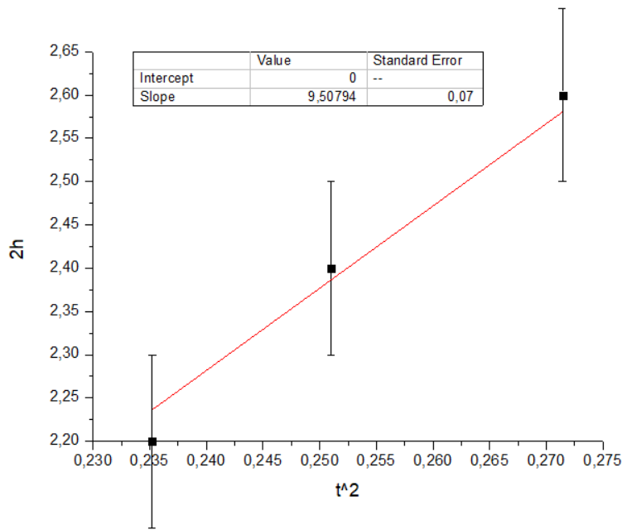
Graph for the second ball
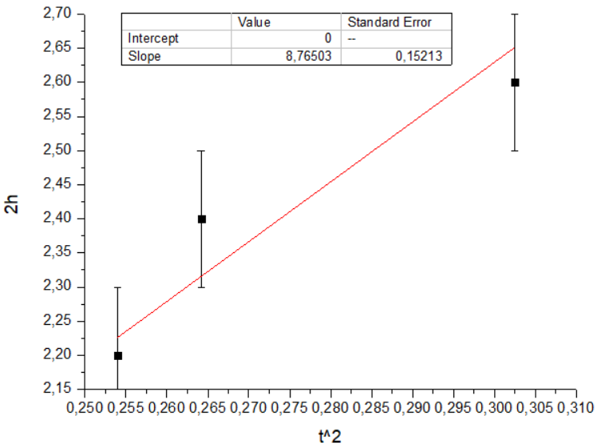
Graph for the third ball
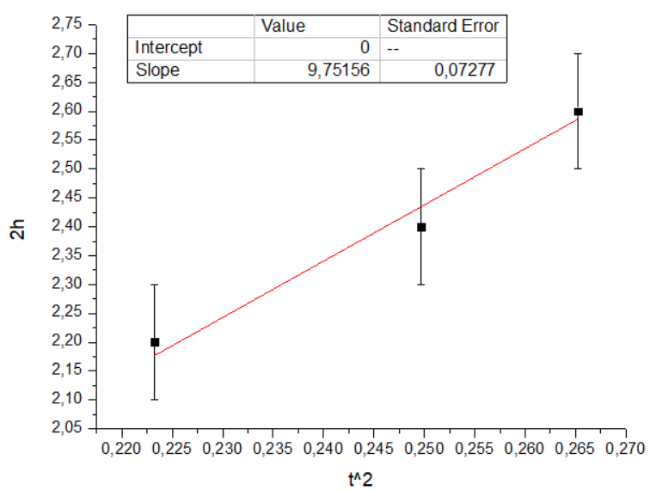

The experimental gravity plotted can be obtained by a linear (L) trend line. Clear the "x" by replacing the "y" with the height (1.1 m, 1.2 m or 1.3 m). Then the time is extrapolated to E6 obtaining the experimental gravity plotted.
Table 7. Results for the calculation of the experimental gravity used in each of the spheres used.
Ball | Average experimental gravity  g_{exp} (m/s²) | Theoretical gravity  g_{teo} (m/s²) | % error | Experimental gravity plotted g_{gra} (m/s²) | Theoretical gravity  g_{teo} (m/s²) | % error
Yellow | 9.5±0.4 | 9.82 | 3.26% | 9.51±0.07 | 9.82 | 3.16%
White (Golf) | 8.8±0.2 | 9.82 | 10.4% | 8.8±0.2 | 9.82 | 10.4%
Metallic | 9.8±0.4 | 9.82 | 0.2% | 9.75±0.07 | 9.82 | 0.7%

Discussion
- Explain how the final speed of each ball changed just before it hit the ground. Justify the answer.
- Analyze the physical meaning of the acceleration values obtained in each of the objects in free fall. What factors influenced to vary the values from one ball to another?
Answer:
There are many ways to answer these questions, each student will have their own. In general, the answers should be directed towards the effect of air resistance on the fall. The denser the ball and the smaller its size. Moreover, the smaller the effect of air resistance and the more the experimental results should resemble the theoretical ones. They could also mention something about experimental errors. An error of 5cm in height measurement is quite significant, for example.

References
- Labsland & UNED CR. (2022). Deferred Free Fall Laboratory. https://labsland.com/en/labs/freefall
- Pasco Scientific. (2022). Discover Freefall System. [online]: https://cdn.pasco.com/product_document/Discover-Freefall-System-Manual-ME-9889.pdf
- Wilson, J; Buffa, A & Lou, B. (2007). Physics. Edition 7. PEARSON EDUCATION, Mexico. ISBN: 0131495798.
- Young, H. D., Freedman, R. A., Ford, A. L., Sears, F. W., & Zemansky, M. W. (2018). Física universitaria. Volumen 1. Edición 14. PEARSON EDUCATION. México D.F. ISBN: 978-607-32-4439-8.

