

FREE FALL
(For college)

Original author: Eduardo Arias Navarro (UNED)
Adapted by: LabsLand

Index

Introduction 3
Objectives 3
Educational stage and estimated time 3
Contextualization 4
Introductory exercise 6
Procedure 8
Data treatment 11
Discussion 12
References 13

Introduction
This activity is made up of an initial analytical exercise and four practical assumptions for their subsequent discussion. Each assumption has different characteristics that will indicate different results. This version includes example solutions and additional information for the instructor.

Objectives
- Study free fall motion by varying height and falling objects characteristics.
- Determine the experimental value of gravity for different objects in free fall.
- Introduce the student to remote experimentation in deferred mode.

Educational stage and estimated time
This activity is aimed at High school students. It has a duration of approximately 60 minutes. It can be done in a single session, separate sessions or even shorter sessions if the student has the option to finish calculations as homework.

Contextualization
The study of motion in Physics is known as kinematics. This area includes the analysis of different types of movement. In this activity, we will focus on free fall.
In 1638 the physicist-astronomer Galileo Galilei (1594-1642)¹ proved that Aristotelian theory was incorrect. This theory considered that bodies accelerate proportionally to their weight. Therefore ,Galileo argued the following sentence:
The constant acceleration of a body in free fall is called the acceleration due to gravity, and we denote its magnitude by the letter “g”. Therefore, on the earth's surface, an approximate value is considered to be:
$$g=9.80 m/s^{2} = 980 cm/s^{2}= 32 ft/s^{2}$$
Motion equations
To ideally understand this movement, kinematics (the study of movement) require that objects describe a constant acceleration, exerted by gravity along the earth's surface, considering that this may also vary over time (Wilson et al ., 2007). In this way, objects restricted to one dimension, that is, a rectilinear motion with constant acceleration, mathematically describe their equations as follows.

Scalar equation of speed (E1) | Scalar equation of position (E2)
$$v_{}(t)=v_{0}+a_{}t$$ | $$x(t)=x_{0}+v_{0}t+\frac{1}{2}a_{}t^{2}$$
v_{x}(t): : Velocity at a given point as a function of time (or final position).  v_{o}: Initial speed.  a: Acceleration (or gravity) exerted in the movement.  t: Time that the movement lasts. | x(t): Position at a given point as a function of time (or final position).  x₀: Initial position.  v_{o}: Initial speed.  t: Time that the movement lasts.  a: Acceleration (or gravity) exerted in the movement.

¹You can find out more about this scientist at:: https://en.wikipedia.org/wiki/Galileo_Galilei
Thus, obtaining the following equation (E3):For an object in free fall, it will be delimited $x$ as $y$, in addition an acceleration will be considered $a_{y}=-g$, from the above the equations can be rewritten as:
$v_{(t)}=v_{0}-gt$ (E1’) | $y(t)=y_{0}+v_{0}t-\frac{1}{2}gt^{2}$ (E2’)
In this way, with the previous equations it is possible to analyze the free fall of an object. For this reason, for the determination of the time it takes for an object to fall a height $h$ in free fall, starting from rest, it depends on the gravitational acceleration $g$ the height $h$ from it falls (E3). This relationship is E3, which is achieved from equation E2', and taking into account that:
- The initial position (y₀) is the height (h).
- The final position (y) is 0.
- Acceleration is gravity (g) and is negative.
- The initial speed (v₀) is null. Remember that here the object has Potential Energy, not Kinetic Energy. The latter will begin to increase as you drop the ball.
$$y(t)=y_{0}+v_{0}t-\frac{1}{2}gt^{2}⇒ 0=h+0-\frac{1}{2}gt^{2}$$
$$-h=-\frac{1}{2}gt^{2}⇒h=\frac{1}{2}gt^{2}$$

Free fall equation according to gravity, height and time (E3)
$$g=\frac{2h}{t^{2}}$$

Introductory exercise
Free fall on the Earth
On the Earth, a 25kg stone is dropped from rest and its speed is measured at various times. Then, the obtained data is used to construct the graph of its speed “v” as a function of time “t” (see figure). Using the information from the graph, answer the following questions:
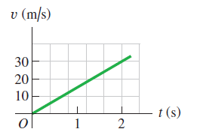
a) What is the acceleration due to gravity on the Earth? (use the data in the figures).
b) An astronaut drops a piece of equipment from rest outside the lander 3.5 m above the surface of the Earth. How long will it take this piece to reach the ground, and how fast will it reach the ground?

Table 1. Idea of ​​technical information to collect in the previous work.
Problem solution

Procedure
- Access the deferred free fall laboratory platform in LabsLand and press the “Access” option. Note: Your teacher should tell you in more detail how you should access the LabsLand lab.
- Explore the lab seeing the different settings. Observe that there are several different spheres: filled, hollow and colored with their respective report of mass and diameter measurements. See Figure 1 for reference.
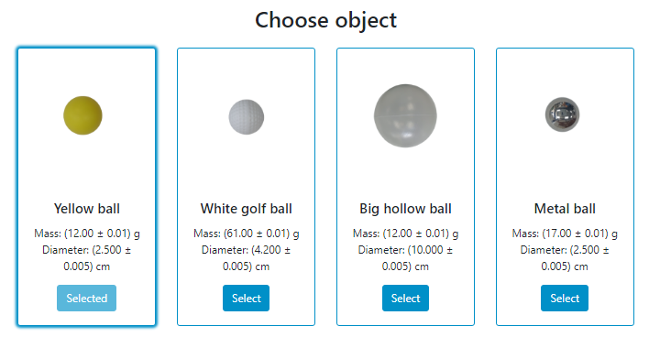
Figure 1. Example of different spheres or balls in the deferred free fall laboratory interface.
- In practice, we will work with three of the spheres in order to analyze the behavior of the free fall of each of these objects.
- Before starting, proceed to write the mass values of each ball in table 2.

Table 2. Data of the spheres to determine the density.
Ball | Mass m (g) | Diameter (cm)
Yellow
White golf
Big hollow
Metallic
- Then, choose the yellow ball to start the experiment, then choose a height of 1.3 m by sliding the bar to the right, as shown in figure 2.
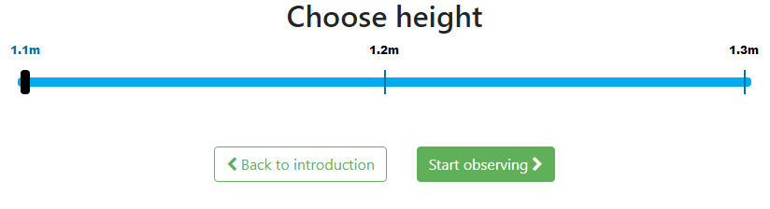
Figure 2. Slide bar to choose the desired height for the spheres or balls in the laboratory interface.
- Once this option is selected, click on "start observing", this will take you to a new page where you will see two screens, a front one with the free fall device with the height and the object that you configured at rest and another screen view showing an accessory connected to the initial device that allows you to record the fall time.
- Next, by clicking on “start”, the time will begin to run until the object falls.
- Once the object has fallen, a fall time for the selected object will appear (see figure 3). Record this value in table 3, which represents the fall time for the yellow ball at a height of 1.3 m.
Note: The laboratory allows access to full screen if you want to observe the falling object or any other detail in detail.
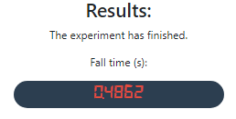
Figure 3. Fall time screen once the object hit the ground.
- Repeat this experiment three more times for the yellow ball at the same height and record the fall time results reported by the laboratory in table 3.
- Once the 3 times have been recorded, proceed to calculate an average time and record its value in table 3.
- Proceed again to configure the laboratory with the yellow ball, but this time selecting a height of 1.2 m, repeat the experiment three times. Write down for each case its time of fall and determine the average time.
- Repeat the previous point but this time at a height of 1.1 m.

Table 3. Fall time experimental data for the yellow ball.
Height h (m) | Time t₁ (s) | Time t₂ (s) | Time t₃ (s) | Average time t (s)
1,3
1,2
1,1
- Select another sphere and repeat the configuration again from the height of 1.3 m until completing the fall times of 1.1 m. Record the results in table 4.
Table 4. Fall time experimental data for the second selected ball.
Selected ball: White (Golf)
Height h (m) | Time t₁ (s) | Time t₂ (s) | Time t₃ (s) | Average time t (s)
1,3
1,2
1,1

Data treatment
- Based on the results obtained in tables 3, 4 and 5, determine the speed of the balls just before they hit the ground (equation E1’) and record the results in table 5.
- Using equations 3 calculate the value of gravity. Recorded the results in table 5.

Table 5. Results of each of the spheres used.
Ball | Height h (m) | Average time  t (s) | Final velocity v_{y} (m/s) | Gravity  g_{exp} (m/s²)
Yellow | 1,3
Yellow | 1,2
Yellow | 1,1
White  (Golf) | 1,3
White  (Golf) | 1,2
White  (Golf) | 1,1

Discussion
Explain how the size and type of spheres influence final velocity, gravity, and time, based on experimental data. Is gravity influenced by the weight of the spheres? Which sphere takes longer to fall?

References
- Labsland & UNED CR. (2022). Deferred Free Fall Laboratory. https://labsland.com/en/labs/freefall
- Pasco Scientific. (2022). Discover Freefall System. [online]: https://cdn.pasco.com/product_document/Discover-Freefall-System-Manual-ME-9889.pdf
- Wilson, J; Buffa, A & Lou, B. (2007). Physics. Edition 7. PEARSON EDUCATION, Mexico. ISBN: 0131495798.
- Young, H. D., Freedman, R. A., Ford, A. L., Sears, F. W., & Zemansky, M. W. (2018). Física universitaria. Volumen 1. Edición 14. PEARSON EDUCATION. México D.F. ISBN: 978-607-32-4439-8.

