EXPERIMENTS WITH 3D PRINTER


With the collaboration of the Spanish Foundation for Science and Technology - Ministry of Science and Innovation


Author: Javier García Zubía (University of Deusto)
Adapted by: LabsLand
Index

Objectives 2
Educational cycle and estimated time 2
Introduction 3
Practice 3
Results and Conclusions 6

Objectives
The objectives of this virtual laboratory are:
- Identify 3D technology to manufacture things in our environment.
- Identify on which parameters the printing of the letter A depends.
- Identify which letter A is better than another and why.
- Organize the process to carry out a systematic experiment with all the options.
- Represent the results of the experiment.
- Communicate results.
- Look for Lecce on the map, because the experiment is there.

Educational cycle and estimated time
This laboratory can be carried out by students of High school, Bachelor and University educational stages, especially those cycles that are oriented to technology and 3D printers. The duration will depend on how many configurations you want to make. Therefore, it is recommended that a time limit be set and students try the different configurations. A maximum of 90 combinations can be made and it takes 1 minute to set up one combination. However, each printout takes different times (although the recordings can be sped up fifteen times).

Introduction
The 3D printer is a new technology that allows you to do everything, or almost everything. They are instruments that by introducing some parameters can be built from tiny pieces to moderately sized pieces. Today, these printers can be purchased for home use, in laboratories, in businesses, and other places. In the following link a video explains how these work and the materials used to create the figures.
YouTube video: The Ultimate Beginner's Guide to 3D Printing - Part 1

Practice
First, you must access the 3D printer deferred laboratory platform in LabsLand and press the “Access” option. Note: Your teacher should tell you in more detail how you should access the LabsLand lab.
The experiment consists of three parts: a) orientation of the piece, b) configuration of the printer(thickness, temperature and supports) and c) observation.
In a) and b) you can choose:
- The orientation of the letter A: Front, Side and Top. That is, how the A will be printed.
- Choose the thickness of the wire that prints the letter: 0.15 mm, 0.5 mm and 1 mm.
- Choose the printing temperature: 140 °C, 170 °C, 200 °C, 230 °C and 260 °C. This is the temperature at which the figure will be printed.
- Choose whether the letter is printed with or without supports. The supports serve to give support to the piece.
- Print the letter A.
- Decide if the quality is good, bad or fair, reviewing the visual results and notes that had been provided.
- Sort the different letters A according to their quality.
- Identify which parameters are best for 3D printing. Try to explain the reasons.
- Answer the question: Is the best always in the extremes?
The number of experiments that can be carried out is 3 x 3 x 5 x 2 = 90, (Front-Side-Top) x (0,15-0,5-1 mm) x (140-170-200-230-260 °C) x (With-Without Support).
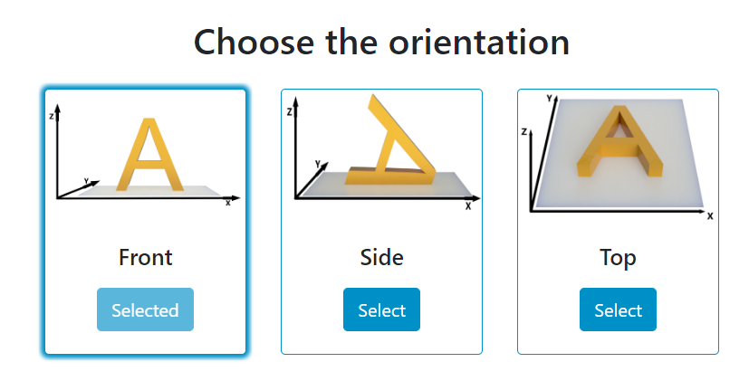
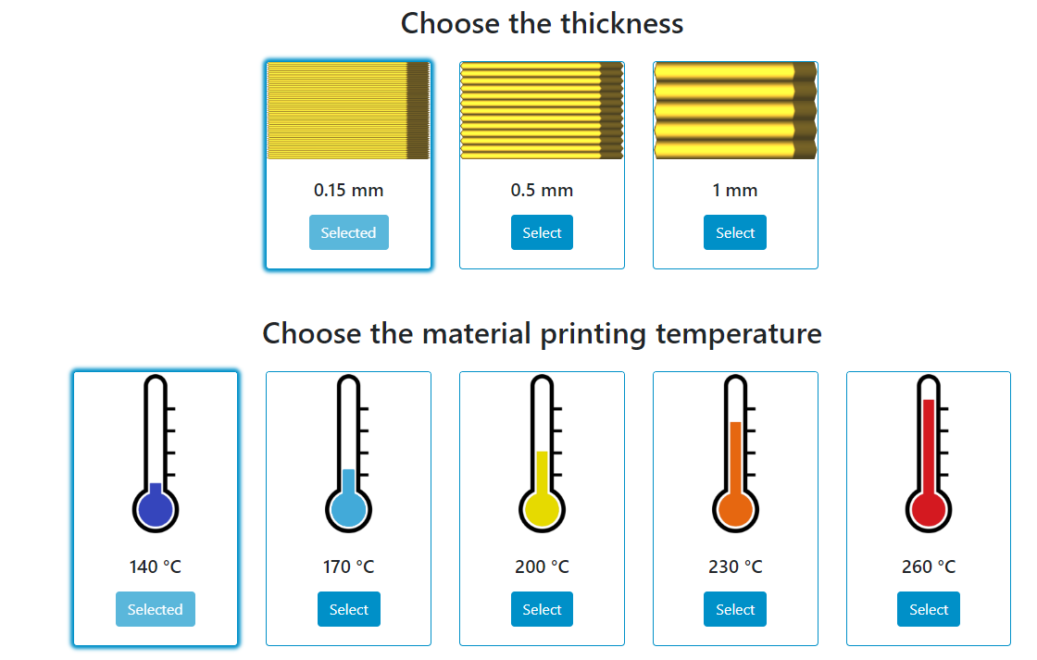
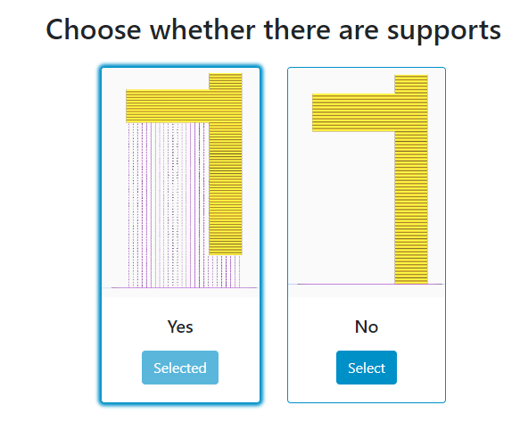
Figure 1. Configuration editor.
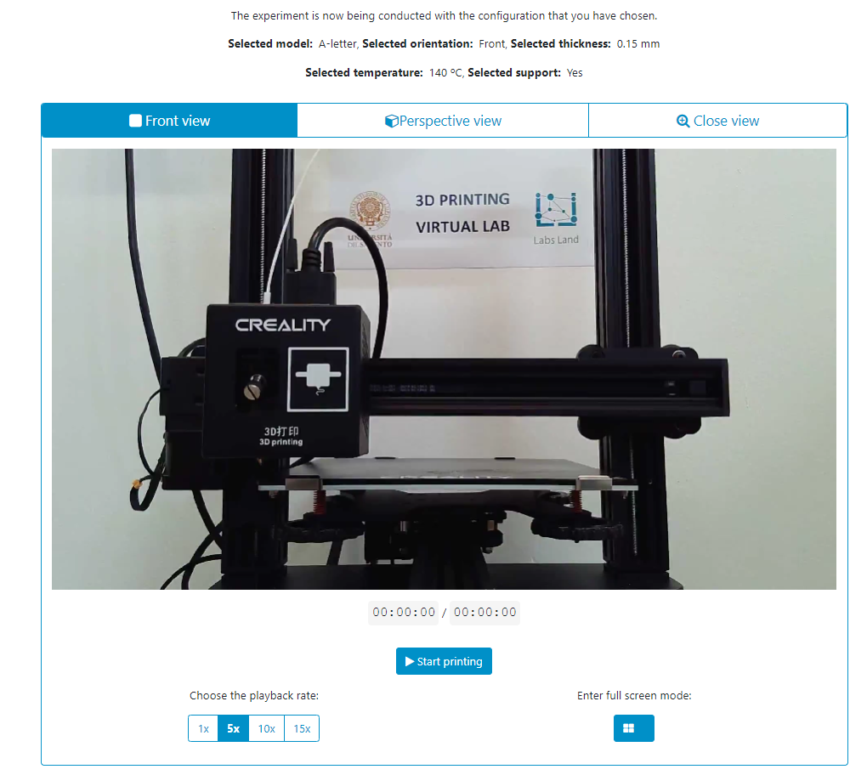
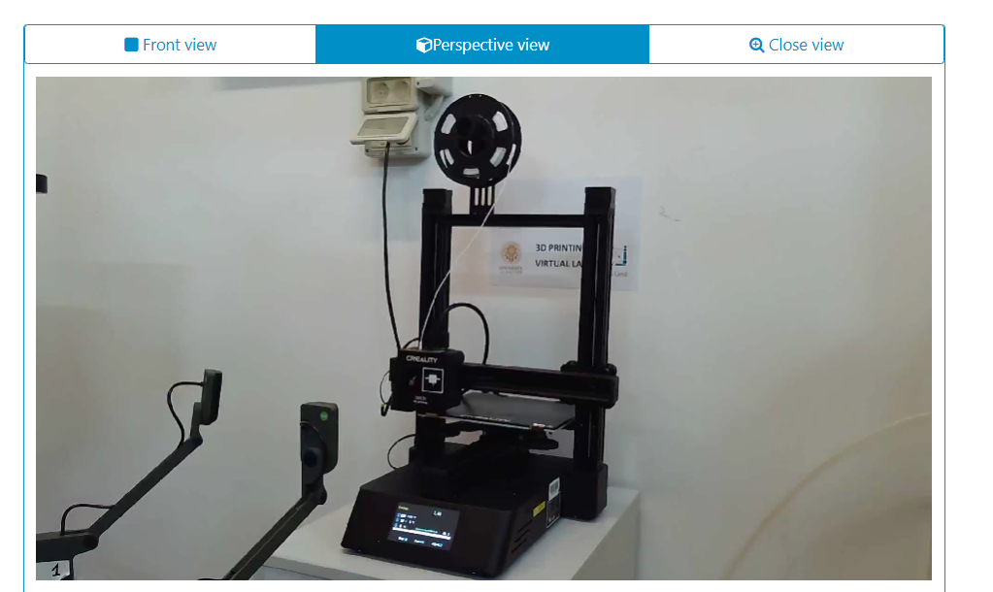
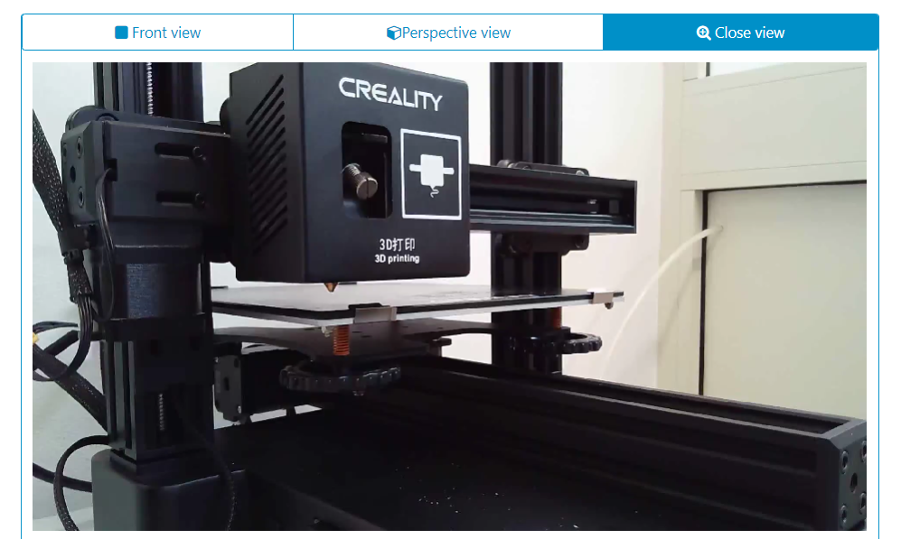
Figure 2. Deferred execution of the experiment, which can be observed from 3 different points of view.

Results and conclusions
In this experiment, it is important to be systematic in order not only to find the best A of the printed ones, but also to be sure that you have tried all the combinations. And there are 90 of them and, therefore, we will have to organize them or let them do it. They will form five groups in class and each group will try 18 different combinations, in this way, they will learn to organize themselves, work in groups and will be able to see the results of all the combinations
Proof | Orientation | Thickness | Temperature | Support | Result
1 | Frontal | 1mm | 260°C | Nope | 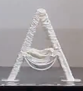
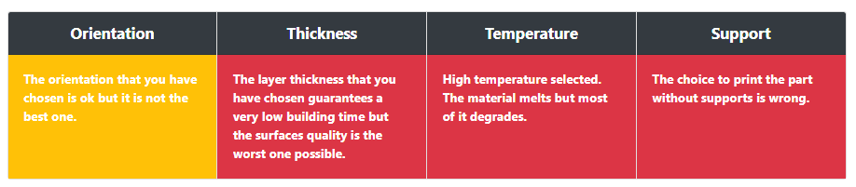
2 | Side | 1mm | 260°C | Nope | 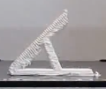
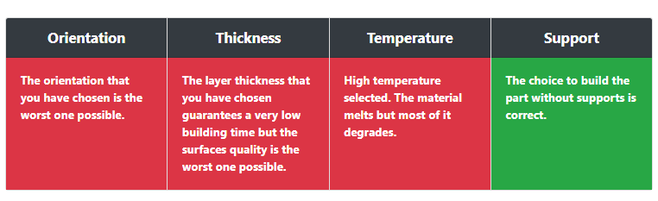
Figure 3. Two of the ninety possible configurations.

The most optimal configuration is the following:
Orientation | Thickness | Temperature | Support | Result
Higher | 0.15mm | 200°C | Nope | 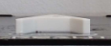
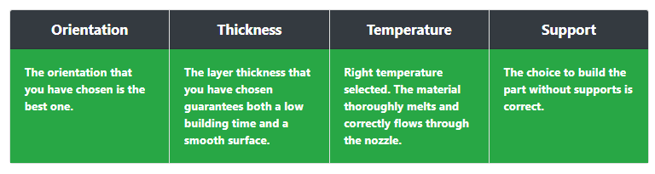
Figure 4. The optimal configuration.
Finally, make an excel or document with all the parameters and settings made and their results. A debate can be held on which is the most optimal or extrapolate it to other types of objects. To do this, each section must be evaluated and then as a whole.
Finally, you can visit the place where said printer is located through Google Maps or a similar page. This place is Lecce, which is in Italy.

